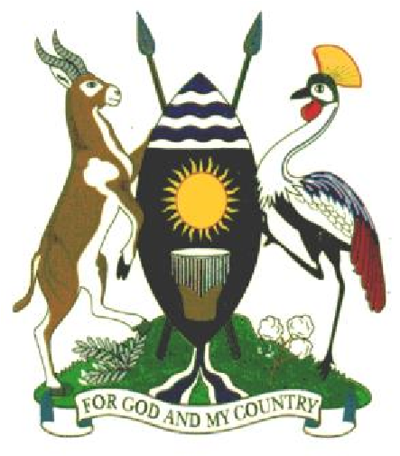
The Republic of Uganda

MINISTRY OF WATER AND ENVIRONMENT
DIRECTORATEOF WATER DEVELOPMENT
URBAN WATER SUPPLY AND SEWERAGE DEPARTMENT
WATER AND SANITATION DEVELOPMENT FACILITY – SOUTH WEST

Who We Are…?
Ministry of Water and Environment (MWE) – Uganda; is a Government Ministry responsible for managing and sustainably utilizing water and environmental resources. Its vision is to ensure the sound management and sustainable use of water and environment for the betterment of Ugandans. The Ministry is headed by the Minister of Water and Environment.
The Ministry's core values include ensuring transparency and accountability in its operations, as well as addressing social and gender-related issues in its projects. The Ministry is also committed to resolving disputes related to environmental and social risks and gender considerations.
The Ministry of Water and Environment is structured into three main directorates: the Directorate of Water Resources Management (DWRM), the Directorate of Water Development (DWD), and the Directorate of Environmental Affairs (DEA). These directorates are responsible for the overall management, development, and protection of the country's water and environmental resources.
Directorate of Water Development (DWD is responsible for providing overall technical oversight for the planning, implementation and supervision of the delivery of urban, rural water and sanitation services, and water for production across the country. DWD is responsible for regulation of provision of water supply and sanitation and the provision of capacity development and other support services to Local Governments, Private Operators and other service providers. DWD comprises four (4) Departments; Rural Water Supply and Sanitation; Urban Water Supply and Sewerage Services, Water Utility and Regulation; and Water for Production.
Urban Department, specifically the Urban Water Supply and Sewerage Services focuses on improving urban water and sanitation services, including piped water supply and sewerage, in towns and rural growth centres.
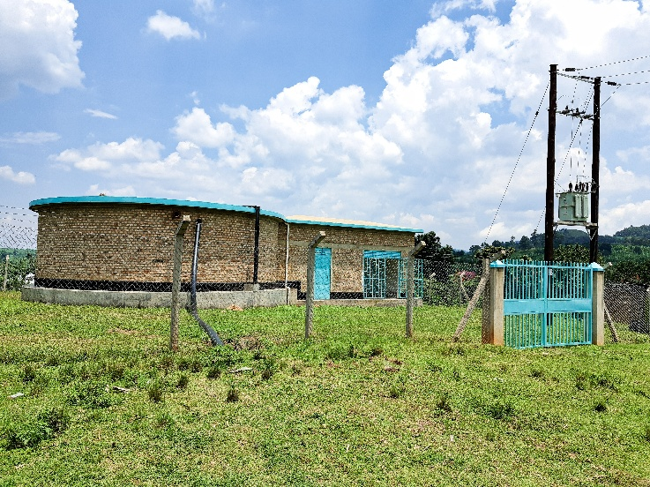
Twine Concrete Storage tank with power connection
Water and Sanitation Development Facilities (WSDFs), these are de-concentrated entities of the MWE that facilitate the identification, financing and implementation of piped water supply and sanitation projects in Small Towns (STs) and Rural Growth Centres (RGCs), in cooperation with the Local Governments, and establishing operation and maintenance structures of the constructed water supply systems and sanitation facilities.
The WSDF-SW was established in 2006 as a pilot in the South Western region, and later, the WSDF model was replicated in other regions of the country: WSDF-East, WSDF-Central, WSDF-North and WSDF-Karamoja. The model has proved to be an effective planning and implementation mechanism that immensely contribute to the Sector Investment plan (SIP).

Area of operation.
The Water and Sanitation Development Facility – South West (WSDF-SW), with a base-office in Mbarara City, is under the Urban Water Supply and Sewerage Service Department (UWSSD). WSDF-SW initiated by the Government of Uganda (GoU) under the Ministry of Water and Environment (MWE) as a framework for funding urban water supply and improved sanitation services.
WSDF-SW covers 31 districts of south western Uganda. This area includes five sub-regions of Central (Kyotera, Rakai, Ssembabule); Ankole (Buhweju, Bushenyi, Ibanda, Isingiro, Kazo, Kiruhura, Mbarara, Mitooma, Ntungamo, Rubirizi, Rwampara, Sheema); Kigezi (Kabale, Kanungu, Kisoro, Rubanda, Rukiga, Rukungiri); Tooro (Bunyangabu, Kabarole, Kamwenge, Kitagwenda, Kyegegwa, Kyenjojo); Rwenzori (Bundibugyo, Kasese, Ntoroko).

Alignment to NDP-IV.
The interventions of WSDF-SW contribute towards the National Development Plan (NDP-IV) Goal, which is, to achieve higher household incomes and employment for sustainable socio-economic transformation. WSDF-SW falls under Human Capital Development Programme with an Objective of Improving population health, safety, Access to safe water, sanitation and hygiene services. The Outcome aims at Improved health and wellbeing of the population, which is measured through three indicators: a. % of population with access to safe water, b. % of population with access to improved sanitation; and c. % of the population with access to basic hygiene services.
This above is achieved through:
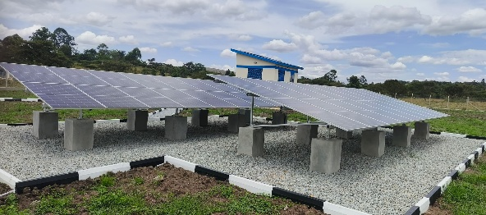
Climate-resilient Design
- Design and construction of climate-resilient urban water supply systems and improved sanitation facilities.
- Stakeholders’ engagement, and Awareness raising on Gender, HIV/AIDs and other Cross-cutting issues.
- Conduct promotional campaigns for environmental conservation, sanitation and handwashing.
- Facilitate the smooth transfer of the investment to the gazetted operators.

Achievements
Since 2006, WSDF-SW has implemented several projects with support from the Government of Uganda (GoU), and the Development Partners (DPs) as follows:

WSDF–SW II Project 1525:
This current project runs between July 2019 and June 2027 with funding from the Government of Uganda, has completed:
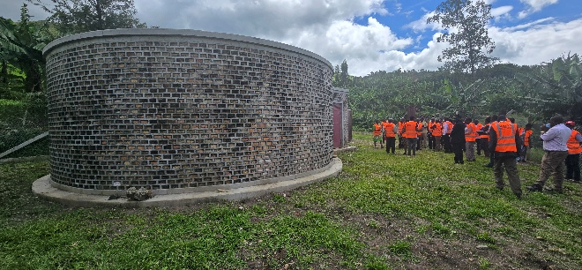
Concrete-storage
- 11 Water supply systems serving approximately 104,910 people;
- 07 Public toilets equipped with eco-friendly features and incinerators;
- Stakeholders’ engagement on gender, HIV/AIDs and other cross-cutting issues; and
- Transfer of the investment of to the appropriate operators.

Support to Water and Sanitation Development:
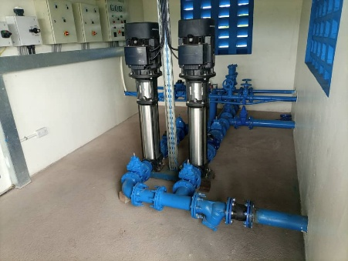
Surface water-pump
Between 19th December 2012 and 30th June 2019; WSDF-SW (Project 1283) implemented a project: “Support to the Water Supply and Sanitation Development in Small Towns and Rural Growth Centres received funding worth Uganda Shillings 90,609,986,941 from three sources: the European Union (EU) MDG-Initiative, ADA and Government of Uganda. Thirty-nine projects were constructed completion as follow: 31 new (typical) schemes, 05 extensions /expansions, 02 Faecal Sludge Treatment Plants (FSTPs), and 01 MWE-SW Regional Office block to accommodate the staff: An estimated design population of 529,871 people, residing in 505 villages /cells, was served.

South Western Towns Water and Sanitation Project III:
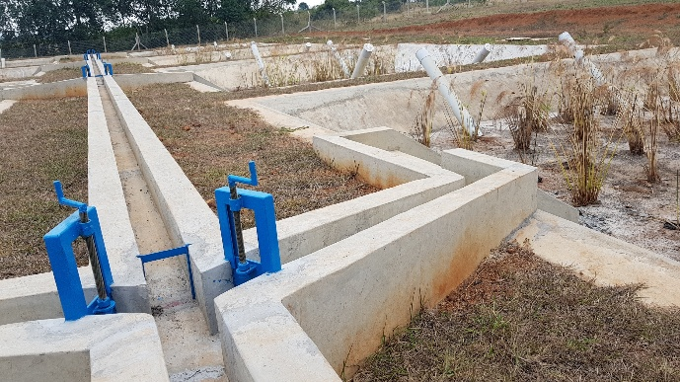
Faecal Sludge Treatment Plant (FSTP)
Between 2006 and 2012; South Western Towns Water and Sanitation Project (SWTWSP) III received funding worth Uganda Shillings 44,530,960,248 from three funding sources: ACP-EU Water Facilities Grant, the Austrian Development Cooperation, and the Government of Uganda: water supply systems and sanitation facilities were constructed to completion in 46 STs /RGCs to serve a population of 452,479 people.

What we do.
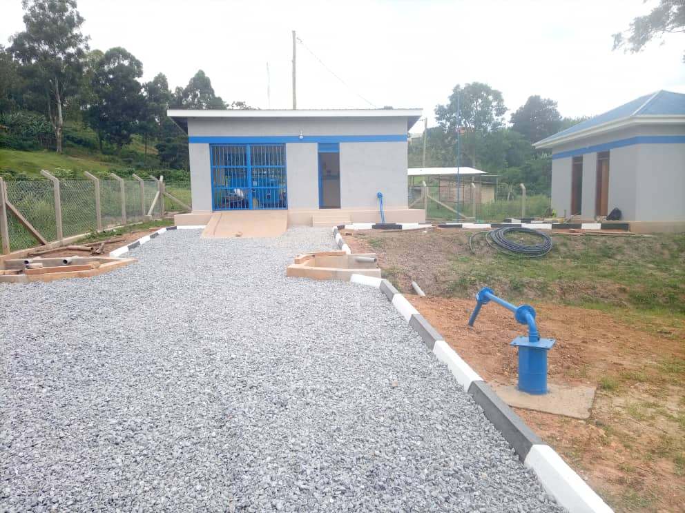
Water source development

Advancing Sanitation and Hygiene.
We promote improved sanitation standards for public health and human dignity. Our interventions include:
- Construction of public and institutional toilets equipped with handwashing facilities.
- Promotion of environmentally friendly sanitation
- solutions such as ecosan (ecological sanitation) toilets.
- Installation of menstrual hygiene-friendly facilities and incinerators in schools.
- Community-led total sanitation (CLTS) campaigns.
- Behavioural change communication for hygiene improvement.

Supporting Local Development and Livelihoods.
Beyond infrastructure, WSDF–SW integrates socio-economic empowerment into its projects:
- Job creation during construction and operation phases.
- Training of local artisans, masons, and water user committees.
- Enhanced access to clean water for small businesses, health centres, schools, and markets.
- Improved time and labour savings, especially for women and girls.

Ensuring Environmental and Social Sustainability.
We embed sustainability in all our projects:
- Environmental and Social Impact Assessments (ESIAs).
- Community engagement, stakeholder consultations, and grievance redress mechanisms.
- Monitoring and evaluation systems to track long-term outcomes.
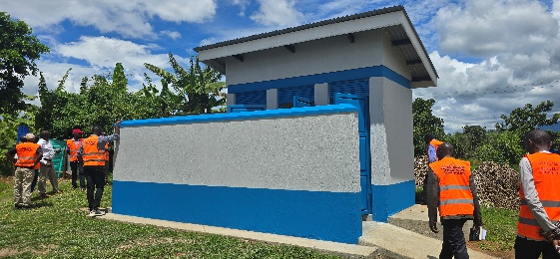  Lined Pit-latrine, Institutional | 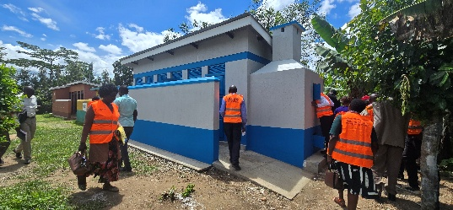

Looking to the Future.
WSDF–SW remains focused on:
- Expanding safe water coverage to more underserved communities.
- Adopting smart, climate-resilient infrastructure solutions.
- Deepening partnerships with local governments, development partners, and the private sector.
- Enhancing community ownership and capacity to manage facilities
- Prioritizing inclusive WASH solutions for women, youth, and people with disabilities

Out Team.
WSDF–SW brings together a committed, multidisciplinary team of experts in:
- Water and civil engineering;
- Sanitation and environmental health;
- Social work and community development;
- Procurement and financial management;
- Surveying, GIS, and mapping;
- Management, communications, monitoring, evaluation and learning.
We work hand-in-hand with communities, district local governments, and national stakeholders to deliver meaningful change, one project at a time.

Get in Touch.
Ministry of Water and Environment
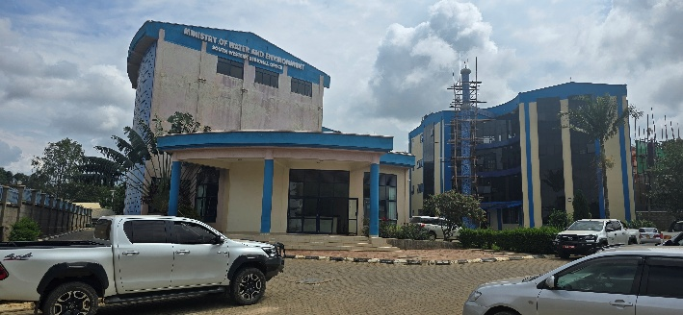
MWE-SW Regional Office, Mbarara City
Water and Sanitation Development Facility – South West
Plot 1, Mbarara-Kabale Road
P.O. BOX 575, Mbarara, Uganda
Tel: +256 0485 420386
Web: www.mwe.go.ug

