###### 



**MINISTRY OF WATER AND ENVIRONMENT**

**STAKEHOLDER ENGAGEMENT PLAN (SEP)**

**FOR**

**INVESTING IN FORESTS AND PROTECTED AREAS FOR CLIMATE-SMART DEVELOPMENT PROJECT ADDITIONAL FINANCING (IFPA-CD)**

**JUNE 2025**

# EXECUTIVE SUMMARY

**Project Background**: The Government of Uganda (GoU) developed the Uganda Investing in Forests and Protected Areas for Climate Smart Development (IFPA-CD) to improve sustainable management of forests and protected areas and increase benefits to communities from forests in target landscapes. The project that is being financed by the World Bank (WB) and GoU and contributes to the World Bank Group’s twin goals of ending extreme poverty and building shared prosperity in a sustainable manner.

The project is being implemented by the Ministry of Water and Evironment (MWE), Ministry of Tourism, Wildlife and Antiquities (MTWA), Uganda Widlife Authority (UWA), National Forestry Authority (NFA), targeted District Local Governments (DLG), and contracted Technical Service Providers (TSPs). Under Additional Financing, some activities related to development of wood value chains will be implemented by the Uganda Timber Growers Association (UTGA).

The project focuses on improving the management of forests and increasing revenues for sustaining forests and supporting resilient livelihoods. The Project concept is aligned to support raising incomes in rural areas and seeks to strengthen natural resources management and build resilience, with particular attention to growing incomes of women.

**Methodology**: The Stakeholder Engagement Plan (SEP) was developed for IFPA-CD during project preparation in 2019-2020 in a process that included stakeholder consultations and full disclosure. In view of the proposed AF, the SEP has been updated. The update has been informed by the findings from relevant document reviews such as Reports of World Bank’s implementation support missions such as Aide Memoires, Environmental and Social Management Framework (ESMF), The Process Framework, The Vulnerable and Marginalised Group Framework, The Vulnerable and Marginalised Group Plans, Implementation Status Reports (ISRs), Progress reports from the Government of Uganda implementing agencies, Findings of stakeholder consultations, The Grievience Redress Framework, District Development Plans, Management Plans for Central Forest Reserves, Management Plans for National Parks and Wildlife Reserves. The SEP was also updated in July 2024 to include provisions related to enhanced inclusion and non-discrimination.

Where information in the original SEP for IFPA-CD remains relevant, it has been maintained.

**Location of the Project Area:** The Project’s geographical focus is on selected priority areas in western and north-western Uganda, which includes the Albert Water Management Zone (AWMZ) and West Nile part of Upper Nile Water Management Zone, plus Lamwo district. Component 3 focuses on the 19 refugee hosting districts of Hoima, Kagadi, Kakumiro, Kamwenge, Kibaale, Kikuube, Kiryandongo, Kyegegwa, Adjumani, Arua, Terego, Koboko, Lamwo, Madi Okollo, Moyo, Obongi, Yumbe and Amuru district.

**Project Components:** The Project focuses on four main components, namely: 1) Improved management of protected areas 2) Increased revenues and jobs from forests and wildlife protected areas 3) Improved landscape management 4) Project management and monitoring

**Stakeholder Engagement Plan**

During the preparation of the IFPA-CD project, a Stakeholder Engagement Framework was designed (in 2020) followed by a detailed Stakeholder Engagement Plan (SEP) which was prepared at the start of project implementation to guide stakeholder engagement. The SEP defines programs for stakeholder engagement, describes commitments and process for stakeholder engagement and outlines ways in which IFPA-CD project implementation team communicates with stakeholders. It includes mechanisms by which people can raise concerns or make complaints and receive feedback on issues of IFPA-CD project implementation.

As part of preparation of the AF, the SEP is being updated to meet the World Bank’s ESS10 requirements and is being disclosed as part of the AF appraisal process. The main purpose of stakeholder engagement is to ensure that stakeholders are effectively engaged in project actions with the view to understand and own the IFPA-CD project.

**Stakeholder Engagement Interventions:** The project has had extensive stakeholder engagement from early stages of the project identification, preparation and implementation with project affected parties and other interested parties. The engagements were under the REDD+ readiness processes, IFPA-CD and during preparation of IFPA-CD-AF. The main stakeholders consulted included the Marginalized and Vulnerable Groups (the Batwa), the beneficiary populations and communities, district technical officers and politicians from lower-level local councils (LCs) to Constituency (LC1), religious leaders, officials at the Water Management Zone level, stakeholders from key sectoral ministries at the central level, and Members of Parliament (MPs).

**Stakeholder Identification and Analysis Criteria:** Stakeholder engagement process for the IFPA-CD starts with identification, mapping and analysis of project stakeholders and this plan serves to clarify the stakeholder identification procedure at national and project area level during project implementation. This guides MWE and Implementing Agencies, Local Governments and TSPs to comply with national and World Bank requirements for effective stakeholder engagements.

**Mapping Stakeholders:** Broadly, IFPA-CD Project stakeholders are ‘people or institutions who have a role in the Project or could be positively or negatively affected by the Project, or who are interested in the Project. IFPA-CD Project stakeholders are grouped into primary, secondary and tertiary stakeholders.

**Vulnerable Groups (VG):** Under the IFPA-CD project, vulnerable groups include the rural women, child-headed households, youths, and orphans, persons with disabilities, the elderly, and hard to reach community members and the sick. Their concerns, contributions and priorities inform project design.

**Vulnerable and Marginalised Groups (VMGs):** This term applies to groups meeting the definitions in ESS7, such as the Batwa ethnic group who are present in the project area i.e. around Echuya CFR, Mgahinga Gorilla, Bwindi Impenetrable and Semuliki National Parks. They represent a specific sub-category within the broader vulnerable groups due to their unique identities and aspirations that are distinct from the mainstream vulnerable groups. The Vulnerable and Marginalized Groups Framework (VMGF) and site-specific Vulnerable and Marginalized Groups Plans (VMGPs) have been developed. They highlight priorities for IFPA-CD support regarding the Batwa, including budget and modalities for implementation of project activities.

**Strategy for Consultations**; The project applies various methods of engagements that meets international standards for stakeholder consultations which emphasizes the need for consultations to be free and prior informed.

**Strategy for incorporating and providing feedback to stakeholders:** Views, suggestions and recommendations received from stakeholders are responded to during the public consultative meetings or through administrative correspondences or through follow up field visits and discussions. Feedback on policy issues that require attention by the Project Steering Committee (PSC) is provided soon after the next PSC meeting.

**Strategy for information disclosure**: Project information such as the PAD, ESMF, ESCP, SEP, VMGPs, etc. are disclosed to stakeholders and public accompanied by registers of comments and suggestions from the public that are subsequently documented by MWE, UWA, NFA and Technical Service Providers (TSP) in a formal manner. The Grievance Redress Mechanism **(**GRM) ensures that there is an adequate mechanism for stakeholders airing their views and receiving prompt feedback.

**Management functions and responsibilities:** The overall responsibility for implementing this SEP is with the MWE (PCU) through the National Project Coordinator (NPC). Within the PCU, the Environmental and Social team supports, monitors and reports on the over-all performance of the SEP and works closely with UWA and NFA to ensure a coordinated approach.

**Grievance Redress Mechanism (GRM):** In line with ESS10, IFPA-CD GRM was established purposely to facilitate communication between conflicting parties, promoting dialogue, and facilitating a reasonable agreement between the parties to a grievance. It provides credible and accessible means for Project Affected Persons (PAPs) and other stakeholders to pursue grievances, allowing the project to address genuine issues in a timely manner and to minimise chances of distractions to project implementation. For UWA, Grievance Redress Committees (GRCs) were formed at Conservation Area and Protected Area levels, and the roll out to lower levels is on-going. For NFA, GRCs have been formed at Range level, and roll out to lower levels is on-going. In refugee hosting districts, GRCs run from lower levels up to the national level. Different levels of GRCs have different roles and responsibilities. The GRC processes involves Receiving, Acknowledging and Recording Grievances, Sorting and categorization, Verification and resolution, Giving feedback, Safe handling of grievance records, Anonymous grievances and Right to Appeal.

**TABLE OF CONTENTS**

EXECUTIVE SUMMARY 2

1. INTRODUCTION/PROJECT DESCRIPTION 9

1.1 Project Design 9

1.2 Description of Additional Financing 10

1.3 Proposed Changes 10

1.4 Proposed activities by components 10

2. THE STAKEHOLDER ENGANGEMENT PLAN 13

2.1. Purpose of Stakeholder Engagement 13

2.2. Objectives of the Stakeholder Engagement Plan 13

2.3. General Principles of Stakeholder Engagement Under the Project 14

3. LOCATION OF THE PROJECT AREA 15

4. BRIEF SUMMARY OF PREVIOUS STAKEHOLDER ENGAGEMENT ACTIVITIES 21

5. STAKEHOLDER IDENTIFICATION AND ANALYSIS 25

5.1 Stakeholder analysis criteria 25

5.2 Mapping Stakeholders 25

5.3. Engagement with Vulnerable and Marginalised Groups 27

6. STRATEGY FOR STAKEHOLDER ENGAGEMENT 31

6.1 Strategy for Consultations 31

6.2. Strategies for Meaningful Stakeholder Engagement 32

6.3 IFPA-CD Stakeholder Engagement Interventions to-date 36

6.4. Strategy for Providing Feedback 39

6.5. Strategy for Future Consultations (Future Phases) 40

6.6. Strategy for information disclosure 41

7. RESOURCES AND RESPONSIBILITIES FOR IMPLEMENTING STAKEHOLDER ENGAGEMENT ACTIVITIES 43

7.1. Resources 43

7.2 Management functions and responsibilities 43

8. The IFPA-CD project GRM 44

8.1 Definition of a Grievance under IFPA-CD project 44

8.2 Justification for a robust GRM under IFPA-CD Project 44

8.4 Implications for not having a GRM 45

8.5 Principles of GRM 45

8.6 GRM Structures 46

8.7 Roles and Responsibilities of Grievance Redress Committees 51

8.8 The GRM Process 52

8.9. Disclosure of the GRM Information 57

8.10 Grievance prevention 57

8.11 The World Bank’s Grievance Redress Service (GRS) 58

9.0 MONITORING AND REPORTING 59

ANNEX 1 DETAILS OF GRCs FOR CENTRAL FOREST RESERVES AND SURROUNDING DISTRICTS 61

ANNEX 2 DETAILS OF GRCs FOR WILDLIFE PROTECTED AREAS AND SURROUNDING DISTRICTS 71

Annex 3: Actions Taken by Gou to Ensure Inclusion and Non-Discrimination 78

Annex 4: Enhanced Implementation Support and Monitoring on Non-Discrimination 92

ANNEX 5: Guidelines For Implementing Mitigation Measures to Address Exclusion and Discrimination -Related Risk 97

**List of Tables**

Table 1. Project Components and Subcomponents 9

Table 2. Wildlife Protected Areas under the Project 15

Table 3. Central Forest Reserves under the Project 16

Table 4. Project Districts with Activities outside Protected Areas (under Component 3) 17

Table 5. Project Districts Adjacent to Wildlife Protected Areas Supported Under the Project 19

Table 6. Project Districts Adjacent to Central Forest Reserves Supported with Core Interventions under the Project 19

Table 7. Consultations under REDD+ Process 21

Table 8. Consultations for the Design of IFPA-CD Project 22

Table 10. Consultations with Primary Stakeholders 27

Table 11. Batwa Communication and Information Access Needs 29

Table 12. Consultations Plan for the Batwa 30

Table 13. Arrangement for Engaging Batwa in Decision-Making Processes 31

Table 14. Methods and Approaches for Ensuring Free and Prior Informed Engagements 33

Table 15. Key Stakeholder Engagement Interventions 39

Table 16. Type of Information Disclosed 42

Table 17. Communication and Feedback Mechanisms 42

Table 18. GRM Structures in the Districts in Refugee-Hosting Areas 49

Table 19. Estimates of GRM Structures at Wildlife Protected Areas under the Project and Surrounding Districts 49

Table 20. Estimates of GRM Structures for the Central Forest Reserves and Surrounding Districts 50

Table 21. Roles And Responsibilities of GRCs 52

Table 22. GRM Establish and Capacity Building Interventions to Date 53

**ABBREVIATIONS**

BINP Bwindi Impenetrable National Park

CFR Central Forest Reserve

CSO Civil Society Organization

DEA Directorate of Environment Affairs

DFID Department for International Development (UK)

DLG District Local Government

DESSS Directorate of Environmetal Sector Support Services

BMCA Bwindi and Mgahinga Conservation Area

BMCT Bwindi and Mgahinga Conservation Trust

ECO Ecological Conservation Organization

ECOTRUST Environmental Conservation Trust of Uganda

ED Executive Director

ESCP Environmental and Social Commitment Plan

ESMF Environmental and Social Management Framework

ESMP Environmental and Social Management Plan

FFI Fauna and Flora International

FGRM Feedback and Grievances Redress Mechanisms

FSSD Forestry Sector Support Department

GAP Gender Action Plan

GBVAP Gender Based Violence Action Plan

GCF Global Climate Funds

GIZ German Development Agency

GRC Grievance Redress Committee

GRM Grievance Redress Mechanism

IFPA-CD Investing in Forest and Protected Areas for Climate Smart Development Project

IGCP International Gorilla Conservation Programme

IUCN International Union for Conservation of Nature and Natural Resources

JGI Jane Goodall institute

LMP Labour Management Procedure

MFNP Murchison Falls National Park

MoFPED Ministry of Finance, Planning and Economic Development

MoGLSD Ministry of Gender, Labour and Social Development

MTWA Ministry of Tourism, Wildlife and Antiquities

MWE Ministry of Water and Environment

NEMA National Environment Management Authority

NFA National Forestry Authority

NGO Non-Government Organization

NP National Park

NPA National Planning Authority

NTC National Technical Committee

NU Nature Uganda

OPM Office of the Prime Minister

PA Protected Area

PAD Project Appraisal Document (of IFPA-CD)

PAP Project Affected People

PCU Project Coordination Unit

PS Permanent Secretary

PSC Project Steering Committee

QENP Queen Elizabeth National Park

SEP Stakeholder Engagement Plan

SESA Strategic Environmental and Social Assessment

SLM Sustainable Land Management

SNP Semuliki National Park

SOP Standard Operating Procedures (for COVID-19)

TSP Technical Support Services

UN United Nations

UNHCR United National High Commission for Refugees

UTA Uganda Tourism Association

UTGA Uganda Timber Growers Association

UWA Uganda Wildlife Authority

VMGF Vulnerable and Marginalized Groups Framework

VMGP Vulnerable and Marginalized Groups Plan

VSLA Village Savings and Loans Associations

WB World Bank

WCS Wildlife Conservation Society

WESWG Water and Environment Sector Working Group

WR Wildlife Reserve

WWF Worldwide Fund for Nature

# INTRODUCTION/PROJECT DESCRIPTION

## 1.1 Project Design

As part of efforts to conserve and sustain forest cover, the Government of Uganda (GoU) developed the Uganda Investing in Forests and Protected Areas for Climate Smart Development (IFPA-CD) Project that is being financed by the World Bank (WB) and GoU. The Project contributes to the World Bank Group’s twin goals of ending extreme poverty and building shared prosperity in a sustainable manner. The Project is also closely aligned with the Uganda Country Partnership Framework (FY16-21) (CPF)[1] and Uganda Vision 2040. The project aims to improve sustainable management of forests and protected areas and increase benefits to communities from forests in target landscapes. This will be achieved by undertaking integrated interventions by the Ministry of Water and Evironment (MWE), Ministry of Tourism, Wildlife and Antiquities (MTWA), Uganda Widlife Authority (UWA), National Forestry Authority (NFA), targeted District Local Governments (DLG), and contracted Technical Service Providers (TSPs).

The project takes a landscape approach to improve management and economic productivity of forest ecosystems in the targeted landscapes. The project combines investments in forest management in state- and community-managed lands and focuses on improving the management of forests and increasing revenues for sustaining forests and supporting resilient livelihoods.

The Project area targets some of the poorest districts in Uganda, which are also some of those most affected by the refugee influx. Specifically, the Project concept is aligned to support raising incomes in rural areas and seeks to strengthen natural resources management and build resilience, with particular attention to growing incomes of women.

**Outcomes:** The expected project outcomes are:

1. Increased provision of ecosystem goods and services though more sustainably managed forests and protected areas and enhancement of forest stocks.
2. Increased revenue generation and other benefits from forests and protected areas for communities, government agencies and private sector in the Albertine Rift and West Nile Region.

The project is structured in four main components and eight subcomponents, see Table 1 below.

**Table 1. Project Components and Subcomponents**

|  |  |
| --- | --- |
| **Component** | **Sub-component** |
| **Component 1. Improved management of forest protected areas** | 1.1. Improvement of infrastructure and equipment for the management of forest protected areas |
| 1.2. Increasing the involvement of local communities in the management of forest and wildlife areas by increasing their access and benefits from these areas |
| 1.3. Restoration of degraded natural forests and habitats in Wildlife and Forest Protected Areas |
| 1.4. Increased forest protection in CFRs and WRs in close proximity to refugee settlements |
| **Component 2. Increased Revenues and Jobs from Forests and Wildlife Protected Areas** | 2.1. Investments in tourism |
| 2.2. Investments in productive forestry |
| **Component 3. Improved landscape management** | 3.1. Increased trees cover on community and private land |
| 3.2. Supporting farm forestry for refugee fuel supply |
| **Component 4. Project management and monitoring** |  |

## 1.2 Description of Additional Financing

AF is under Uganda Multi Donor Trust Fund (MDTF) in the amount of approximately US$27 million.

## 1.3 Proposed Changes

The proposed changes with the AF entail scaling up of activities and expanding the coverage of interventions within the original project landscape. Proposed activities under the AF are well aligned with the original Project Development Objective (PDO), therefore the PDO will remain unchanged.

The content of the components (Section 2.4) of the parent project are adjusted to reflect the expanded scope and new activities proposed under the AF. The proposed changes are to increase the overall cost of the Project to US$203.9 million (consisting of US$178.2 million (US$148.2 million from the World Bank and US$30 million from the Government of Uganda) in the parent project plus US$27 million AF).

In addition to AF, the project has restructured and included new wildlife and forest protected areas as well as 9 plantation CFRs. These include Karuma Wildlife Reserve, 9 Plantation Central Forest Reserves under NFA have been added to the target for plantation establishment (Nyakunyu, Kagorra, Oruha, Kikumiro, Kyehara, Lendu, Mafuga, Okarevu and Usi forest reserves. Natural forests (5) added include: Ozubu   681 ha, Kijuna    1225 Ha, Kanaga     650 ha, Nyabiku    355 ha, Ruzaire        1,160 ha

## 1.4 Proposed AF activities by components

**Sub-component 1.1: Improvement of infrastructure and equipment for the management of forest protected areas.**

*The AF will expand support for enhanced biodiversity monitoring*. This includes expansion of Uganda’s National Forest Monitoring System (NFMS) to include biodiversity inventories in key landscapes (e.g., QENP, Budongo CFR), rollout of the Earth Ranger[2] system in select PAs (Toro-Semliki WR, Kibale NP, Katonga WR, Bwindi Impenetrable NP, and Mgahinga Gorilla NP), and procurement of monitoring tools, vehicles, and IT infrastructure. The project will support comprehensive biodiversity stocktaking in key PAs: UWA will undertake a full biodiversity inventory in the QENP landscape (including assessment of opportunities and threats to biodiversity in PAs) covering QE NP, Kyambura WR, Kasyoha-Kitoma CFR, Kalinzu CFR, Kigezi WR, South Maramagambo CFR, and North Maramagambo CFR, and NFA will undertake full biodiversity updates (and regular monitoring in years 2 and 3) in Budongo, Wambabya, Kitechura, Ibambaro, Muhangi, Kagombe, Itwara, Kibego, and Echuya CFRs. Coordination with partners such as Makerere University, IUCN, and the Wildlife Conservation Society will ensure data integration and sustainability.

* + - 1. *The AF will also finance construction* (as well as design, supervision of works, and environmental and social [E&S] due diligence) of offices and housing infrastructure for NFA staff in select CFRs (Budongo [2 units], Kalinzu [1 unit], Lendu [1 unit], Mafuga [1 unit], Oruha [1 unit]); the provision of mobility (vehicles); and construction of additional junior staff housing for UWA staff in MGNP (Garamba outpost) and Toro Semliki WR (5 units), as well as flush toilets at selected sites. The offices will use climate-smart/climate-adjusted designs, with water harvesting facilities and with solar panels as the main power source.

**Subcomponent 1.2: Increasing the involvement of local communities in the management of forest and wildlife areas by increasing their access and benefits from these areas**

With the AF, activities will be expanded to deepen engagement with CFM and CRM groups. Planned activities include roll-out of updated CFM guidelines, new community awareness campaigns, and additional support to income-generating activities such as soap making, briquetting, and beekeeping. VMGPs will be updated and implemented in Echuya CFR, Bwindi NP, MGNP, and Semuliki NP.

**Sub-component 1.3: Restoration of degraded natural forests and habitats in forest reserves**

Additions to the removal of invasives will be primarily financed under the AF. The subcomponent also finances the removal of invasive vegetation over 10,200 ha—3,000 ha in CFRs (Budongo, Matiri, Kalinzu, and North and South Maramagambo) and 7,200 ha in NPs and WRs (Bwindi Impenetrable NP, Kibale NP, Murchison Falls NP, MGNP, Semuliki NP, Queen Elizabeth NP, and Toro Semliki WR).

**Subcomponent 2.1: Investments in tourism**

**The AF** will support the following activities:

1. *Under NFA*:construction of tourism infrastructure (including a visitor information center [including equipment] and other related site infrastructure, as designed, as well as basic internet connectivity and materials and equipment for the center) in Echuya CFR. The AF will also support upgrade of the existing community ecotourism site, development of a picnic site, a craft shop for the community group, and improvements to their office. The AF will also support a capacity assessment for NFA tourism staff and training on tourism development.
2. *Under UWA*,the AF will support development of a ‘Strategic Sustainable Nature-Based Tourism (NBT) Development Plan’, guiding long-term product development, governance, and destination competitiveness aligned with biodiversity conservation. This plan will build upon Uganda’s new Tourism Policy and target niche biodiversity tourism markets. Additional support includes furnishing and equipping five new visitor information centers (originally planned to be financed under IDA) and the procurement of a grader and safari vehicle to improve road accessibility and tourism experience in QENP.

**Subcomponent 2.2: Investments in productive forestry**

**The AF** will support the following activities:

1. *Capacity building support to the Uganda Timber Growers Association (UTGA).* UTGA is an independent private sector, member-driven association of commercial tree growers, including associated tree nursery operators and forestry contractors. Delivered via NFA, funding support will include investments in governance, marketing, business planning, and industry development as outlined in UTGA’s Business Plan (2022–2027). Specific investments will include technical assistance, provision of equipment and temporary staff for the UTGA timber yard, exposure visits for UTGA members, and support to cluster engagements with the members. The AF will also support Forest Stewardship Council certification expansion and chain of custody systems, including audit-related activities.
2. *Support to NFA for establishment of timber plantations* within Kagorra, Oruha, Kikumiro, Kyehara, Mafuga, Lendu, Nyakunyu, Okavureru, and Usi CFRs with a total target area of 2,000 ha; maintenance support will be also provided to 3,500 ha of existing NFA plantations.
3. *Matching industry grants for processing and value chain activities.* The recipients of the grants will be determined through call for proposals, with an intention to provide approximately 12 matching grants. These will be competitively awarded based on criteria such as innovation, employment creation, and climate benefits. Eligible investments may include sawmill upgrades, drying kilns, engineered wood technologies, or efficient residue utilization. A TSP will manage the grant facility, while MWE will oversee disbursements. This activity will have a broader geographic scope, also encompassing additional districts or other administrative areas where specifically stated: Buikwe, Ibanda, Isingiro, Jinja district and Jinja Municipality (including Jinja City), Kalungu, Kampala City, Kasanda, Kayunga, Kazo, Kiboga, Kiruhura, Kyankwanzi, Luwero, Masaka, Mayuge, Mbarara, Mityana, Mpigi, Mubende, Mukono, Nakaseke, Nakasongola, Ntungamo, Rwampara, Sheema, and Wakiso.
4. *Support to Nyabyeya Forestry College* to strengthen vocational and technical training in commercial forestry and wood processing, through investments in processing equipment that can be used for practical training that meets the industry standards and related training. The beneficiaries of this training will include contractors and the workforce in the industry. The outcome expected from this investment is a more knowledgeable and skilled workforce capable of delivering high-quality products that meet the demands of clients.

# THE STAKEHOLDER ENGAGEMENT PLAN

During the preparation of the IFPA-CD project, a Stakeholder Engagement Framework was designed as one of the instruments to guide stakeholder identification, analysis and engagement. It was duly disclosed in 2020. A more detailed Stakeholder Engagement Plan (SEP) was prepared at the start of project implementation to guide stakeholder engagement; it was disclosed as a draft.

As part of preparation of the AF, the SEP is being updated to meet the World Bank’s ESS10 requirements and is being disclosed as part of the AF appraisal process. The SEP describes the commitments and process for stakeholder engagement during the remaining period of IFPA-CD implementation (2024-2028). It describes the stakeholder identification and prioritization, engagement approaches and strategies for the national, regional and local stakeholders during the entire project cycle. This SEP is, therefore, an instrument for mapping and prioritizing stakeholders across levels and regions; for guiding planned consultations and disclosure of relevant project information to/with identified stakeholders.

Planned consultations are useful in creating awareness of the project’s potential impacts and mitigation measures; enabling the stakeholders to be consulted from an informed position about the project; and providing a mechanism for receiving feedback and its consideration in relevant project designs, plans and activities, including options and alternatives.

Following the GoU and World Bank focus on enhancement of inclusion and non-discrimination measures in all projects in 2023, the preparation of this document and its annexes include specific measures to mitigate the social risks associated with discrimination against or exclusion of any affected individuals and groups from accessing project benefits and opportunities in World Bank­–financed projects and program in Uganda. These measures are described in various sections of this document including Annexes 3, 4 and 5.

## 2.1. Purpose of Stakeholder Engagement

The purpose of stakeholder engagement is to ensure that stakeholders are effectively engaged in project actions with the view to understand and own the IFPA-CD project. Overall, stakeholder engagement is intended to be all-inclusive devoid of manipulation, interference, coercion, and intimidation, discrimination, and conducted on the basis of timely, relevant, understandable and accessible information. It involves providing information and opportunity to contribute towards decisions that influence the implementation of IFPA-CD project interventions as well as to provide opportunities for all stakeholders to raise their concerns and opinions as appropriate.

## Objectives of the Stakeholder Engagement Plan

The overall objective of this SEP is to define a program for an inclusive stakeholder engagement, including public information disclosure and consultation, throughout the entire project implementation cycle. The SEP outlines the ways in which IFPA-CD project implementation teams communicate with stakeholders and includes a mechanism by which people can raise concerns or make complaints about IFPA-CD project and any activities related to the project and receive feedback on issues raised. The involvement of the local population is essential to the success of the project in order to ensure smooth collaboration between staff of the implementing agencies and local communities and to minimize and mitigate environmental and social risks related to the proposed project activities.

The specific objectives of the SEP are to:

1. Provide guidance for stakeholder engagement such that the project meets the standards of International Best Practice.
2. Identify key stakeholders that are affected, interested and/or able to influence the Project and its activities.
3. Identify the most effective methods, timing and structures through which to share project information, and to ensure regular, accessible, transparent and appropriate consultation.
4. Provide an inclusive stakeholders’ engagement process that provides stakeholders with an opportunity to influence project planning and implementation.
5. Establish formal inclusive and non-discriminatory grievance/resolution mechanisms ensuring access to vulnerable or marginalized individuals and groups.
6. Define roles and responsibilities for the implementation of the SEP.
7. Define reporting and monitoring measures to ensure the effectiveness of the SEP and periodical reviews of the SEP based on findings.

## General Principles of Stakeholder Engagement Under the Project

* The project utilizes various methods of engagement as part of its continuous interaction with the stakeholders aiming at ensuring an effective and meaningful engagement.
* Some of the methods are tailored to the targeted stakeholders. For example, techniques used for consulting with statutory officials are different from those of liaising with the local communities with a lesser emphasis on technical aspects. Application of tailored techniques, which ensures maximum participation of the vulnerable or marginalized individuals and groups in project consultations.
* The technique of every consultative activity strives to meet general requirements on accessibility, i.e. conducting consultations at venues or e-platforms that are easily reachable and do not impose restrictions of access or cultural inappropriateness (i.e. with due respect to the local customs and norms) and exclusions.

Ensure provision of logistical assistance to stakeholders to enable them to participate in project activities and consultative meetings, most especially the vulnerable or marginalised stakeholders.

Since the status of vulnerable or marginalized individuals and groups may lead to people’s diffidence and reluctance or physical incapacity to participate in large-scale community meetings, holding separate/dedicated small group discussions with them at an easily accessible venue is one of the ways for the project to reach out to the such groups who, under standard circumstances, are likely to be insufficiently represented at community gatherings.

# LOCATION OF THE PROJECT AREA

The Project’s geographical focus is on selected priority areas in western and north-western Uganda. The Project area includes the Albert Water Management Zone (AWMZ) and West Nile part (plus Lamwo district) of Upper Nile Water Management Zone.

The Albert Nile WMZ is largely comprised of the Lake Albert catchment area, which is shared between Uganda and the DRC, is located at the northern tip of the western rift valley. On the Ugandan side, it is stretching from the slopes of the Rwenzori Mountains in the Southwest, through the escarpment of Albertine Rift Valley down to the Victoria Nile delta in the North-eastern end of the lake. The spatial extent of this catchment is a total area of 18,037 km2. Lake Albert covers an area of 5,270 km2 of which 2,850 km2 (54%) is on the Ugandan side. At an altitude of 615 m, it lies between two parallel escarpments, that on the western side rising abruptly to nearly 2,000 m above the water surface. Like most large rift valley lakes, the lake is ribbon shaped lying in the northeast southwest direction and runs approximately 160km in length and is 35km at its widest point. The lake is relatively shallow with an average depth of 25m and maximum depth of 58m and has a total volume of about 280 km3. The implementation of the Project within this WMZ targets the Districts of Hoima, Kamwenge, Kibaale, Kiryandongo, Kikuube, Kakumiro, Kagadi Kyegegwa which form part of the Albert Water Management Zone (AWMZ) and target Protected Areas and Central Forest Reserves.

The upper Nile region surrounding Lake Victoria is one of the most densely populated of Africa with up to 1200 persons’ km. Population growth rates are among the highest in the world. In 1985, 32% of the Ugandan portion of the catchment was occupied by agriculture and, with population having doubled in the interim, deforestation and excessive cultivation with little input use have been the predominant land use trends. In West Nile, which is part of the Upper Nile WMZ, the Project will be implemented in the Districts of Adjumani, Madi Okollo, Terego, Obongi, Arua, Amuru, Koboko Moyo, Yumbe, Lamwo and Nwoya. The Project also targets Wildlife Protected Areas, plantation, Central Forests and Central Forest Reserves as listed in Table 2 and Table 3 below.

Refugee hosting districts supported through the project have been selected, because they are situated within project target landscapes of Albertine and West Nile regions, they host refugee communities or are within a 5 km radius of the refugee settlements. In order to ensure appropriate coverage and landscape contiguity, the project is working in clusters of districts based on the boundaries set as of July 1, 2010. This allows the project benefit from the technical capacity of local government staff in the original districts, while securing continuity in cases of creation of new districts.

**Table 2. Wildlife Protected Areas under the Project**

|  |  |  |
| --- | --- | --- |
| **S/No** | **Name of Park/Wildlife Reserve** | **Size (Ha)** |
| 1 | Bwindi Impenetrable National Park | 32,100 |
| 2 | Mgahinga Gorilla National Park | 3,370 |
| 3 | Kibale National Park | 79,500 |
| 4 | Semuliki National Park | 22,000 |
| 5 | Queen Elizabeth National Park | 197,800 |
| 6 | Murchison Falls National Park | 384,000 |
| 7 | Rwenzori Mountains National Park | 99,600 |
| 8 | Toro-Semliki Wildlife Reserve | 54,300 |
| 9 | Kabwoya Wildlife Reserve | 22,532 |
| 10 | Katonga Wildlife Reserve | 21,000 |
| 11 | Karuma Wildlife Reserve | 67,500 |

**Table 3. Central Forest Reserves under the Project**

|  |  |  |
| --- | --- | --- |
|  | **Name of CFR** (Managed by NFA) | |
|  | Budongo | **New:** Kagorra |
|  | Bugoma (in refugee hosting areas) | **New:** Kikumiro |
|  | Buhungiro | **New:** Kyehara |
|  | Echuya | **New:** Lendu |
|  | Era (in refugee hosting areas) | **New:** Mafuga |
|  | Ibambaro | **New:** Nyakunyu |
|  | Ihimbo | **New:** Okavureru |
|  | Itwara | **New:** Oruha |
|  | Kagombe (in refugee hosting areas) | **New:** Usi |
|  | Kakasi | **New:** Kanaga (in refugee hosting areas) |
|  | Kalinzu | **New:** Kijuna (in refugee hosting areas) |
|  | Kasokwa | **New:** Nyabiku (in refugee hosting areas) |
|  | Kasyoha-Kitomi | **New:** Ozubu (in refugee hosting areas) |
|  | Kibego | **New:** Ruzaire (in refugee hosting areas) |
|  | Kitechura |  |
|  | Matiri |  |
|  | Mt Kei (in refugee hosting areas) |  |
|  | Muhangi |  |
|  | Nkera |  |
|  | North Maramagambo |  |
|  | South Maramagambo |  |
|  | Nyakarongo (in refugee hosting areas) |  |
|  | Otzi (East) (in refugee hosting areas) |  |
|  | Otzi (West) (in refugee hosting areas) |  |
|  | Rwensambya (in refugee hosting areas) |  |
|  | Wambabya (in refugee hosting areas) |  |
|  | Wati (in refugee hosting areas) |  |

**Table 4. Project Districts with Activities outside Protected Areas (under Component 3)**

| **Districts as of July 1, 2010** | **Districts as of September 1, 2023** |
| --- | --- |
| ***Albert Water Management Zone*** | |
| 1. Hoima | 1. Hoima 2. Kikuube |
| 1. Kamwenge | 1. Kamwenge 2. Kitagwenda |
| 1. Kibaale | 1. Kakumiro 2. Kagadi 3. Kibaale |
| 1. Kiryandongo | 1. Kiryandongo |
| 1. Kyegegwa | 1. Kyegegwa |
| ***West Nile / Upper Nile Water Management Zone*** | |
| 1. Adjumani | 1. Adjumani |
| 1. Amuru | 1. Amuru |
| 1. Arua | 1. Madi Okollo 2. Terego |
| 1. Koboko | 1. Koboko |
| 1. Lamwo | 1. Lamwo |
| 1. Moyo | 1. Moyo 2. Obongi |
| 1. Yumbe | 1. Yumbe |
| 1. *Nwoya* | 1. ***Nwoya*** |

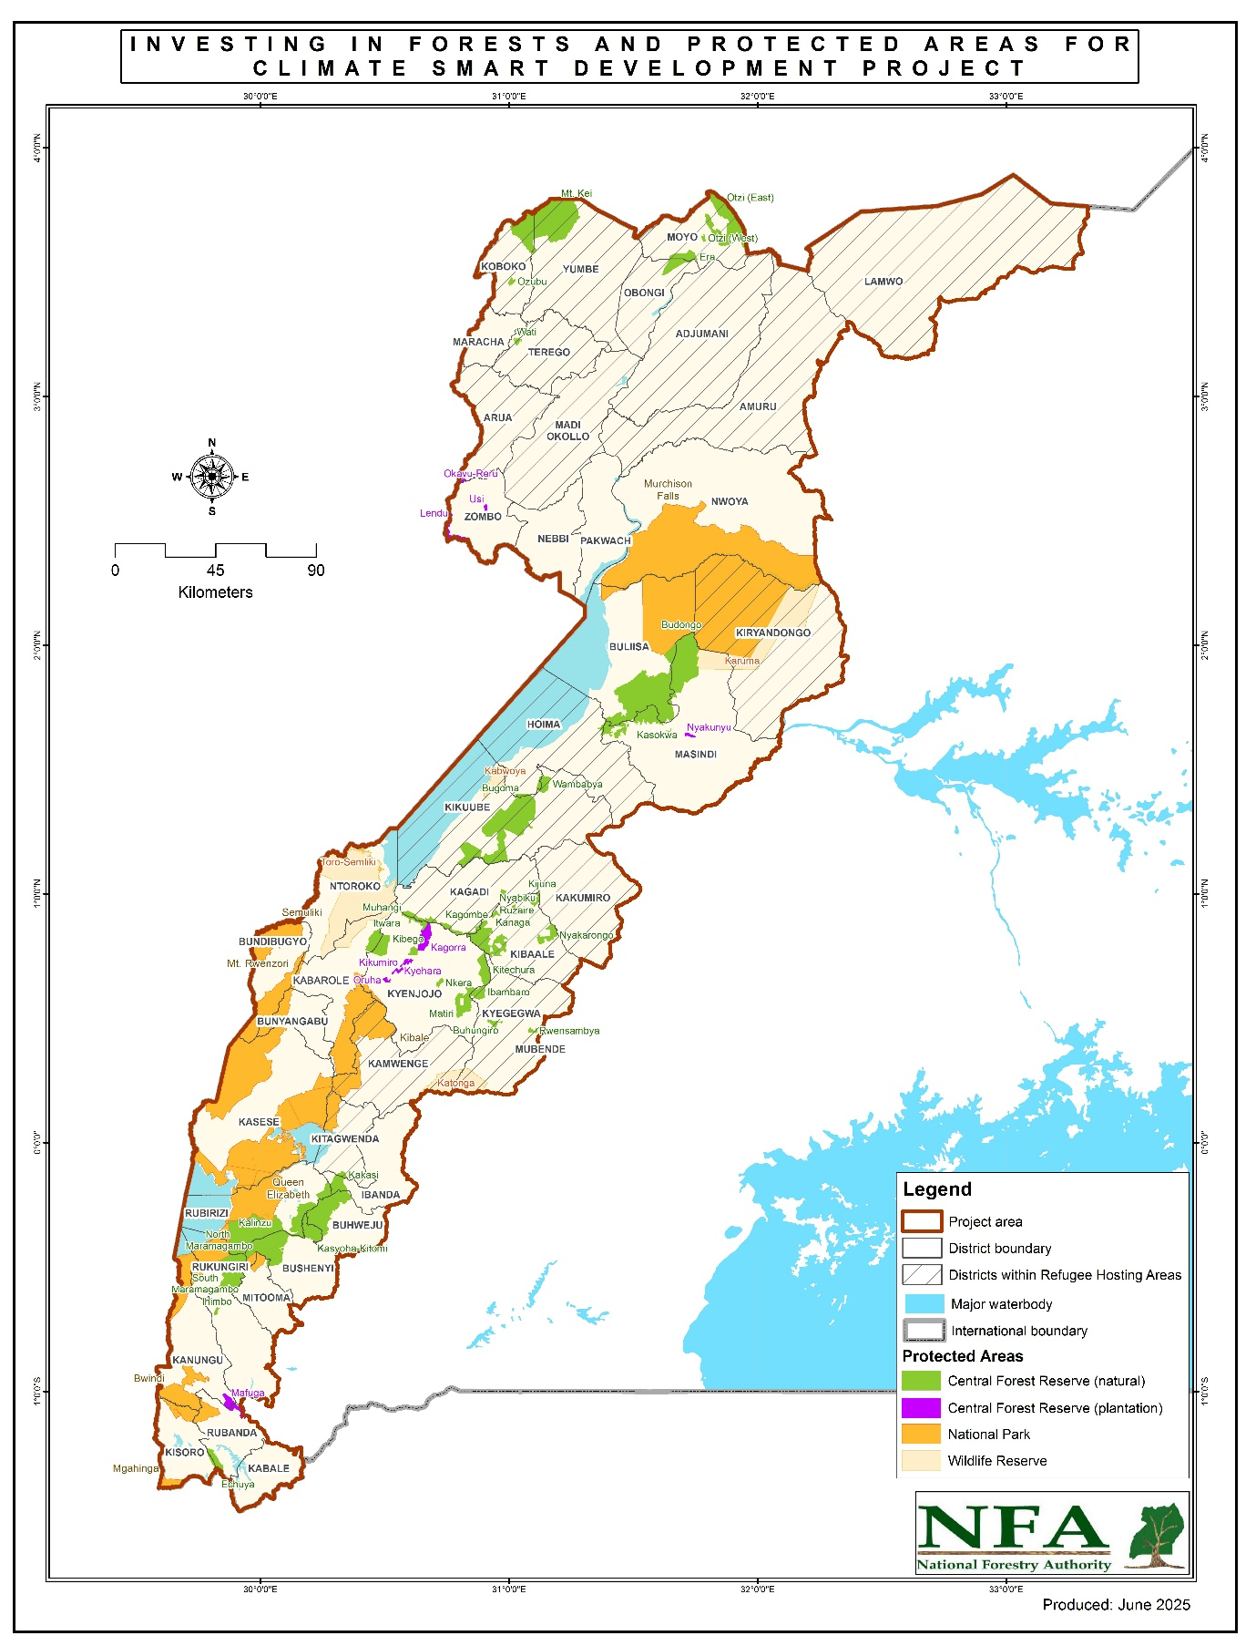

**Figure 1: Project Location Map**

**Table 5. Project Districts Adjacent to Wildlife Protected Areas Supported Under the Project**

|  |  |  |
| --- | --- | --- |
| **S/No** | **Protected Area** | **Adjacent Districts** |
|  | Toro-Semliki Wildlife Reserve | Ntoroko |
| Kabarole |
|  | QENP | Rubirizi |
| Mitooma |
| Rukungiri |
| Ibanda |
| Kanungu |
| Kasese |
| Kamwenge |
| Kitagwenda |
|  | Semuliki NP | Bundibugyo |
| Ntoroko |
|  | Kibale NP | Kyenjojo |
| Bunyangabu |
| Kamwenge |
| Kasese |
| Kabarole |
|  | Mgahinga Gorilla National Park | Kisoro |
|  | Katonga Wildlife Reserve | Kyegegwa |
| Kamwenge |
| Kazo |
|  | Murchison Falls National Park | Buliisa  Masindi  Pakwach  Nwoya  Oyam  Kiryadongo  Hoima  Kikuube  Obongi  Adjumani  Moyo |
|  | Rwenzori Mountains National Park | Bundibungyo  Kasese  Ntoroko  Bunyangabu |
|  | Kabwoya Wildlife Reserve | Hoima  Kibuube |
|  | Bwindi Impenetrable National Park | Kanungu  Rubanda |

**Table 6. Project Districts Adjacent to Central Forest Reserves Supported with Core Interventions under the Project**

|  |  |  |  |
| --- | --- | --- | --- |
| **S/No** | **Management Area** | **Central Forest Reserve** | **Surrounding Districts** |
| 1 | Budongo System | Budongo CFR | Buliisa |
| Hoima |
| Masindi |
| Hoima |
| Kikuube |
| Kagombe CFR | Kagadi |
| Kibaale |
| Kyenjojo |
| Kasokwa CFR | Masindi |
| Nyakarongo CFR | Kibaale |
| Rwensama CFR | Masindi |
| Wambabya CFR | Hoima |
| Kikuube |
| 2 | Mafuga Plantations | Echuya CFR | Kisoro |
| Rubanda |
| 3 | Muzizi River | Buhungiro CFR | Kyegegwa |
| Ibambaro CFR | Kyegegwa |
| Kyenjojo |
| Itwara CFR | Kabarole |
| Kyenjojo |
| Kibego CFR | Kyenjojo |
| Kitechura CFR | Kyenjojo |
| Kyegegwa |
| Matiri CFR | Kyenjojo |
| Muhangi CFR | Kyenjojo |
| Nkera CFR | Kirongo |
| Kyenjojo |
| Rwensambya CFR | Kyegegwa |
| 4 | Southwestern | Ihimbo CFR | Rukungiri |
| Kakasi CFR | Kitagwenda |
| Kalinzu CFR | Bushenyi |
| Rubirizi |
| Mitooma |
| Kasyoha-Kitomi CFR | Buhweju |
| Rubirizi |
| Bushenyi |
| Ibanda |
| Kitagwenda |
| North Maramagambo CFR (Dual Joint Management with UWA) | Bushenyi |
| Mitooma |
| Rubirizi |
| Mitooma |
| Rukungiri |
| Bushenyi |
| Mitooma |
| 5 | West Nile | Era CFR | Moyo |
| Mt. Kei CFR | Koboko |
| Yumbe |
| Otzi (East) CFR | Moyo |
| Wati CFR | Arua |

# 

# BRIEF SUMMARY OF PREVIOUS STAKEHOLDER ENGAGEMENT ACTIVITIES

Stakeholder engagement activities started as part of the REDD+ Readiness activities and the preparation of the Forest Investment Plan, which laid the foundation for the IFPA-CD project. The following consultations were carried out:

**Table 7. Consultations under REDD+ Process**

|  |  |  |  |
| --- | --- | --- | --- |
| **S/No** | **Dates** | **Stakeholders Met** | **Purpose of Consultations** |
| 1 | February 2017 | Implementing Partners and and local communities | To agree on FIP Priorities and Projects |
| 2 | 14th February 2017 | Forest dependent communities - the Basua and Bambuti Communities | To provide updates and seek their views for project design |
| 3 | 16th February 2017 | Forest dependent communities- the Batwa communities around Bwindi, Mgahinga National parks and Echuya Forest Reserve | To provide updates and seek their views for the design of REDD+ project |
| 4 | 14th -16th February 2017 | Project stakeholders from Masindi, Hoima, Kibaale, Buliisa, Kabarole, Kyenjojjo, Kamwenge, Kyegegwa, Kasese, Bundibugyo, Ntoroko, Mubende | To provide updates and seek their views for project design |
| 5 | 14th March 2017 | National representatives from the Albertine Region | To provide updates and seek their views on FGRM |
| 6 | 10th April 2017 | National representatives from the Albertine Region | To deliberate on the Smart Energy Solutions for Africa (Strategic Environmental and Social Assessment) |
| 7 | 17th – 18th May 2017 | 52 Participants from Government MDAs, CSOs MPs, LG Officials. | Second Consultative Workshop on the REDD+ Strategy for Uganda |
| 8 | 2013-2018 | Consultations/engagement at national, district and community levels, including engagements with the Forest dependent (VMGs) the Batwa community in the Albertine Rift. | REDD+ Stakeholder engagement processes that led to the preparation of Uganda’s REDD+ Strategy and Action Plan (2017) and Forest Investment Plan (2017). |
| 9 | 1st March 2018 | Water and Environment Sector working Group (WESWG) | The meeting of WESWG endorsed the original concept note and recommended its approval by Ministry of Finance, Planning and Economic Development (MoFPED) and onward submission to Green Climate Fund (GCF) and World Bank for funding consideration |
| 10 | March and May 2018 | Local Government officials. Field Staff of NFA, UWA, DWRM. CSO/NGOs, Media and Private Sector representatives | To discuss project implementation challenges of REDD+ project and devise solutions |
| 11 | 30th August 2018 | Joint meeting of the Water and Environment Working Group and Tourism Working Group | To harmonize the priorities for the IFPA-CD Project and recommended further IFPA-CD project development as a joint IFPA-CD project for MWE and Ministry of Tourism, Wildlife and Antiquities (MTWA). |
| 12 | 2 -17th February 2019 | project stakeholders from **Bushenyi,** Ibanda, Mbarara, Ntungamo, Lyantonde, Kiruhura, Isingiro, Buhweju, Rubirizi, Ruhinda, Sheema, Kabale, Kisoro, Kanungu, Rukungiri | To provide updates and seek their views for project design |
| 13 | 2nd March 2019 | Leaders of all Batwa communities | Consultations on REDD+ Strategy options held on at Nkuringo Cultural Centre, Kisoro |
| 14 | July 2019 | The REDD+ Secretariat, in Southwestern Uganda (In Rubanda and Kisori District), Bundibugyo, Kween and Moroto District. | Landscape consultation and participation platforms. Community consultative meetings for Implementing Partners to discuss strategies to enhance participation of Vulnerable and Marginalised Groups (VMG) |
| 15 | 2nd December 2019. | Members of Parliament of Uganda | Consultations meeting on REDD+ with Members of Parliament of Uganda |
| 16 | June 2019- January 2020 | Stakeholders at national levels, selected districts and communities | IFPA-CD project formulation Missions |

Building on the above engagements, IFPA-CD project was designed, and the following engagements were conducted to inform actual project identification and preparation. Consultations with the Vulnerable and Marginalised Groups (VMGs) (the Batwa) were carried out under the guidance of the Vulnerable and Marginalised Group Framework (VMGF) and subsequently four Vulnerable and Marginalised Group Plans (VMGPs) were developed.

**Table 8. Consultations for the Design of IFPA-CD Project**

|  |  |  |  |
| --- | --- | --- | --- |
| **S/No** | **Dates** | **Stakeholders Met** | **Purpose of Consultations** |
| 1 | 30th August 2018 | Water and Environment Sector Working Group and Tourism Sector Working Group. | Joint Sector Working Group meeting held |
| 2 |  | Joint Water and Environment Sector Technical Team meeting | Successive Joint Water and Environment Sector Technical Reviews and Joint Water and Environment Sector Review meetings during 2018 and 2019. |
| 3 | 2 March 2019 | Communities of Nyabaremure and Batwa | To agree on plans to enhance participation of Marginalised groups |
| 4 | June 2019 | Engagements in the project landscape during Project Formulation Mission | To get inputs and views of stakeholders for in cooperation in the project design |
| 5 | 12-17 June 2019 | Local Government Officials, UWA, NFA, WMZO Officials and Refugee Camps Commandants | To provide updates and seek their views for project design |
| 6 | September 2019 | Stakeholder engagements during Project Formulation Mission | To get inputs and views of stakeholders for in cooperation in the project design |
| 7 | January 2020 | Stakeholder engagements during Project Formulation Mission | To get inputs and views of stakeholders for in cooperation in the project design |
| 8 | March 2020 | Consultations with UNHCR and Office of the Prime Minister | To get views from refugees' agencies for the design of IFPA-CD activities in the refugee hosting districts |
| 9 | March 2020 | Members of Parliament | Members of Parliament Visit to Project area in early |
| 10 | March 2020 | Members of Parliament | Stakeholder engagement during Project negotiations |
| 11 | June 2021 | The Bwindi Batwa Development Association (BBDA) and community members | To seek their views in the design of the VGMP for Bwindi |
| 12 | June 2022 | The Batwa community living in the Southern sector of Bwindi Impenetrable Forest National Park[3] | To learn about their concerns and preferences regarding the design and proposed implementation of the IFPA-CD project to give them equitable access to project benefits and minimize any unfavourable outcomes for the Batwa. |
| 13 | June 2022 | The Batwa community living adjacent to the Northern Sector of Bwindi Impenetrable National Park | To learn about their concerns and preferences regarding the design and proposed implementation of the IFPA-CD project to give them equitable access to project benefits and minimize any unfavourable outcomes for the Batwa. |
| 14 | June 2022 | Project stakeholders (NGOs, UWA, District Local Government and community groups) working with the Batwa community in the Southern and Northern sector of Bwindi Impenetrable Forest National Park[4] | To seek their views regarding key issues to be considered in project design to address the concerns of the Batwa community |
| 15 | September 2022 | Special consultation with the Batwa around Echuya CFM was carried out | To learn about their concerns and preferences regarding the design and proposed implementation of the IFPA-CD project to give them equitable access to project benefits and minimize any unfavourable outcomes for the Batwa community in Echuya CFR |
| 16 | September 2022 | Project stakeholders (NGOs, UWA, District Local Government and community groups) working with the Batwa community in the Echuya CFR | To seek their views regarding key issues to be considered in project design to address the concerns of the Batwa community within Echuya CFR |
| 17 | September 2022 | Special consultation with the Batwa around Mgahinga Gorrila National Park (MGNP) was carried out | To learn about their concerns and preferences regarding the design and proposed implementation of the IFPA-CD project to give them equitable access to project benefits and minimize any unfavourable outcomes for the Batwa community in Mgahinga Gorrila National Park (MGNP) |
| 18 | September 2022 | Project stakeholders (NGOs, UWA, District Local Government and community groups) working with the Batwa community in the Mgahinga Gorrila National Park (MGNP) | To seek their views regarding key issues to be considered in project design to address the concerns of the Batwa community within Mgahinga Gorrila National Park (MGNP) |
| 19 | October 2022 | Special consultation with the Batwa around SNP was carried out | To learn about their concerns and preferences regarding the design and proposed implementation of the IFPA-CD project to give them equitable access to project benefits and minimize any unfavourable outcomes for the Batwa community in Semuliki National Park |
| 20 | October 2022 | Project stakeholders (NGOs, UWA, District Local Government and community groups) working with the Batwa community in the Semuliki National Park | To seek their views in regard to key issues to be considered in project design to address the concerns of the Batwa community within Semuliki National Park |

During the above engagements, the focus was on the following aspects:

|  |  |  |
| --- | --- | --- |
| **Information Category** | **Mode of disclosure** | **Reference** |
| Project rationale, intervention logic, project investment and budgets, project area/sites, implementation arrangements, fiducial arrangement, procurement plan and procedures, monitoring and evaluation mechanisms, safeguards | * Meetings and Focused Group discussions * Publication and dissemination of project brochure and briefs * Electronic PDF documents on MWE websites * Field consultations with stakeholders and Vulnerable and Marginalized groups (Batwa) * Print and audio media | * Project Appraisal Document * Project Procurement Strategy for Development * Project Implementation Manual |
| Environmental and Social Risks Safeguards | * Meetings and Focused Group Discussions * Electronic PDF documents on MWE websites * Consultations with Vulnerable and Margined Group | * Environmental and Social Management Framework (ESMF) * Environmental and Social Commitment Plan (ESCP) * Gender Action Plan (GAP) * Labour Management Plan (LMP) * Grievances Redress Mechanism (GRM) * Vulnerable and Marginalized Groups Framework (VMGF), Vulnerable and Marginalized Group Plans (VMGPs). |
| Stakeholder Engagement Framework | * Meetings and Focused Group Discussions * Electronic PDF documents on MWE websites | * SEP |

1. **STAKEHOLDER IDENTIFICATION AND ANALYSIS**

## 5.1 Stakeholder analysis criteria

Stakeholder engagement process for the IFPA-CD starts with identification, mapping and analysis of project stakeholders and this plan serves to clarify the stakeholder identification procedure at national and project area level during project implementation. This guides MWE and Implementing Agencies, Local Governments and TSPs to comply with national and World Bank requirements for effective stakeholder engagements.

The following criteria are used to identify stakeholders under IFPA-CD project:

* **Liability:** being community or social group, especially, those with acknowledged interaction with the targeted PAs to whom project implementation or whose livelihoods and socio-economic aspirations are likely to be negatively affected by project investments directly or indirectly (e.g., Vulnerable and Marginalized Groups (Batwa) and communities adjacent to targeted protected areas).
* **Influence**: being institutions or community or other social and economic groups that may be able to substantially influence project implementation and operations. This covers institutions with mandates over project supported components (forestry, wildlife, environment, wetlands, water, agriculture, land, biomass energy, tourism, climate, refugees, training in wood value chains, etc.), District Local Governments and institutions who take decisions on project financing (MoFPED, National Planning Authority (NPA), Parliament).
* **Partnership:** being opportunities for building partnership relations between the project implementers (MWE NFA, UWA, and Local Governments) and a given institution, community group or individual households in the framework of the project implementation operations. This covers institutions with interest to complement project activities for impact creation or to advance their investments and benefits through partnerships or collaboration with project (e.g., private sector players in nature based tourism, forestry/wood value chains, commercial forestry; NGOs/CSOs active in environment/natural resources/wildlife conservation and management, land use/land management, agriculture, commercial private tree farming and conservation financing institutions), among others.
* **Dependency:** being social or community groups, businesses or individuals whose economic or livelihoods interests will be dependent on the project operations (e.g. project contractors/employees and their dependents, Local suppliers).
* **Representation and inclusion:** being individuals or institutions with legitimate right to represent Vulnerable and Marginalized Groups (VMGs) (the Batwa) or other vulnerable groups (e.g., Women, Youth/Elderly/Disabled, etc.).
* **Expressed interest**: being institutions or social group or individuals not necessarily directly affected by the planned or current activities but have expressed interest to the project (e.g., Media, Civic institutions, etc.).

## 5.2 Mapping Stakeholders

Broadly, IFPA-CD Project stakeholders are ‘people or institutions who have a role in the Project or could be positively or negatively affected by the Project, or who are interested in the Project’. Engagements with all identified stakeholders ensure the greatest possible contribution from the stakeholder parties toward the successful implementation of the project and enables the project to draw on their local knowledge and experience, pre-existing expertise, mandates, ongoing programmes and initiatives, political and social leverage, networks and agendas. IFPA-CD Project stakeholders are grouped into:

**Primary stakeholders** are individuals, groups or local communities that may be affected by the Project, positively or negatively, and directly or indirectly, including those who are directly affected or are disadvantaged or vulnerable. These include the CFM /CRM /ecotourism groups, Batwa community, Refugees, communities, bordering the targeted PAs and landowners in the project area. Amongst these stakeholders may include the vulnerable or marginalized individuals and groups, which may be based on age, gender, status, education level, sex, culture, literacy, sickness, physical or mental disability, etc, who in further assessment may be identified, consultations conducted, risks assessed, and mitigation measure proposed. The identified likely impacts and commitment to address these impacts have been incorporated in the Environmental and Social Commitment Plan (ESCP).

**Table 10. Consultations with Primary Stakeholders**

|  |  |  |  |  |  |
| --- | --- | --- | --- | --- | --- |
| **Institution** | **Interest/Targeted inputs** | **Target** | **Location** | **Venue** | **Timing** |
| Communities around PAs where Electric Fencing are being installed + vulnerable groups in communities around the targeted protected areas affected by Problem Animals | Access to resources within PA | Local  Communities  around QENP  and MFNP | QENP - UWA, District | Kyambura | ongoing |
| Safety of people and livestock | MFNP - UWA District | Purongo | ongoing |
| Special interest Groups (Forest resource use Groups) | Access to resources within PA | Collaborative Forest Management/Collaborative Resources Management Groups | CFM - Echuya (NFA, NU) | Echuya NFA Grounds | ongoing |
| CRM - Kasyoha Kitomi (NFA, NU) | NFA Offices | ongoing |
| CRM - Budongo (NFA) | NFA Offices | ongoing |
| CRM Kibale | Mainaro | ongoing |
| Ecotourism | Community Ecotourism Groups (Forest) | BINP | Buhoma | ongoing |
| Community Ecotourism Groups (Forests) | SNP | Ntandi | ongoing |
| Community Ecotourism Groups (Savannah) | MFNP /QENP | Ranger Posts | ongoing |

**Secondary stakeholders** may be able to influence the outcome of the Project because of their knowledge about the affected communities or political influence over them or influence project decisions and operations. These include government institutions with mandate over environment management, social development, tourism, labour, agriculture, etc, non-government agencies and organizations, Conservation Trust Funds, UN Humanitarian agencies, Private sector in wood value chains and tourism (beyond direct project beneficiaries), project contractors and employees, NGOs/CSOs active in the project area, Public and Civic institutions (schools, churches, Universities, etc.), and Cultural institutions among others.

1. For each location and activity, the specific interested parties are identified and engaged as appropriate.
2. Civil society groups and NGOs at national and local levels that pursue environmental and socio-economic interests and may become partners of the project are likely to be located outside the project’s direct area of influence.
3. Business owners and providers of services, goods and materials within the project area are involved in the project’s wider supply chain or may be considered for the role of project’s suppliers in the future.
4. Government entities – government officials, permitting and regulatory agencies at the national and local levels, including environmental, technical, social protection and labour authorities.
5. Mass media and associated interest groups, including local and national printed and broadcasting media, digital/web-based entities, and their associations.
6. Project employees.

**Note:**

* The project verifies stakeholder representatives to confirm that they are legitimate and genuine.
* For each IFPA-CD Project site and activity, stakeholders are further analysed using the criteria to specify those stakeholders falling under each category and devising appropriate mechanism for their engagement. However, for the Vulnerable and Marginalized Group (Batwa), additional measures have been described in the VMGF and VMGPs.

Vulnerable Individuals and Groups. By the virtue of the location of the project, there is potential of affecting the VMGs (the Batwa as mentioned above). However, in addition to the VMGs, there is potential exclusion from and discrimination against other categories of vulnerable or marginalized individuals and groups from project benefits and opportunities. The vulnerable status may stem from an individual’s or group’s national, ethnic or social origin, colour, gender, language, religion, political or other opinion, property, age, culture, literacy, sickness, physical or mental disability, poverty or economic disadvantage, dependence on unique natural resources, etc. Under the IFPA-CD project, vulnerable groups include the rural women, child-headed households, youths, and orphans, persons with disabilities, the elderly, and hard to reach community members, the sick. Further identification of potential vulnerable or marginalized individuals or groups may be done during project implementation.

Project design and all interventions are tailored to meet their interests and efforts are being made to ensure that they participate in all project related activities, without exclusion and discrimination. Their concerns and priorities inform project design. Their contributions as stakeholders enables the project to draw on their local knowledge and experience, pre-existing expertise, mandates, ongoing programmes and initiatives, political and social leverage, networks and agendas for successful project implementation.

## 5.3. Engagement with Vulnerable and Marginalised Groups

In Uganda (and in the context of the IPFA-CD Project) the Vulnerable and Marginalised Group (VMG) is the term applied to groups meeting the requirement of ESS7, which is the Batwa ethnic group present in the project area, because they represent a specific sub-category within the broader vulnerable group category. They are a distinct social and cultural group, have identities and aspirations that are distinct from mainstream vulnerable groups within the project location, often disadvantaged and are the most economically marginalized and vulnerable segments of the vulnerable population adjacent to the target protected areas of Echuya CFR, Mgahinga, Bwindi Impenetrable and Semuliki National Parks. For this reason, several NGOs and other non-state institutions have focused on uplifting the quality of life/livelihoods of the Batwa, and IFPA-CD Project intends to build on the above efforts to engage the Batwa community in the design, planning and implementation of the project to enhance project benefits to them. The project recognizes that previous or ongoing Batwa engagements in these programmes have faced challenges of:

1. Social discrimination of Batwa by hosting communities;
2. Language barriers and low levels of literacy that hinders their participation in development and planning processes.
3. Cultural attachment to the forests and deep-rooted cultural values and practices that undermine their adoption of new technologies and livelihood options; and
4. None or low representation in political or natural resources governance processes.

Despite the above, the project design/formulation process engaged Batwa in the design of the Environment and Social Management Framework (ESMF), development of the Process Framework (PF) and the development of the Vulnerable and Marginalised Group Framework (VMGF) and subsequent Plans (VGMPs). Prior to the IFPA-CD design, Batwa were engaged through an elaborate consultations process on REDD+ Strategy priorities, Strategic Environmental and Social Assessment (SESA) for REDD+, Feedback and Grievances Redress Mechanism (FGRM) and Benefit Sharing Arrangements for REDD+. During 2018/2019, the Batwa were targeted for capacity building preparing them for their engagement under REDD+, and presently, the IFPA-CD project. An assessment of the needs of the Batwa to effectively participate in project reveals additional challenges in form of communication and access to information.

A summary of the VMGF was prepared as part of project preparation and translated in four local languages used by the Batwa: Kufumbira, Kiswahili, Lwamba, and Runyankole.

**Table 11. Batwa Communication and Information Access Needs**

|  |  |  |  |  |
| --- | --- | --- | --- | --- |
| Group Location | Key characteristics | Language needs | Preferred notification means | Specific needs (accessibility, large print, time to engage, etc.) |
| Echuya CFR | * Small family groups living is clustered settlements * Migratory families to other /from other communities around Echuya, Bwindi and Mgahinga | Translation into Kifumbira/  Kinyarwanda  /Rukiga | Oral  Posters  Translator (trusted /familiar people) | Meeting = morning hours  Dedicated Batwa forum/meeting (with no participation of non-Batwa)  Focused Group Discussion  Meals/refreshments |
| Mgahinga NP | * Small families living in clustered community settlements * Households settled on land donated by NGOs * Migratory families to other /from other communities around Echuya, Bwindi and Mgahinga | Kifumbira/  Kinyarwanda |
| Bwindi NP | * Small families living in clustered community settlements * Households settled on land donated by NGOs * Migratory families to other /from other communities around Echuya, Bwindi and Mgahinga | Kifumbira/  Kinyarwanda/  Rukiga/Swahili |
| Semliki NP | * Small families living in clustered community settlements * Have “cultural head”- King of Batwa * Migratory families to other /from other communities around Semliki NP and Democratic Republic of Congo | Rwamba/Swahili |

The Project ensures meaningful consultations with the Batwa following a consultation plan designed for the Batwa.

**Table 12. Consultations Plan for the Batwa**

|  |  |  |  |  |  |
| --- | --- | --- | --- | --- | --- |
| **Institution** | **Interest/Targeted groups** | **Target** | **Modality** | **Venue** | **Date** |
| **Vulnerable and Marginalized Groups (Batwa)** | Access and use of forest resources within Semliki, Mgahinga and Bwindi NP; Echuya CFR | Batwa  Communities | * Meeting with CFM Groups - Echuya (NFA and NatureUganda) | Echuya NFA Grounds | ongoing |
| * Meeting with CFM Groups + Batwa Trail - Mgahinga (MGNP, BMCT and OUBDU | Mgahinga | ongoing |
| * Meeting CFM/CRM BINP - Mpungu or Buhoma or Rushaga (BINP + BMCT) | Mpungu/Buhoma | ongoing |
| * Meeting Batwa SNP -Ntandi/Sempaya -(SNP, Flora and Fauna International (FFI) | Ntandi | ongoing |

**Development of the Vulnerable and Marginalized Groups Plans (VMGP)**

A Vulnerable and Marginalized Groups Plan (VMGP) for each location where the Batwa are present and have cultural attachment was prepared and disclosed under the parent project. These took into consideration the unique issues in regard to the Batwa community who are present and have collective attachment in some of the proposed project areas, highlighted specific constraints faced by the Batwa community and defined priorities for IFPA-CD project support to Batwa, budget and modalities for implementation of these activities. The four VMGPs is now being updated and to be finalized 60 days after project effectiveness.

Additionally, the arrangements for engaging the Batwa in implementing the project GRM, CRM and CFM as indicated in the ESCP, are being followed. During implementation of the SEP, reference is made to the GRM framework for further guidance. Table 13 presents additional measures for engaging the Batwa group in project decision-making processes during project implementation phase.

**Table 13. Arrangement for Engaging Batwa in Decision-Making Processes**

|  |  |  |  |
| --- | --- | --- | --- |
| **Affected People** | **Decision making process** | **Arrangements/modality** | **Responsibility** |
|  | Project reviews | Informants during supervisory missions, midterm review, end of project evaluation | UWA, NFA, PCU |
| CFM | Representation of community including the Batwa group interests | PCU, UWA, NFA |
| CRM | Representation of community including the Batwa group interests | PCU, UWA, NFA |
| GRC | Resolving grievances and ensuring good working environment for both the community, the Batwa and project implementers | PCU, UWA, NFA |
| Activity Planning | Annual activity planning basing on the VMGP | PCU, UWA, NFA |
| Information management | Translation of project information into vernaculars/local dialects | PCU, TSU, UWA, NFA |
| Disseminating project information to Batwa | PCU, TSU, UWA, NFA |

# STRATEGY FOR STAKEHOLDER ENGAGEMENT

This section presents information on planned stakeholder engagement actions, methods and processes during the implementation of IFPA-CD project July 2021 – June 2028. Information provided highlights the principles and considerations during consultations and engagement with targeted stakeholders, processes/ approaches and modalities for the engagement.

## 6.1 Strategy for Consultations

Various methods of engagement are being used as part of the project’s interaction with the stakeholders, to ensure that different stakeholder groups are successfully reached and are involved in the process of consultations, decision-making and the development of impact management solutions.

The IFPA-CD AF Project applies international standards for stakeholder consultations which emphasize the importance of a consultation being ‘free, prior and informed’, which requires accessible and unconstrained process that is accompanied by the timely provision of relevant and understandable information. To fulfil this requirement, the project applies a range of consultation methods that specifically focus on fulfilling the requirements of this approach. In this regard **Project information** is communicated in advance of public consultations. This includes an announcement for the consultation meeting through a medium that reaches the targeted stakeholders (e.g., radio announcement), distribution of invitations and full details of the forthcoming consultations meeting well in advance, including the agenda. The Project ensures that this information is widely available, readily accessible, clearly outlined, and reaches all areas and segments of the target community/stakeholders. Specifically, the project endeavour to:

1. **Make advance public notification of an upcoming consultation meeting** via publicly accessible locations and channels. The project keeps proof of the announcement/publication (e.g. a copy of the newspaper/radio announcement or notice for meeting) for accountability and reporting purposes. Existing notice boards and such other public avenues in the communities or offices of local CSOs/NGOs, offices or widely visited public premises (e.g., government offices, churches, schools, health facilities, etc.) are used for distributing the announcements as appropriate.
2. **Maintain list of invitees** to the meeting and their contacts. Wherever possible, attendees’ signatures or other formats for confirming attendance are obtained as a proof of their participation.
3. **Select most accessible or appropriate methods of communication** that reach the potential audience with lower levels of literacy or those who are not well-versed in the technical aspects of the project. In this regards, Oral communication in vernacular is preferred as an option that enables the information to be readily conveyed to such persons during consultation meetings or via radio and mobile phone messages.
4. **Keep record of all participants** for purposes of accountability and guiding targeted follow up actions with respective stakeholders.
5. **Keep record of meetings deliberations** for the purposes of transparency and the accuracy of capturing public comments. Meeting records are made via a combination of taking written minutes of the meeting, audio recording (e.g. by means of voice recorders) and photographing.
6. **Conduct separate meetings** and **Focus Group Discussions** for the vulnerable or marginalized individuals and groups to enable them to express themselves without barriers often associated with inferiority, cultural or other factors.
7. **Manage meeting size** by making necessary arrangements to ensure audibility and visibility of the presentation and any demonstrations involved. This may include provisions for use of microphones, proper illuminations, projectors, etc. Meeting size are taken into account SOPs and other requirements for preventing transmission of COVID-19 or other diseases.
8. **Evaluate the meetings** in order to capture levels of participant’s satisfaction or reservations about the meeting, issues discussed, feedback provided, conclusions or recommendation made, etc.
9. **Provide consultations or meeting Agenda** in a clear and itemized outline of the meeting’s structure, sequence, chairperson, a range of issues that are discussed and a format of the discussion (e.g. presentation/ demonstration followed by a Questions & Answers – Q&A session, facilitated work in small groups, feature story and experience sharing, thematic sessions with a free speaking format enabling the exchange of ideas). This is intended to give prospective participants an opportunity to prepare their questions and comments in advance.
10. **Allocate sufficient amount of time for a concluding Q&A session** at the end of any public meeting or a hearing thereby providing the audience opportunity to convey their comments and suggestions that can subsequently be incorporated into the implementation or decisions of the project.
11. **Keeping a record of all public comments received and responses provided** during the consultations meetings in order to enhance project accountability for stakeholder’s views and inputs. The recorded comments and how they have been addressed by the project are included in the project regular reporting to the stakeholders.
12. **Disclose project information** in the public domain accompanied by a register for comments and suggestions that can be used by any member of the affected community and general public/stakeholder to provide their written feedback on the contents of the presented information during the entire duration of the requisite disclosure period. Where necessary, a project representative or an appointed agents are made available to receive and record any verbal feedback in case some stakeholders experience a difficulty with providing comments in the written form.

The following engagement methods and techniques are applied by project to ensure “free, prior and informed” consultations with Stakeholders.

## Strategies for Meaningful Stakeholder Engagement

Table 14 summarizes methods and approaches identified for project use to ensure meaningful stakeholder engagements are free and informed by prior information. In all the approaches, the project will be informed by the EISM guidelines in ensuring inclusion and non-discrimination of any potential vulnerable or marginalized individuals and groups, which may be adversely affected by the project.

**Table 14. Methods and Approaches for Ensuring Free and Prior Informed Engagements**

|  |  |  |  |  |
| --- | --- | --- | --- | --- |
| **Method / Tool** | **Description and Use** | **Contents** | **Dissemination method** | **Target group** |
| **Information provision** | | | | |
| **Distribution of printed public materials: leaflets, brochures, fact sheets, posters, etc.** | Used to convey information on the Project and regular updates on its progress to local and national stakeholders. | Printed materials present illustrative and written information on Project activities, progress as well as impact mitigation measures.  Aim at concise contents and adapted to a layperson reader.  Use Graphics and pictorials to describe technical aspects.  Use language understood by targeted audience | Distribute materials as part of consultation meetings, public hearings, discussions and meetings with stakeholders, as well as household visits in remote areas.  Place materials at the offices of local administrations and NGOs and other venues commonly accesses by public. | Households/communities, local authorities in the Project Area. |
| **Distribution of printed public materials: newsletters/ updates** | A quarterly newsletter or an update circular sent out to Project stakeholders on a regular basis to maintain awareness of the status of the Project | Important highlights of Project achievements, announcements of planned activities, changes, challenges, and overall progress. | Quarterly circulation of the newsletter or update sheet in the Project Area and other stakeholders that expressed their interest in receiving these periodicals.  Means of distribution – emailing and physical delivery | Households /communities in the Project Area  Public offices at local and national levels, Protected Areas, public institutions such as schools, Tourism offices, etc. |
| **Print Media** | Newspaper inserts, announcements, press releases, short articles or feature stories in the printed media | Notification of forthcoming public events or commencement of specific Project activities.  General description of the Project and its benefits to the community/stakeholders  Commemoration of national/international events e.g., World Wildlife/ Forests/Water/ Environment/biodiversity days, Refugees, etc. | Placement of paid information in local and national printed media, including those intended for general reader and specialised audience | Residents in project area, national level audiences |
| **Radio or television entries** | Short radio programmes, video materials or documentary broadcast on TV. | Description of the Project, Project development updates, solutions for impact mitigation.  Advance announcement of the forthcoming public events or commencement of specific Project activities. | Collaboration with media producers that operate in the project area and can reach local audiences.  Collaboration with media producers that operate at national level | Residents in project area  National levels stakeholders /audiences |
| **Visual presentations** | Visually convey Project information to affected communities and other interested audiences. | Description of the Project and related solutions/impact management measures. Updates on Project implementation. | Presentations are widely used as part of the public hearings and other consultation events with various stakeholders. | Affected communities in in the project area, participants of the public hearings, consultations, rounds tables, focus group discussions and other forums attended by Project stakeholders. Authorities and other governmental bodies. |
| **Notice boards** | Displays of printed information on notice boards in public places. | Advance announcements of the forthcoming public events, commencement of specific Project activities, or changes to the scheduled process. | Place printed announcements and notifications in visible and easily accessible places frequented by the local public | Directly affected communities in the project area |
| **Information Feedback** | | | | |
| **Information repositories accompanied by a feedback mechanism** | Placement of Project-related information and printed materials in dedicated/designated locations that also provide visitors and readers with an opportunity to leave their comments in a feedback register. | Various Project-related materials, ESMF documentation, environmental and social action plans. | Deposition of materials in publicly available places (offices of local NGOs, local administrations, libraries) for the duration of a disclosure period or permanently. Stakeholders are also given free access to a register of comments and suggestions. | Directly affected communities in the project area |
| **Dedicated telephone line (hotline)** | Setting up a designated and manned telephone line that can be used by the public to obtain information, make enquiries, or provide feedback on the Project. Initially, telephone numbers of Project’s Safeguards and Communications staff are being shared with the public | Any issues that are of interest or concern to the local communities and other stakeholders. | Telephone numbers are specified on the printed materials distributed to Project stakeholders and are mentioned during public meetings. Project’s designated staff shall be assigned to answer and respond to the calls, and to direct callers to specialist experts or to offer a call-back if a question requires detailed consideration | Local communities within the Project Area.  Any other stakeholders and interested parties in general. |
| **Internet/Digital Media** | Project website to promote various information and updates on the overall Project, including, impact assessment and impact management process, procurements, employment opportunities, as well as on Project’s engagement activities with the public. Website has a built-in feature that allows viewers to leave comments or ask questions about the Project. | Information about Project implementers, TSPs and collaborating partners  Project implementation updates, health and safety, community relations, community updates, employment and procurement, environmental and social aspects. | A link to the Project website should be specified on the printed materials distributed to stakeholders.  Other on-line based platforms such as web-conferencing, webinar presentations, web-based meetings, Internet surveys, etc. are being used. | Affected and beneficiary communities, Project stakeholders and other interested parties that have access to the internet resources. |
| **Surveys, Interviews and Questionnaires** | Use of public opinion surveys, interviews and questionnaires to obtain stakeholder views and to complement the statutory process of public hearings. | Description of the proposed Project activity and related solutions/impact management measures. Questions targeting stakeholder perception of the Project activity, associated impacts and benefits, concerns and suggestions. | Soliciting participation in surveys/interviews with specific stakeholder groups. Administering questionnaires as part of the household visits. | Directly affected households/community in the Project Area. |
| **Feedback & Suggestion Box** | Suggestion boxes will be used to encourage residents in the affected communities to leave written feedback and comments about the project activity. Contents of the suggestion box shall be checked by designated project staff on a regular basis to ensure timely collection of input and response/action, as necessary.  Use of Feedback & Suggestion Box will be applied to construction works. (This will be given priority in the subsequent implementation period) | Any questions, queries or concerns, especially for stakeholders that may have a difficulty expressing their views and issues during public meetings. | Appropriate location for a suggestion box shall be selected in a safe public place at the construction sites to make it readily accessible for the community.  Information about the availability of the suggestion box should be communicated as part of Project’s regular interaction with local stakeholders. | Directly affected households and communities in the Project Area. |
| **Consultation & Participation** | | | | |
| **Public hearings** | Project representatives, the affected public, authorities, regulatory bodies and other stakeholders for detailed discussion on a specific activity or facility that is planned by the Project, and which is subject to the statutory expert review. | Detailed information on the activity and/or facility in question, including a presentation and an interactive Questions & Answers session with the audience. | Wide and prior announcement of the public hearing and the relevant details, including notifications in local and national mass media.  Send out targeted invitations to stakeholders.  Public disclosure of activity information and associated impact assessment documentation in directly affected communities in the Project Area.  Give viewers/readers of the activity information are free access to a register of comments and suggestions that is made available during the disclosure period. | Directly affected communities in the Project Area. |
| **Household visits** | Household-level visits are being conducted to supplement the statutory process of public hearings, particularly to solicit feedback from community members and vulnerable persons who may be unable to attend the formal hearing events. | Description of the Project and activity related solutions/impact management measures. Any questions, queries or concerns, especially for stakeholders that may have a difficulty expressing their views and issues during formal community-wide meetings. | Visits shall be conducted by Project’s designated staff with a specified periodicity. | Directly affected in the Project Area. |
| **Focus Group Discussions and Workshops** | Are being used to facilitate discussion on Project’s specific issues that merit collective examination with various groups of stakeholders. | Project’s specific activities and plans, design solutions and impact mitigation/management measures that require detailed discussion with affected stakeholders. | Announcements of the forthcoming meetings are widely circulated to participants in advance. Targeted invitations are sent out to stakeholders. | Directly affected households/community in the Project Area including, youth, elderly, women, and other vulnerable groups. |
| **Information centres and field offices (TSPs)** | TSPs field offices, once TSPs have been contracted, will be meant to serve as depository of Project-related information with TSP staff available to respond to queries or provide clarifications. | Project-related materials and information. Any issues that are of interest or concern to the local communities and other stakeholders. | Information about the field office with open hours for the public, together with contact details, will be provided on the Project’s printed materials distributed to stakeholders, as well as during public meetings and household visits. | Directly affected communities in the Project Area and any other stakeholders and interested parties. |
| **Project Site Visits** | Visits to Project activity sites are organised for local communities.  Targeted invitations are distributed to selected audience offering local communities, elected officials, local authorities and the media to demonstrate Project activities and solution. Visitors are accompanied by the Project’s staff and specialists to cover various aspects and to address questions arising from the public during the tour. | Demonstration of specific examples of Project’s solutions and approaches to managing impacts. | Targeted invitations distributed to selected audience offering an opportunity to participate in a visit to the Project Site.  Possible safety restrictions on the site access during active construction works is foreseen. | Local communities elected officials, media groups. NGOs, etc. |

## 6.3 IFPA-CD Stakeholder Engagement Interventions to-date

Based on the above consultation strategy, the following main interventions have been conducted since the launch of IFPA-CD in March 2022.

**Table 15. Key Stakeholder Engagement Interventions**

|  |  |  |  |  |  |
| --- | --- | --- | --- | --- | --- |
| Dates | Consultations /Trainings | Stakeholders Met | Purpose | Issues Raised | Responses |
| 2023, 2024 and 2025 | Formation and capacity building of GRC members at range 5, conservation 11, sub county 189 and 5 districts | Officials from the districts surrounding the protected areas, range and conservation area staff | Establish and train Protected Area (PA) GRCs on their roles and responsibilities and orienting the GRCs in the functionality of the GRM. | Revenue sharing | UWA has a mechanism to share revenues with districts and sub counties |
| GRC guidelines from MLGSD | Need to customize the structure and have one committee |
| How to make the GRCs known to the local communities? | Trainings,  Preparation of the IECs materials and Radio talk shows |
| Need to show how conflicts will be mitigated. | During screening and implementation of safeguard measures |
| At what stage should the grievances go either to the RDC or judiciary? | If the GRC formed has failed |
| Facilitation of GRCs | It’s a voluntary assignment |
| May 2025 | Engagements with UNHCR | UNHCR Staff in charge FRRM, OPM | To streamline IFPA-CD grievance redress mechanisms (GRMs) with the Inter-Agency Feedback, Referral, and Resolution Mechanism (FRRM) system | Need for an MoU between MWE and UNHCR | OPM to share with UNHCR the MoU between MWE and OPM for UNHCR to understand how to relate  MWE to share Frequently Asked Questions (FAQs) with UNHCR |
| 2024 | Stakeholder consultations in the refugee hosting districts (19 consultations made) | District and Sub county officials | To get their views in the proposed plan to implement fuelwood, agroforestry and woodlots | Which kind of tree seedlings will be planted? | Species will be preferred in-line with the agroforestry model agreed. For woodlots the commercially viable species will be preferred |
| What are the specific district activities? | Agroforestry, woodlot establishment, commercial plantations, procurement and distribution of fuel wood specifically eucalyptus to persons with specific needs in refugee settlements |
| Why consult towards the end of the project | The project implementation has been going on by NFA and UWA. It is only the refugee component which delayed to start due to challenges in the procurement of the service providers. |
| Eucalyptus doesn’t do well in some parts of North and West Nile districts hence people won’t be able to benefit from Agroforestry, Woodlots and plantation subsidy. | The Technical Service Provider will carry out a Needs Assessment/ site species matching prior to provision of tree seedlings for planting and growing. |
| Most service providers from Kampala don’t work well with district leaders and they spend just two to three days in the field. | MWE will coordinate their work with the districts |
| How are these service providers selected? | The advertised through the national media and others on international media. Local providers may be sub contracted |
|  | Inclusion and Nondiscrimination training completed (472 stakeholders from 33 districts) | Technical staff from UWA, NFA and MWE Service Providers and contractors and districts (CAOs, LCVs, DFOs, DEOs, DCDOs and sub county officials) | To build capacity on additional safeguards measures on inclusion and nondiscrimination | Need for resources to conduct community sensitization on IND issues for the whole district | Districts are already receiving funds under IFPA-CD project every quarter |
| Why have you come towards the project end | The project has requested for additional financing and an extension |
| Why did the World Bank stop funding projects in Uganda | Upon passing of the Anti-Homosexually Act in 2023, the World Bank was so concerned that the act would escalate discrimination of potential project beneficiaries |
| The Anti-Homosexually Act was passed to stop the bad practice in Uganda, why are you again talking about Homosexually and yet this is bad practice | We have not come to promote homosexuality but to learn how to work with people of different backgrounds and sexual orientation |
| We need joint review meetings with contractors | The review meetings will be organized |
| 2025 | Field visit and engagements at Nyabyeya Forestry College (NFC) | Technical staff of the college | To assess the investment needs for support that will scale-up NFC to become an educational facility of significance in wood processing and value addition. | Need to support the upgrade of the college | A proposal to support an upgraded wood processing facility was reviewed  New equipment will be acquired Capacity of the staff will be built |
| 2025 | Engagement with Uganda Timber Grower’s Association (UTGA) | representatives from Uganda Timber Grower’s Association (UTGA) | assessing their capacity to implement activities involving wood processing. The key action points from this engagement are | Need to support the upgrade of the UTGA | Provide capacity building for UTGA  Support the enhancement of an existing model nursery development  Acquire vehicles and office equipment. |
| 2025 | Field visit and engagements with the Batwa CSOs and Batwa Community | MWE, Bank team, NFA, UWA and the three Batwa-led organizations and the Batwa community | To agree on the need to review and validation of VMGPs, | Need to have more holistic approach to Batwa engagements with the project | UWA and NFA to streamline the management and benefit-sharing mechanisms  Explore establishment of a Batwa Cultural Centre,  Establishment of Batwa-only CFM and CRM groups |
| Other Consultations Conducted | | | | | |
| 2024 | Stakeholder meetings were held for boundary re-opening in various CFRs and boundary elements aimed at preventing human wildlife conflict (electric fence and elephant trench) | | | | |
| 20242 | Consultation of the Kwonga clan on the proposed support (One consultation meeting with the clan members, other stakeholders and district officials held) | | | | |
| 2024 | Appointment of IFPA-CD district Focal persons (Focal persons have been appointed by the districts) | | | | |
| 2025 | Follow-up meeting with Batwa NGOs (Meeting with the Batwa NGOs held and concerns raised are discussed) | | | | |
| 2023 | Conduct trainings/sensitizations on ESIRT, the Project Labour Management Procedures (including the ESHS Code of Conduct) and reporting templates etc | | | | |

## 6.4. Strategy for Providing Feedback

**Incorporating and providing feedback to Vulnerable Groups (VG) and Vulnerable and Marginalised Groups (VMG)**

Views, suggestions and recommendations received from these groups i.e. VGs and VMGs are responded to during the public consultative meetings or through administrative correspondences or through follow up field visits and discussions with households/community. A Grievance Redress Mechanism (GRM) provides reference for the actions and procedures that will be applied to receive and respond to the views from these groups.

Issues that require urgent remedial action are processed through administrative and decision-making steps and feedback provided to the affected people/community within a reasonable period (not exceeding 1 month). Feedback on policy issues that require attention by the Project Steering Committee (PSC) is provided soon after the next PSC meeting. PSC meets at least twice a year.

Issues that qualify to be incorporated in subsequent project implementation activities and processes are handled during annual work planning processes or post mid-term review planning processes.

In addition to the above consultations, Consultations were done in March 2023 to January 2024, with civil society organizations, donors, and other interested parties regarding the exclusions and discrimination risks and impacts, which apply to IFPA-CD and other World Bank funded project. The engagement was led by the World Bank, and included meetings with Government of Uganda representation, other Development partners and NGOs/CSOs. The identified risks and concerns included:

1. Limited capacity of project teams in assessing and addressing vulnerable or marginalized individuals or groups -related risks
2. Vulnerable or marginalized individuals or groups may decline to take part in consultations for fear of being reported.
3. The possibility of exclusion from employment opportunities or involvement of in CFM and CRM groups agreements and/or Memorandum of Understandings (MoU)
4. Project teams may not be equipped to adequately address complaints related to discrimination, particularly as complaints may be challenging to address without causing harm to the parties involved.
5. Risk of exclusion of vulnerable or marginalized individuals or groups in the selection of beneficiaries
6. The need to provide safe spaces and other psychological support for vulnerable or marginalized individuals and groups as this may arise.

**Incorporating views and providing feedback from primary and secondary stakeholders**

Views, suggestions and recommendations received from Stakeholders are responded to during the public consultative meetings or through administrative correspondences or through follow up meetings with concerned stakeholder (s).

Issues that require urgent remedial action are processed through administrative and decision-making steps and feedback provided to the affected stakeholder within reasonable period (not exceeding 1 month). Feedback on issues that require attention by the Steering Committee are provided soon after the next Steering committee meeting.

Issues that qualify to be incorporated in subsequent project implementation activities and processes are handled during annual work planning processes or post mid-term review planning processes

## 

## 6.5. Strategy for Future Consultations (Future Phases)

Recommendations for future phases will be formally discussed during the mid-term review planned for March 2024. The mid-term review process will be participatory thereby giving early opportunity to stakeholders to become part of the project review/assessment and identification of need for the future phases. The mid-term review report will be adopted by the Project Steering Committee. Recommendations for future phases will be communicated to the stakeholders via disclosure of the mid-term review report or MWE correspondences to targeted stakeholders.

The process of formulating the “future phases” shall apply the similar stakeholder consultations and engagement process as was applied during the formulation of the project, subject to any modifications to accommodate emerging issues or local circumstances. Depending on the circumstances then, a modification of this Stakeholder Engagement Plan (SEP) will guide engagements in formulating the future phases.

Decisions on scope of future phases will be processed in accordance with GoU procedures that emphasise stakeholder engagement and ownership at local and sectoral levels.

In addition, the future planned modifications of SEP with be enhanced to strengthen mitigation of potential social risks associated with exclusion and discrimination of vulnerable or marginalized individuals and groups, which may be adversely affected by the project. World Bank hired an independent consultant to support the implementation of EISM with roles and responsibilities defined in Annex 4 and 5.

## 6.6. Strategy for information disclosure

IFPA-CD project information namely project brief, PAD, ESMF, ESCP, SEP, VMGF, VMGPs, etc. are disclosed to stakeholders and general public. These are disclosed on the MWE website <https://www.mwe.go.ug/library/investing-forests-and-protected-areas-climate-smart-development-ifpa-cd-project-0>, NFA website <https://www.nfa.go.ug/index.php/resources/projects> , and UWA website <https://ugandawildlife.org/uwa-projects/investing-in-forest-and-protected-areas-for-climate-smart-development-project/> .

Disclosure to affected people and other stakeholders in the project area are accompanied by registers of comments and suggestions from the public that are subsequently documented by MWE, UWA, NFA and TSPs in a formal manner. Feedback on comments and or suggestions made during public meetings are provided during such meeting or within 2 weeks after the meeting.

The IFPA-CD implementing agencies continues applying a similar approach to disclose any additional Environmental and Social assessment information that may be prepared as part of the project implementation. Efforts are made to translate key messages into vernacular for purposes of ensuring that local stakeholders and affected people can comprehend the information.

The Environmental and Social Management Framework (ESMF) (disclosed on March 18, 2020), the Process Framework (disclosed on January 21, 2020), the Stakeholder Engagement Framework (disclosed on January 27, 2020), and Labor Management Procedures (disclosed on January 21, 2020) were disclosed before project appraisal. A Vulnerable and Marginalized Groups Framework was disclosed on March 18, 2020. the related four VMGPs were disclosed on April 27, 2023. Key commitments related to environmental and social risks are recorded in the Environmental and Social Commitment Plan (disclosed on March 23, 2020 and re-disclosed after an amendment on June 16, 2021).

In addition, the IFPA-CD project aims to ensure that project information is accessed by stakeholders through consultations, dissemination of published information, meetings and workshops. The project operationalizes the GRM to ensure that there is an adequate mechanism for stakeholders airing their views and receiving feedback.

The SEP has remained in the public domain for the entire period of project implementation and is often updated on a regular basis as the project progresses, to ensure timely identification of any new stakeholders and interested parties and their involvement in the process of collaboration with the project. The methods of engagement are also revised periodically to maintain their effectiveness and relevance to the project’s evolving environment.

The outline summarizes the main types of information that are shared with stakeholder groups, sources, language and format of presentation as well as time frame for receipt of comments or suggestions from stakeholders.

**Table 16. Type of Information Disclosed**

|  |  |  |  |  |
| --- | --- | --- | --- | --- |
| **Information category** | **Location/access source** | **Language** | **Format** | **Time frame for comments/feedback** |
| Project documents (PAD) | MWE, UWA, NFA, MTWA | English | Electronic PDF Document  Printed Hard Copies | n/a |
| Project Implementation Manual | MWE | English | Electronic PDF Document  Printed Hard Copies | 3 months |
| Safeguards | MWE, UWA, NFA | English | Electronic PDF Document | continuous |
| UWA, NFA, Districts | VMGF (Rufumbira/Rukiga/  Bamba/Swahili) | Printed hard copy | 1 month |
| Procurement contracts | MWE, UWA, NFA | English | Electronic PDF Document | 10 days |

With regards to disclosing project progress and implementation issues, the following strategies are being applied

**Table 17. Communication and Feedback Mechanisms**

|  |  |  |
| --- | --- | --- |
| Stakeholder | Communication channels | Feedback Loop |
| GoU /mandated institutions and agencies | * Project progress reports (Quarterly/semi-annual/annual) * Project work plans and budgets * Technical reports, Publications and briefs * Reports from Supervisory Missions, Annual Review, mid-term Review, End of project Evaluation * Deliberations/records of meeting of Steering Committee, NTC | * Participation during/input into: * *Annual work planning and reviews sessions* * *Agenda and deliberations of NTC, PSC* * *Experience sharing and lessons learning processes* * Written responses/correspondences * Meetings * Supervisory Missions/field visits |
| Partners and collaborating stakeholders | * Project progress Reports (Quarterly/semi-annual/annual) * Technical reports, publications and briefs | * Annual work planning and reviews * Experience sharing and lessons learning processes |
| Project targeted people/community/beneficiary | * Project progress Reports (Quarterly/semi-annual/annual) * Technical reports, publications and briefs | * Experience sharing and lessons learning processes |

## 

1. **RESOURCES AND RESPONSIBILITIES FOR IMPLEMENTING STAKEHOLDER ENGAGEMENT ACTIVITIES**

## 7.1. Resources

**Financial resources** for implementing the SEP are integrated in work plans and activity budget of PCU, MWE user Departments, UWA, NFA, TSPs or Contractor/Consultant. The NPC confirms these provisions prior to the approval of annual work plans and activity budgets.

**Contacts** for the Safeguards Focal Points/Desks at MWE/PCU, UWA, NFA, TSPs, and Contractor/consultants are provided to stakeholders at the time of disseminating the SEP or in case of TSPs and Contractors/Consultants, after signing service contract. Updates on the contact names and addresses are provided to stakeholders as soon as changes happen.

**Stakeholder database:** The Safeguards Focal Points in MWE User departments, UWA, NFA, TSP, Contractor/Consultant has established and maintained a database of all stakeholders engaged, track and document stakeholder participation in consultations, meetings or other platforms convened for purposes of soliciting stakeholder inputs or for providing feedback to stakeholders, track and document views or concerns and feedback provided to stakeholders by their respective institutions or by MWE.

## 

## 7.2 Management functions and responsibilities

**Management**: The over-all responsibility for implementing this SEP is the MWE (PCU). The National Project Coordinator (NPC) is responsible for ensuring that the SEP is satisfactorily implemented by MWE user departments, UWA, NFA and TSPs. The NPC ensures that stakeholder engagement have been adequately planned for and budgets for these actions included in annual budgets of MWE user departments, UWA, NFA, TSPs and Contractors/Consultants. The NPC is being assisted by the Technical Project Coordinator, Environmental Risks and Social Risks Management Specialists/desks. The Institutional Focal Points for UWA and NFA is responsible for ensuring that the applicable provisions of SEP have been satisfactory implemented by UWA and NFA, respectively. The Institutional Focal Points ensures that stakeholder engagement have been adequately planned for and budgets for these actions included in annual budgets of their respective institutions. The Contract Managers for TSPs and Consultants are responsible for ensuring that the applicable provisions of SEP have been satisfactory implemented by TSPs and Contractors/Consultants, respectively.

**Responsibilities:** Within the PCU, the Environmental and Social team supports, monitors and reports on the over-all performance of the SEP and work closely with UWA and NFA to ensure a coordinated approach. The E&S team at the PCU supports and monitors implementation of applicable provisions of this SEP by the Technical Service Providers and Contractors/Consultants. The Technical Service Providers and Contractors/Consultants report on their performance in stakeholder engagement and issues that require attention by MWE/PCU, UWA and NFA.

Within MWE User Departments, UWA and NFA, the designated E&S Focal Points support, will monitor and report on performance of the SEP on behalf of their implementing entities as well as liaising with ES team at PCU for back up support where needed.

Management of EISM: The World Bank have hired an international and credible entity (firm, agency) with a strong knowledge of the Ugandan context and a track record of enhanced third-party implementation support and performance monitoring to undertake the tasks described in this section for all projects presently being implemented in the Uganda portfolio. The entity is expected to work with NGO/CSOs and country-based development partners.

Specific measures will include: (i) assisting project teams to enhance existing project-level grievance mechanisms and develop and operate the independent mechanism (the EISM) that would identify, manage, and monitor cases of discrimination; (ii) where cases of discrimination are reported through the above mechanism, the EISM will report the grievances to the World Bank (in accordance to ESS10, regarding GRM), propose appropriate remediation, and follow up on agreed actions to resolve the case; (iii) support the WB to monitor the efficacy of the agreed measures to mitigate the impacts under the project; and (iv) carry out stakeholder consultation and community outreach that will ensure that the World Bank is aware of any breaches of preventative measures with regard to discrimination against vulnerable or marginalized individuals or groups.

# 8. The IFPA-CD project GRM

The IFPA-CD Environmental and Social Management Framework (ESMF) and the Vulnerable and Marginalised Groups’ Framework (VMGF) outline key principles for establishment of the project Grievance Reddress Mechanism (GRM). The frameworks provided an outline for developing a GRM and establishing Grievance Redress Committees (GRC) at various levels as appropriate.

## 8.1 Definition of a Grievance under IFPA-CD project

A Grievance refers to a complaint, a feeling of dissatisfaction, an injustice, a wrongdoing, an accusation, or criticism. It may include queries, suggestions and comments. A grievance should not be mistaken to be “a case”, because the two concepts are different. A case is a question contested before Courts of justice or an equivalent legal process. Examples of likely grievances are disagreement on boundary between a Protected Area (PA) and private land or damage to crops during construction of an electric fence around a PA. It is therefore important to establish a robust Grievance Redress Mechanism (GRM) for better management of project related grievances as well as serving as a channel for registering positive feedback on project implementation.

## 

## 8.2 Justification for a robust GRM under IFPA-CD Project

The GRM is an inclusive and participatory entity that is aimed at facilitating communication between conflicting parties, promoting dialogue, and facilitating a reasonable agreement between the parties to a grievance. The GRM is expected to objectively determine facts and draw conclusions from them to provide the basis for action. The GRM is designed to contribute to conflict detection, prevention and resolution, as well as the transformation of the grievance into peaceful co-existence and community cohesion. It will help to channel grievances into an acceptable, institutionalized system for resolving conflicts that are likely to occur during project implementation. It focuses on dialogue and problem solving as an intermediate way for stakeholders to discuss and resolve grievances.

The implementation of GRMs is known to be influential in enhancing resilience and identifying and mitigating project risks and impacts from early in the project cycle. GRMs provide predictable grievances resolution processes that are regarded as effective and fair. The implementation of good practices coupled with a grievance management framework helps project implementers identify the key environmental and social management actions, community benefit provisions, and comprehensive decision-making processes that are required to avoid disruptions during project implementation.

It is also important to note that the Environmental and Social Standard ten (ESS 10) on stakeholder engagement and information disclosure under the World Bank’s Environmental and Social Framework (ESF) requires that an inclusive and responsive grievance mechanism accessible to all project affected parties and proportionate to project risks and impacts be established.

The IFPA-CD Project GRM aims to provide a fair, legitimate, reliable, and cost-effective redress procedure to enable PAPs and other interested parties to present their grievances and find satisfactory resolutions. It is also a critical tool for promoting transparency and accountability in accordance with the ministry guidelines as well as for World Bank funded projects. It is therefore important to have a GRM to properly handle project related grievances.

Therefore, the IFPA-CD GRM is designed to act as recourse for situations in which, despite proactive stakeholder engagement, some stakeholders may have a concern about the project’s potential impacts on them. Ultimately the purpose of the GRM is to find a win-win solution and in case the GRM fails, the parties to a grievance may resort to the formal courts at any stage of the grievance resolution process. It is intended to complement, not replace, formal legal channels for managing grievances (e.g. the court system, organizational audit mechanisms, etc.).

**8.3 The Objective of GRM for IFPA–CD**

1. To receive and resolve project related grievances in a timely, appropriate and efficient manner;
2. To build trust among project staff and communities;
3. To promote community empowerment and participation in project decisions that affect them; and
4. To provide feedback mechanisms to project affected persons on resolution of their complaints.
5. To enhance information sharing about the project;
6. To provide cost effective method for channelling complaints/ grievances;
7. To provide an avenue for resolving grievances and disputes at the lowest project level;
8. To provide opportunity for the community to be able to report their grievances with dignity and also receive a fair hearing;
9. To facilitate speedy resolution of conflicts before they escalate;
10. To facilitate access to information;
11. To help project implementers win the trust and confidence of the community;
12. To prevent adverse impacts to the community
13. Help to avoid project delays and cost overlaps thus improving quality of work.

## 8.4 Implications for not having a GRM

The consequences are numerous and adverse including inability to register and build on positive feedback, Project Affected Persons may seek redress/ resolution from judicial or administrative systems which are cumbersome or inappropriate to addressing project triggered grievances because they tend to be hostile or foment violent behaviour towards the project or waste time and resources, derail benefits and possibly cause high cost overruns, deprive people’s right to be heard in a just and fair manner, or cause adverse impacts on people and the environment which could lead to a risk of possible suspension or cancellation of the project.

## 8.5 Principles of GRM

The GRM has been designed according to the following eight internationally accepted principles for the design of GRM:

1. **Accessibility** – provides adequate assistance to those who wish to access it, including specific groups such as children, women and the disabled accessibility needs to take into consideration language, literacy, awareness, finance, distance or fear of reprisal.
2. **Predictability** – offers a clear and known procedure, with timeframes for each stage, clarity on the types of processes and outcomes it can and cannot offer and means of monitoring the implementation of any outcome.
3. **Fairness** – all decisions should be perceived as fair and objective especially in terms of access to information and opportunities for meaningful participation in the final decision
4. **Rights compatibility** – it is with applicable national and international standards; should not restrict access to other redress mechanisms
5. **Transparency** – procedures and outcomes or decisions should be made public and in a transparent manner
6. **Capability** – should have required technical, human and financial resources to deal with issues at stake
7. **Feedback** – Should serve to channel citizen feedback to improve project outcomes for the people
8. **Legitimate:** has clear, transparent, and sufficiently independent governance structure to ensure that there is no bias or interference and the process can be conducted fairly with respect to all parties
9. **Inclusive and non-discriminative** of the potential vulnerable or marginalized individuals and groups who may be adversely affected.

In addition to the above principles, the following are also considered:

* The grievance redress procedure to be followed should consider existing and effective community and traditional dispute settlement systems.
* The GRM and its application widely disseminated to all stakeholders, through Local Council structures, CFM, CRM, NFA/UWA field offices, GRM structures, NGOs/CBOs;
* Grievance review is done independently and impartially to foster the trust and confidence of all stakeholders.
* All methods and results of consulting the public including the management of grievances is documented/recorded and disclosed to the affected persons as appropriate.
* The principle of confidentiality of the issues/information and anonymity of the complainant applies to GRM processes as appropriate.

## 8.6 GRM Structures

## 

**Introduction**

The GRM is grounded on existing local dispute management models/mechanisms that involves the local leaders and technical staff in providing a forum for listening to and resolving grievances. The GRM is spearheaded by Grievances Redress Committees (GRC) established at appropriate levels.

The Composition of the GRC takes into consideration the technical competencies of the GRC members at all levels to receive and resolve grievances. The members are formally assigned responsibility to work with the respective committees. In choosing the members, consideration is given to the diverse stakeholder interest groups in the participating project areas and the need for balancing geographical and gender distribution. The GRCs can co-opt members to the respective committees such as the CRM/CFM as and when the need arises given their cooperative advantage,

Grievances received are resolved at the lowest level of Local Council one with its comittees (village level) to the extent possible. However, there is provision for referrals in the case of grievances escalating to the next level.

**The GRM Structures**

Given the complex nature of the IFPA-CD Project in terms of the geographical coverage within the refugee hosting districts, protected and conservation areas, it has been difficult to adopt “a one size fits all” GRM structure for all the project area of operations because some forest reserves and conservation areas are located within just one district while others are surrounded by more than one district.

Project implementation arrangements for the refugee hosting districts are different from that of the Central Forest Reserves and National Parks. For management purposes, the National Forestry Authority (NFA) has grouped the Central Forest Reserves into ranges while the Uganda Wildlife Authority (UWA) grouped the National Parks into conservation areas.

While the four-level structure was adopted for refugee hosting districts, the range and conservation areas adopted different GRM structures suitable for their geographical coverage in terms of the number of districts covered by the range and or conservation area. Hence, the composition of the GRCs is not the same for the refugee hosting districts, range and conservation areas as shown below.

**GRM Structures in the Districts in Refugee-Hosting Areas**

District-level Grievance Redress Committees (GRCs) have been constituted in 19 districts (Hoima, Kikuube, Kamwenge, Kakumiro, Kagadi, Kibaale, Kiryandongo, Kyegegwa, Adjumani, Amuru, Arua, Madi Okollo, Terego, Koboko, Lamwo, Moyo, Obongi and Yumbe).

At the lower levels in the refugee hosting districts i.e., District, Sub-County level, Parish and Village Level, the GRM used by DRDIP have been adopted by IFPA-CD to resolve grievances. The GRCs formed by DRDIP have been trained by the project and they are able to receive and resolve grievances related to IFPA-CD.

Within the refugee settlements, the Inter-Agency Feedback Referral and Resolution Mechanism (FRRM) set up by UNHCR will be being used to receive grievances/complaints once the project activity taking place inside the settlements (fuelwood distribution) starts implementation. Grievances not resolved at the district level will be handled by the National Level GRC housed at MWE which compose of members from MTWA, UWA, NFA and OPM.

**Supplementary Channels to** **Facilitate Grievance Reporting**

Because the project stakeholders require various avenues to report grievances, alongside the above structures, a simplified and cost-effective structure was reviewed at MTR to include the Local Council one as the first level GRC. GRC Information, Education and Communication (IEC) material was developed as described below.

**GRM IEC material**

The poster contains a summarized description of the different channels through which the project related grievances may be reported including use of the dedicated toll-free lines, emails and use of social media (WhatsApp) numbers. So far, the posters have been printed in English and widely circulated to local leaders and communities in the project districts purposely to create awareness among the stakeholders especially at the LC1 level for prompt reporting and handling of project related grievances. The posters are to be translated and printed in the different languages spoken in the project areas including the refugee hosting districts (Lugbara and Madi language for West Nile region, Acholi and Langi languages for Northern region and Runyoro- Rutooro and Runyakore-Rukiiga for western region)

**Toll Free Lines**

The toll-free lines - UWA - 0800245245, NFA- 0800264036 and MWE-0800203655, WhatsApp Numbers – UWA- 0740560236, NFA – 0707608920, MWE – 0772841843 and Email Address ifpacd@mwe.go.ug are all active and are meant for receiving grievances directly from complainants.

**Suggestion Boxes**

Suggestion boxes are to be put in strategic locations e.g. trading centres for the stakeholders to drop in their complaints or grievances. The boxes will be opened and actions taken on the grievances reported.

**Personnel**

Two personnel from each implementation agency UWA, NFA and MWE have been assigned and trained to receive, register grievances in the log book and forward IFPA-CD related grievances to the social safeguards focal persons of the respective implementing agencies and to the PIU social team respectively for follow up with the field team for resolution.

**Table 18. GRM Structures in the Districts in Refugee-Hosting Areas**

|  |  |  |  |
| --- | --- | --- | --- |
| **S/No** | **Albert Water Management Zone** | **S/No** | **West Nile/Upper Nile Water Management Zone** |
| 1 | Hoima | 10 | Adjumani |
| 2 | Kikuube | 11 | Amuru |
| 3 | Kamwenge | 12 | Arua |
| 4 | Kitagwenda | 13 | Madi Okollo |
| 5 | Kakumiro | 14 | Terego |
| 6 | Kagadi | 15 | Koboko |
| 7 | Kibaale | 16 | Lamwo |
| 8 | Kiryandongo | 17 | Moyo |
| 9 | Kyegegwa | 18 | Obongi |
|  |  | 19 | Yumbe |

**GRM STRUCTURES AT NATIONAL PARKS AND SURROUNDING DISTRICTS**

Project Districts Surrounding the National Parks adopted Conservation level, District, Sub-County level, Parish and Village Level GRC structures. Details of the GRC structures including names of sub counties, parishes and villages are in annex 2.

**Table 19. Estimates of GRM Structures at Wildlife Protected Areas under the Project and Surrounding Districts**

|  |  |  |  |  |  |
| --- | --- | --- | --- | --- | --- |
| **S/No** | **Conservation Area** | **Surrounding Districts** | **No of S/Counties** | **No of Parishes** | **No of Villages** |
| 1 | Kigezi (Ishasha) Southern Sector of QEPA | Kanungu | 2 | 4 | 7 |
| Rukungiri | 1 | 2 | 9 |
| Mitooma | 1 | 3 | 11 |
| 2 | Toro-Semliki Wildlife Reserves | Ntoroko | 8 | 11 | 29 |
| 3 | QENP | Rubirizi | 6 | 17 | 36 |
| Mitooma | 3 | 11 | 22 |
| Rukungiri | 2 | 5 | 19 |
| Ibanda | 1 | 1 | 3 |
| Kanungu | 2 | 4 | 21 |
| Kasese | 7 | 25 | 57 |
| Kamwenge | 1 | 1 | 4 |
| Kitagwenda | 4 | 10 | 28 |
| 4 | Semiliki NP | Bundibugyo | 5 | 6 | 16 |
| Ntoroko | 8 | 11 | 29 |
| 5 | Kibale NP | Kyenjojo, Bunyangabu, Kasese, Kabarole – information forthcoming | | | |
| Kamwenge | 7 | 9 | 17 |
| 6 | Mgahinga Gorilla National Park | Kisoro | 2 | 3 | 12 |
| 7 | Katonga Wildlife Reserve | Kyegegwa | 2 | 2 | 5 |
| Kamwenge and Kazo – information forthcoming | | | |
| 8 | Murchison Falls National Park | Buliisa, Masindi, Pakwach, Nwoya, Oyam, Kiryadongo, Hoima, Kikuube, Obongi, Adjumani, Moyo – information forthcoming | | | |
| 9 | Rwenzori Mountains National Park | Bundibungyo, Kasese, Ntoroko, Bunyangabu – information forthcoming | | | |
| 10 | Kabwoya Wildlife Reserve | Hoima | 3 | 3 | 4 |
| Kibuube | 2 | 3 | 4 |
| 11 | Bwindi Impenetrable National Park | Kanungu and Rubanda – information forthcoming | | | |

**GRM AT THE CENTRAL FOREST RESERVES AND SURROUNDING DISTRICTS**

Project Districts Surrounding the Central Forest Reserves adopted Range level, District, Sub-County level, Parish and Village Level GRC structures. Details of the GRC structures including names of subcounties, parishes and villages are in annex 1.

**Table 20. Estimates of GRM Structures for the Central Forest Reserves and Surrounding Districts**

|  |  |  |  |  |  |  |
| --- | --- | --- | --- | --- | --- | --- |
| **S/No** | **Management Area** | **Central Forest Reserve** | **Surrounding Districts** | **No of S/Counties** | **No of Parishes** | **No of Villages** |
| 1 | Budongo System | Budongo | Buliisa | 1 | 2 | 11 |
| Hoima | 2 | 6 | 30 |
| Masindi | 1 | 3 | 12 |
| Hoima |  | 1 | 1 |
| Kikuube | 1 | 7 | 15 |
| Kagombe | Kagadi | 4 | 13 | 27 |
| Kibaale | 1 | 2 | 15 |
| Kyenjojo |  | 1 | 8 |
| Kasokwa | Masindi | 1 | 1 | 1 |
| Nyakarongo | Kibaale |  |  |  |
| Rwensama | Masindi | 1 | 1 | 2 |
| Wambabya | Hoima | 2 | 3 | 12 |
| Kikuube |  |  |  |
| 2 | Mafuga Plantations | Echuya | Kisoro |  |  |  |
| Rubanda | 2 | 6 | 16 |
| 3 | Muzizi River | Buhungiro | Kyegegwa |  |  |  |
| Ibambaro | Kyegegwa |  |  |  |
| Kyenjojo | 1 | 4 | 7 |
| Itwara | Kabarole | 1 | 3 | 9 |
| Kyenjojo | 2 | 4 | 10 |
| Kibego | Kyenjojo | 1 | 1 | 7 |
| Kitechura | Kyenjojo | 1 | 5 | 11 |
| Kyegegwa |  |  |  |
| Matiri | Kyenjojo | 1 | 3 | 3 |
| Muhangi | Kyenjojo | 2 | 2 | 4 |
| Nkera | Kirongo | 1 | 1 | 2 |
| Kyenjojo | 1 | 2 | 5 |
| Rwensambya | Kyegegwa |  |  |  |
| 4 | Southwestern | Ihimbo | Rukungiri | 2 | 2 | 8 |
| Kakasi | Kitagwenda | 1 | 2 | 5 |
| Kalinzu | Bushenyi | 2 | 4 | 11 |
| Rubirizi | 1 | 4 | 6 |
| Mitooma | 1 | 2 | 5 |
| Kasyoha-kitomi | Buhweju | 2 | 6 | 15 |
| Rubirizi | 2 | 10 | 29 |
| Bushenyi | 1 | 3 | 7 |
| Ibanda | 1 | 3 | 7 |
| Kitagwenda | 2 | 3 | 4 |
| North Maramagambo | Bushenyi |  |  |  |
| Mitooma | 1 | 1 | 2 |
| Rubirizi |  |  |  |
| Mitooma | 2 | 4 | 12 |
| Rukungiri | 2 | 5 | 9 |
| Bushenyi |  |  |  |
| Mitooma |  |  |  |
| 5 | West Nile | Era | Moyo | 2 | 8 | 33 |
| Mt. Kei | Koboko | 1 | 1 | 1 |
| Yumbe | 1 | 3 | 14 |
| Otzi (east) | Moyo | 1 | 3 | 4 |
| Wati | Arua | 2 | 4 | 4 |

Establishing the GRCs in these locations has been done formally with a letter of assignment by the appointing authorities at the various levels. Terms of Reference shall be shared with them as well as the various tools including complaints registers, Complaints log and reporting templates.

Inducting of GRC members has been undertaken to ensure awareness on GRM and knowledge of appropriate procedures and steps for managing grievances. The Directorate of Environmental Sector Support Services (DESSS) takes lead in training National and District level GRCs. The District GRCs trains the Subcounty GRCs with supervision from the National GRC. The Subcounty CDO takes lead in forming and training the village level GRCs with support from the Subcounty GRC members. The hand-outs on GRM have been developed from time to time and distributed among the various categories of project stakeholders and in the communities in the project area.

**COMPOSITION OF GRIEVIENCE COMMITTEES AT DIFFERENT LEVELS**

**Level 1: Village level Grievance Redress Committee (VGRC). Local Council One**

This is the lowest unit upon which all grievances are channelled and handled before escalating unresolved grievances to higher levels. The motivation to seek for redress is critical, it is therefore important that the mechanism originates from the benefiting community members.

The committee comprises of 7 members and chaired by the Chairperson LC 1 and the 5 members are elected in the village. One of the members should be elected as secretary. The one third gender rule is applied to ensure representation of women, youths and ethnic balance.

**Level 2: The Subcounty level Grievance Redress Committee**

This is established to deal with grievances unsettled at the village level. It comprises of 7 members including: the LC 111 Chairperson (The chair, GRC), the Subcounty chief, Subcounty Community Development Officer (Secretary), Councillor in charge of Production, opinion/ religious leader, NGO/CBO representative and a representative of vulnerable groups (women etc.) as member

**Level 3: District level Grievance Redress Committee**

This is established to deal with any grievances unsettled at the subcounty levels. The GRC at the district is comprised of 7 members: the Chief Administrative Officer (the Chairman), the District Community Development Officer (DCDO), District Forest Officer (DFO), District Lands Officer (DLO), District Agriculture Officer (DAO), District Environment Officer (DEO) and representative of NGO forum. The DCDO shall be the secretary to the District GRC.

**Level 4: Range/Conservation level Grievance Redress Committee**

This is established to deal with any grievances unsettled at the district levels. The GRC at the conservation area and Range levels are comprised of 7 members including some of the Range or Conservation workers, community representatives, district representatives etc

**Level 5: National level**

The National Level GRC is chaired by the Commissioner, Department of Environment Sector Support Services (DESSS) and the secretary is the Social Risk Management Specialist. Other members include: the Environment Risk Management Specialist and nominated officers from MTWA, UWA, NFA and OPM. The National Level GRC handles all appeals not resolved at district level.

## 8.7 Roles and Responsibilities of Grievance Redress Committees

The roles and responsibilities of the GRC are presented in Table 21 below.

**Table 21. Roles And Responsibilities of GRCs**

|  |  |
| --- | --- |
| **GRC** | **Roles and Responsibilities** |
| Village level GRC  (Local Council One) | * Point of contact for beneficiaries and community to file or follow up on grievances * Sensitize community on rights and responsibilities and channels for registering complaints * Follow up on complaints registered in the complaint's boxes directing as appropriate * Log complaints received appropriately * Compile all complaints registered and forward to the Subcounty level for review and solving for those that might have not been resolved at community level. |
|  |  |
| Subcounty level GRC | * Sensitize Parish level GRCs and community members on rights and responsibilities and channels for registering complaints * Follow up on complaints directed to the Subcounty level and see that they are resolved * Ensure complaints registered are properly logged and received appropriately * Ensure documentation specifically the logbook, registers, forms etc. are properly filed and stored * Forward unresolved complaints which may require district level solving |
| District Level GRC | * Sensitize Subcounty GRC on rights and responsibilities and channels for registering a complaint * Follow up on complaints that have been directed to the district level and see that they are resolved * Conduct quarterly review meetings on Subcounty GRC report * Forward unresolved complaints which may require higher level solving to national level GRC |
| Range/Conservation Area Level GRC | * Sensitize the district GRC on rights and responsibilities and channels for registering a complaint * Follow up on complaints that have been directed to the range/conservation level and see that they are resolved * Conduct quarterly review meetings on district GRC report * Forward unresolved complaints which may require higher level solving to national level GRC |
| National Level GRC | * Ensure grievance redress processes are developed and functional * Sensitize GRCs at all levels on their roles and responsibilities * Ensure complaints registers are up to date * Follow up on complaints that have been directed to the national level * Monitor implementation of resolutions made by GRCs at all levels * Share best practices and general guidance to the IFPA-CD project * Conduct sensitization and awareness outreach to relevant stakeholders * Maintain all records of grievances and redress * Analyze common grievances, lessons learning to inform effective program implementation and mitigation measures in future |

Based on the above structures, the following intervention have so far been carried out with a view to establish and building capacity of GRCs at the range and Conservation Area levels:

**Table 22. GRM Establish and Capacity Building Interventions to Date**

|  |  |
| --- | --- |
| **S/No** | **Interventions** |
| 1 | Grievance Redress Committees (GRCs) have been formed for all the Conservation Area levels under UWA |
| 2 | Grievance Redress Committees (GRCs) have been formed for all the Ranges under NFA. |
| 3 | Capacity building of all the conservation level GRCs have been undertaken (Bwindi Impenetrable National Park, Mgahinga Gorilla National Park, Katonga Wildlife Reserve, Kibale National Park, Toro-Semliki Wildlife Reserve, Queen Elizaberth National Park,Murchison Falls National Park, Rwenzori Mountains National Park, Kabwoya Wildlife Reserve and Semuliki NP) |
| 4 | Capacity building of all the range level GRCs is ongoing (West Nile, Southwestern, Muzizi River, Mafuga Plantations and Budongo System range) |

## 8.8 The GRM Process

The GRM is designed with the objective of solving grievances at the earliest possible time in the interest of all parties concerned. The mechanism should aim at being inclusive and non-discriminatory towards all adversely affected potential beneficiaries and interested parties who may be identified as vulnerable or marginalized individuals and groups. Therefore, the internal complaint resolutions systems (GRCs) of the IFPA-CD Project GRM have been strengthened to minimize potential escalation of complaints to the national level or courts of law. Further strengthening of GRMs across the project through EISM (as detailed under Annex 4 and 5).

Those seeking redress and wishing to state grievances do so by notifying any member of the GRC or the GRC contacts provided and publicized in the project areas. Should some PAPs register their complaints with project staffs, they should have them registered with the GRC. Complaints related to security personnel should be registered as is required for any other complaint, and worker and community concerns related to security personnel should be addressed promptly. If the complainant's claim is unresolved, under the village GRC, the matter is brought before the parish GRC.

The GRM process involves the following steps: receiving, acknowledging and recording grievances; sorting and categorization; and giving feedback.

* **Receiving, Acknowledging and Recording Grievances**

All grievances are received, acknowledged and recorded at village level. The secretary of the GRC is in charge of receiving the grievance and recording in the Grievance Registration form Acknowledgement is done within 24 hours and this include outlining the grievance process; providing contact details of the contact person that is responsible for giving feedback about the grievance; giving an indication of how long it is likely to take to resolve the grievance. Complainants are periodically updated on the status of their grievances.

* **Sorting and categorization**

Acknowledgement of grievances received is followed by sorting and categorizing it for appropriate action. The analysis and categorization are based on the following criteria:

1. Is the grievance within the scope of the project, i.e., is it attributable to project activities or staff?

A GRC has no role in addressing a grievance that is outside the scope of the project but gives feedback on the same to the complainant, and where possible forward it to relevant offices.

1. Is it a sensitive or non-sensitive grievance?

Non-sensitive grievances are those that relate directly to the projects interventions and have a potential of being verified and resolved within the GRM structures according to the procedures laid out in these guidelines. Such include grievances related to the project activities, project funding, discrimination and communications.

Sensitive grievances are those that relate to the project but may require a more complex investigation and resolution processes. Such include misuse of funds, corruption or fraud, conflict of interest, political interference, contravention of signed agreements, as well as gender and sexual based harassment or exploitation.

Further analysis of grievances is undertaken to identify the specific nature of the grievances as per the following criteria:

|  |  |
| --- | --- |
| **Potential Type of Grievances** | |
| 1. Non-inclusive 2. Quantity of services 3. Quality of services 4. Timeliness of services 5. Conflict of interest 6. Behavior of staff 7. Recruitment 8. Procurement of commodities or services 9. Political interference | 1. Bribery 2. Embezzlement 3. Fraud 4. Data or information provision 5. Environmental degradation 6. Environmental pollution 7. Timeliness of services 8. Access to sub project resources 9. Resource based conflicts 10. Gender based violence 11. Child abuse |

* **Verification and resolution**

Verification of the grievances logged at village level is done by the GRC to establish whether it is genuine or not and to ascertain its authenticity. The merit of grievances is judged objectively against GRM principles.

Grievances that are straightforward (such as queries and suggestions) are resolved on the spot or immediately by contacting the complainant. Whenever possible, GRC and project affected persons are encouraged to resolve grievances at the village/community level. However, even if a grievance is resolved locally, it must be recorded for knowledge management. If a grievance cannot be resolved immediately the complainant receives a response within seven (7) working days

Grievances not resolved at village level are escalated to the Parish, Sub-County or District level for further verification and investigation (ref. below for details). In cases where complaints cannot be resolved at the district level, the Conservation or Range GRCs will be involved. GRCs at all levels ensure neutrality in the process and outcome of the investigation. If after exhausting the project institutional structures, beneficiaries are still dissatisfied with explanations and solutions offered, they have the option of seeking justice through courts of law.

* **Giving feedback**

Feedback refers to the process of informing the complainant, all GRM users and the public at large about the result of the grievances investigated and resolved as well as the actions taken. Once a grievance has been resolved, the GRC provides feedback to the complainant. The feedback has clarity in conveying the decision reached to allow the complainant whether to appeal or not. GRC provides feedback to the complainant directly through verbal communication (if his or her identity is known) and/or by posting the results of cases in high profile locations, disclosure in public meetings or publish and circulating the resolutions or closure report. Both the date and the resolution are recorded in the grievance log register.

## 

**Safe handling of grievance records**

The grievance forms and the grievance log register are kept in a safe place that is only accessible by the secretary to the GRC. The grievance records are archived at the end of the project and be subjected to the government data disposal guidelines.

## 

**Anonymous grievances**

A grievance received anonymously needs to be assessed to identify whether it is substantial or not and if found substantial, actions are taken to resolve it. This may involve holding meetings with community members to disclose the resolution of the GRC. Despite lack of an avenue to acknowledge and respond directly to the complainant, such a grievance is considered as a warning signal to the project or an indication of underlying discontent. Such grievances including those found to be malicious are documented and taken into account during the general risk analysis of the project.

## 

**Right to Appeal**

A complainant who is not satisfied with the response received from the conservation and or range GRC despite having had the opportunity to request for further clarification or feedback, has the right to make formal communication to the Social Risk Management Specialist. This happens within one month of receipt of the response and the case reviewed by the Specialist. The complainant is informed about the appeal process and notified that response to the appeal is final; however, the complainant is at liberty to pursue the matter legally if s/he is still unsatisfied with the decision.

**Referral System**

The Ugandan laws allow any aggrieved person the right to access justice through systematic administrative and judicial system. If the complainant remains dissatisfied with any of the structured levels of the grievance mechanism, he or she has a right of appeal to any legal authority.

In case of any referrals, the committee receives complaints, record it and provide written referrals within fourteen (14) days to the next level of structure. Copies of these referrals are kept in record file. Efforts are made to follow-up on how the resolution of the project related complaints referred are being handled.

**Gender Based Violence (GBV), Sexual Exploitation and Abuse (SEA), Sexual Harassment (SH), and Sexual Violence Against Children (SVAC) Complaints**

Gender based violence is a very sensitive aspect of conflicts in communities and families; and where it occurs, it leads to stigma to the affected persons/victims and families. This requires ethical and confidentiality to effectively support victims and affected families. It is therefore important that people both inside and outside the project operations have appropriate channels through which they can report GBV/ SEA, including options to report anonymously. GBV issues integrated into this GRM require specialized approach considering needed ethics, sensitivity, and confidentiality. Consequently, this GRM requires specified persons within the GRCs to create confidentiality and ease stigma when dealing with GBV issues. For this purpose, each GRC selects from the very start two people (female and male representative) among them to form a GBV complaints team that attend to the project related GBV/SEA/SH/SVAC issues. In addition, Contractors are required to sign a document (Code of Conduct) that clearly states the rules as regards to the vulnerable groups in the area. Further guidance on dealing with GBV grievances is also be provided by the Ministry of Gender, Labor and Social Development (MoGLSD) and/or the Departments of District Community Based Services of the respective District Local Governments.

**a) GBV Referral Paths**

Depending on the kind of abuse the following are the complaint referral paths:

1. For all cases relating to physical assault without significant injuries, verbal/emotional abuse; it is reported to Village GRCs to initiate mediation. Failure to agree or the perpetrator is a repeat offender, a written referral is made to police.
2. Report to Police - All capital offences including deaths, rape and defilement
3. Report to Medical/Health Practitioners for victims/survivors in critical conditions before reporting to police or GBV service provider.
4. Report to Psycho - Social Service Providers (District Community Development Office, Legal Aid Clinics, and relevant CSOs/CBOs). Victims also have an option of reporting directly to these community institutions.
5. Report to the Magistrates Court - In adverse/extreme circumstances, even after having taken the above paths, the victim can report the matter to the magistrate’s courts.

The training of GRCs considered the need for a GBV/SEA specialist among the facilitators to ensure the delegated members (female and male representatives) on the committees responsible for dealing with GBV victims/survivors in any complaint are equipped with the necessary skills for purposes of sensitivity, confidentiality and ethics required in these cases. The IFPA-CD Project’s GRM incorporates clear information on how feedback, concerns and grievances can be submitted by any Project Affected Person (PAP)/stakeholder, as well as highlighting the varied ways of submitting a complaint. It also provides information on the way the GRM committees work, both in terms of process and deadlines.

**b) Handling GBV/SEA Complaints**

Each GRC has two people nominated to handle and refer complaints related to GBV/SEA. The role of the GBV complaints team, among other duties as GRC members, is to receive GBV complaints, handle them with the sensitivity and confidentiality they deserve; and refer them to appropriate referral paths such as Service Providers and/or Police as the case may be. Possible channels that function as part of the two grievance mechanisms could include:

* For workers: independent helplines, an email address or whistleblowing line, health and safety committees. It is important that these channels provide anonymity for the aggrieved persons.
* For service users or community members: feedback boxes, telephone numbers, a designated community organization, or local women’s organization. Reporting channels need to include anonymous options.

The GRM aims to support GBV/ SEA victims by referring them to GBV/ SEA Services Provider (which can be a local/national NGO already working with GBV/ SEA) for support immediately after the GBV complaints team has received a complaint from a victim. Support options include:

1. Protective homes for GBV victims/survivors,
2. Medical support for incidents involving sexual violence, which may include treatments that need to be administered within 72 hours of the incident to be effective, such as:

* Emergency contraception to prevent unwanted pregnancy
* Post-exposure prophylaxis treatment to reduce the chances of HIV infection.

1. Psychological support for victims and witnesses, which may need to include trauma counselling for victims of sexual violence or harassment,
2. Legal advice for victims, whistle blowers, witnesses, and alleged perpetrators,
3. Measures that support reintegration into the workforce (e.g., counselling), and
4. Child-protection support services and/or expertise for reports involving children.

There are three key elements involved in handling GBV/ SEA complaints: (i) a separate GRM channel, (ii) GBV/ SEA Services Provider, and (iii) representative of NFA/UWA or MoWE. While the process for grievance resolution and people involved may vary, the key guiding principle for resolution should be to ensure complete confidentiality of the victim, a victim centered approach and speedy resolution. The process for addressing complaints entails:

* The GBV complaints team keeps GBV/ SEA allegation reports confidential and, unless the complaint was received through the GBV/ SEA Services Provider or other identified reporting channels, refer the victim immediately to the GBV Service Provider.
* If a case is first received by the GBV/ SEA Services Provider or through other identified reporting channels, the report is sent to the GBV/ SEA Complaints team to ensure it is recorded in the system.
* The GBV/ SEA Services Provider provides the necessary support to the victim until it is no longer needed.

**c) Resolving and closing a GBV/SEA case**

There are two elements related to resolving and closing a GBV/ SEA case:

* The internal project system, in which the case is referred to the GBV/ SEA Services Provider for victim support, and through the established GBV/ SEA resolution mechanism appropriate actions are taken against perpetrators, and
* The support that the victim receives from the GBV/ SEA Services Provider.

When a complaint is received, it should be registered in the project GRM and referred to the GBV Complaints Team with the consent of the complainant. The GBV/ SEA Complaints Team initiates accountability proceeding (with the victim’s consent), as follows:

* If the victim does not wish to place an official complaint with the project, the complaint is closed.
* When the victim proceeds with the complaint, the case is reviewed through the established GBV/ SEA resolution mechanism and a course of action is agreed upon.

A process to resolve GBV/ SEA complaints is shown in the figure below.

**World Bank**

Project GRM

Assign for resolution

**Support to victim if requested**

Service provider

**Support services**

**Police**

Men

Representative

Women Representative

Service Provider

**GBV/SEA Complaints Team**

**Repot to police (with consent of victim)**

Resolution

**Report resolution**

**GBV/SEA complaint**

## 

Figure 2: Process of resolving GBV/ SEA complaints.

**Implementation and Awareness Creation**

Awareness creation is a critical part of implementation of the GRM under the IFPA-CD project. Stakeholders need to be informed about the existence of the GRM, its structures and how it operates including mechanisms for channelling grievances. Information, Education and Communication (IEC) materials has been developed to disseminate information to various stakeholders so that they are provided with information they require on GRC mandate, objectives and operational principles for effective delivery of their functions.

**EISM GRM**

Additionally, as deemed necessary, differentiated consultations and/or outreach activities will be organized for vulnerable or marginalized individuals or groups. EISM GRM is an alternative to lodging complaints through a GOU led Project-level GRM. The EISM GRM shall ensure mitigation of the potential impacts of exclusion and discrimination through the following:

* Enhance existing project-level grievance redress mechanisms to safely, ethically, and confidentially receive cases related to discrimination on World Bank/IFC financed operations and refer them to an appropriate grievance handling mechanism.
* Design and operate a mechanism for receiving grievances related to discrimination on World Bank-financed operations (including from project-level grievance mechanisms noted above).
* Establish a hotline or an alternative complaint mechanism, for individuals to lodge complaints of discrimination on World Bank-financed projects or voice their concerns without fear of reprisal. As indicated earlier, a hotline (0800 333125) hosted and operated by a local NGO on behalf of the EISM firm has been established for vulnerable or marginalized individuals or groups to lodge their complaints of discrimination.
* The guidelines on how the hotline will be used and cases managed are outlined in Annexes 4 &5. This will also be integrated in the Project Implementation Manual (PIM).

## 8.9. Disclosure of the GRM Information

Information on GRM for the IFPA-CD project has been disclosed in the project area as well as the MWE’s website and on the World Bank website. Information leaflets and brochures about the GRM structure shall be presented during project related meetings and public consultations. Training of GRCs has been undertaken as well as awareness raising within the project area. During these gatherings, it is emphasized that the GRM is aimed at quick and amicable resolution of complaints and does not substitute the legal process established under national legislation.

Various avenues (including radio talk shows and awareness campaigns are being used to ensure people are made aware of the availability of the GRM, steps of grievance resolution as well as contacts and locations of focal persons to be approached in case of any grievance.

Various stakeholders including civil society, NGOs are considered as key actors of the GRM and play a crucial role in disseminating the information on GRM and facilitating quick and amicable resolution of complaints. The GRC District Focal Person coordinates information dissemination activities in collaboration with the Social Safeguards Specialist of the Project Coordination Unit as well as Safeguards Focal Points in UWA and NFA on GRM and ensures that the posters providing details on GRM and contacts of grievance focal points are posted in a publicly accessible and visible place such as trading centres, markets, places of worship and health centres and in every affected community.

## 8.10 Grievance prevention

Grievance prevention is key and forms part of the GRM implementation. The following measures have been put in place to prevent grievances from occurring:

a. Identify risk areas that are likely to cause grievances and possible mitigation measures.

b. Provide sufficient and timely information to the community and other stakeholders. Many complaints arise because of lack of information or insufficient information. Therefore, providing accurate and adequate information about the project and its activities and implementation schedule is done regularly. Avenues for information dissemination is in form of radio talk shows, Information and Education Materials, and trainings.

c. Conduct meaningful community and stakeholder engagements. Throughout the project implementation, the project continues sharing information, progress reports, providing opportunity to community members to raise their concerns, responding to their issues in a timely manner, as well as receiving feedback on interventions.

d. Build capacity for the project staff. The project staff are equipped with information about the project such as project design, project activity implementation schedules, and institutional arrangements. They also have basic skills like effective communication, community dynamics, negotiation and conflict resolution. Building trust and maintaining good rapport by providing information on the project and responding to community needs helps solve issues before they become grievances.

## 

## 

## 8.11 The World Bank’s Grievance Redress Service (GRS)

**GRS Definition and Purpose**

The GRS is the World Bank’s easy way to provide PAPs and communities an avenue to bring their complaints directly to the attention of Bank Management. The Project-level GRM remains the primary tool to raise and address grievances in Bank-supported operations except issues that cannot be resolved at the Project level. The GRS facilitates corporate review and resolution of grievances by screening and registering complaints and referring them to the responsible Task Teams/Managers. The GRS undertakes the follow functions within defined time frame:

1. Receives complaints from stakeholders;
2. Evaluates and determines their eligibility and category;
3. Refers complaints to appropriate Task Teams/Managers;
4. Follows up with Task Teams to ensure complaints are resolved;
5. Refers PAPs to the Borrower or other parties where appropriate.

In addition to the enhanced project-level GRM (described above) including the dedicated hotline, the World Bank has developed a specific window under its existing Grievance Redress Service (GRS) to manage complaints related to any World Bank project globally. A protocol has been developed to process all complaints related to exclusion or discrimination in the Uganda portfolio

**Submitting a Complaint to GRS**

Complaints may be submitted by one or more individuals, or their representatives, who believe they are adversely affected directly by an active (i.e. not closed) Bank-supported operation (IDA). A complaint may be submitted in the English or local language. Processing complaints not submitted in English may require additional processing time due to the need for translation. A complaint can be submitted to the Bank GRS through the following channels:

By email: grievances@worldbank.org;

By fax: +12026147313

By mail: The World Bank, Grievance Redress Service, MSN MC 10-1018, 1818 H St NW, Washington, DC 20433, USA and/or

Through the World Bank Uganda Country Office in Kampala – Rwenzori House, 1 Lumumba Avenue, P.O. Box 4463, Kampala (U); Tel: +256 414 3022 00.

The complaint must clearly state the adverse impact(s) allegedly caused or likely to be caused by the Bank supported operation. This is supported by available documentation and correspondence where possible and appropriate. The complainant may also indicate the desired outcome of the complaint, i.e., how it may be resolved. The complaint should have the identity of complainants or assigned representative/s, and address contact details.

# 9.0 MONITORING AND REPORTING

The MWE has the overall responsibility for coordinating monitoring and reporting and ensuring that data and information are produced on time and to the necessary quality. Project performance and results, including progress on stakeholder engagement, are reported on a semi-annual basis to the World Bank.

Inclusive and non-discriminatory citizen engagement indicator measures civic engagement in management of forests under the CFM and CRM arrangements and in community forests. The end of project target is based on an average of 50 persons, both men and women, consulted in each community (without discrimination) under CFM and CRM arrangements and an additional 100 persons around central forest reserves with boundary demarcation activities. This is based on Information compiled from project records for consultations conducted during forest management plan preparation and consultations for the formation of CRM and CFM groups. CFM and CRM groups established with project support should aim to be inclusive and non-discriminative and have at least one woman in the executive committee. UWA and NFA focal points responsible for community engagement will collate the above information based on the documentation.

To strengthen and facilitate systematic documentation of stakeholder engagement sessions, the project has developed and distributed a standardized stakeholder engagement template which provides a simplified reporting format. It covers location, date, venue, number of participants, key issues discussed and if relevant, decisions taken. Pictures should also be taken as appropriate. The template was prepared by MWE in close collaboration with UWA and NFA.

Grievance management: Grievances are captured f o r monitoring a n d reporting u s i n g the Grievance Registration Form, logbooks and reporting templates as detailed in the GRM framework. The Grievance Registration Form is filled out for each grievance (relevant to the project) by GRM parties at Conservation/Range, District, Sub-County, Parish and village level where the grievance is logged.

The District Focal Persons coordinates GRM activities with members of GRC at District, Sub-County, Parish and Village levels on a weekly basis to update the GRC’s database. Training of GRCs at different levels is currently ongoing to strengthen the grievance management and conflict resolution skills of the members. Ongoing efforts include capacity building for CRM and CFM groups, which is critical as all parties are familiar with these entities, and since they will last beyond the life of the project, this initiative may also contribute to longer term improvement in the management of natural resources. The District Focal Persons and the GRC members at the different levels, will receive training on the application of EISM to strengthen the mitigation of the risks associated with exclusion and discrimination of vulnerable or marginalized individuals and groups in accordance with guidance given under Annex 4 and 5.

The District Focal Persons (DFPs) coordinate the monitoring process and provide monthly reports on the status of handling and management of grievances within their respective districts. The respective reports reflect a consolidated picture of the status of grievance handling at the district level.

The above approach facilitates the documentation of the number of consultations with local stakeholders, groups/categories of stakeholders involved, engagement methods used, geographical coverage of engagement activities, number of participants, including women and topics covered.

Involvement of stakeholders in monitoring activities: Monitoring and reporting of the stakeholder engagement process are considered critical to enable the implementing agencies (IAs) to respond appropriately to local issues and concerns. It is likewise important for the IAs to report back to the affected stakeholders to ensure two-way communication, transparency, and the building of trust between UWA/NFA and the affected PA-adjacent communities. UWA and NFA will report back to community beneficiaries on the main findings from the monitoring exercise and on the resolutions of project-related grievances as well as any other matters of relevance to affected community members. Stakeholders will therefore be kept informed about project implementation including progress with regard to the SEP and the grievance management process.

Systematic monitoring and reporting of stakeholder engagement and the reporting back to stakeholder groups allow the process to be evaluated reflecting the objectives of the SEP as well as progress on agreed actions. This will also facilitate adjustments or improvements during implementation and review of outputs at the end of project implementation to evaluate the effectiveness of the SEP as implemented.

In addition to the above and in response to mitigating potential risks and impacts associated with social exclusion and discrimination, the World Bank will ensure effective monitoring of these risks aimed at project beneficiaries or workers, with special support provided through Enhanced Support, Implementation and Monitoring (EISM) mechanism, as may be needed, for individuals or groups who may be identified as vulnerable or marginalized. Furthermore, training will be offered to all concerned parties (including the PCU and the respective participating MDAs and Local Governments as well as CFMs /CRMs) to promote sensitization against non-discrimination and exclusion. Details of EISM is found under Annex 4 and 5.

# ANNEX 1 DETAILS OF GRCs FOR CENTRAL FOREST RESERVES AND SURROUNDING DISTRICTS

|  |  |  |  |  |  |  |  |  |  |  |  |  |  |  |  |  |  |  |  |  |  |  |  |  |  |  |  |  |  |  |  |  |  |  |  |  |  |  |  |  |  |  |  |  |  |  |  |  |  |  |  |  |  |  |  |  |  |  |  |  |  |  |  |  |  |  |  |  |  |  |  |  |  |  |  |  |  |  |  |  |  |  |  |  |  |  |  |  |  |  |  |  |  |  |  |  |  |  |  |  |  |  |  |  |  |  |  |  |  |  |  |  |  |  |  |  |  |  |  |  |  |  |  |  |  |  |  |  |  |  |  |  |  |  |  |  |  |  |  |  |  |  |  |  |  |  |  |  |  |  |  |  |  |  |  |  |  |  |  |  |  |  |  |  |  |  |  |  |  |  |  |  |  |  |  |  |  |  |  |  |  |  |  |  |  |  |  |  |  |  |  |  |  |  |  |  |  |  |  |  |  |  |  |  |  |  |  |  |  |  |  |  |  |  |  |  |  |  |  |  |  |  |  |  |  |  |  |  |  |  |  |  |  |  |  |  |  |  |  |  |  |  |  |  |  |  |  |  |  |  |  |  |  |  |  |  |  |  |  |  |  |  |  |  |  |  |  |  |  |  |  |  |  |  |  |  |  |  |  |  |  |  |  |  |  |  |  |  |  |  |  |  |  |  |  |  |  |  |  |  |  |  |  |  |  |  |  |  |  |  |  |  |  |  |  |  |  |  |  |  |  |  |  |  |  |  |  |  |  |  |  |  |  |  |  |  |  |  |  |  |  |  |  |  |  |  |  |  |  |  |  |  |  |  |  |  |  |  |  |  |  |  |  |  |  |  |  |  |  |  |  |  |  |  |  |  |  |  |  |  |  |  |  |  |  |  |  |  |  |  |  |  |  |  |  |  |  |  |  |  |  |  |  |  |  |  |  |  |  |  |  |  |  |  |  |  |  |  |  |  |  |  |  |  |  |  |  |  |  |  |  |  |  |  |  |  |  |  |  |  |  |  |  |  |  |  |  |  |  |  |  |  |  |  |  |  |  |  |  |  |  |  |  |  |  |  |  |  |  |  |  |  |  |  |  |  |  |  |  |  |  |  |  |  |  |  |  |  |  |  |  |  |  |  |  |  |  |  |  |  |  |  |  |  |  |  |  |  |  |  |  |  |  |  |  |  |  |  |  |  |  |  |  |  |  |  |  |  |  |  |  |  |  |  |  |  |  |  |  |  |  |  |  |  |  |  |  |  |  |  |  |  |  |  |  |  |  |  |  |  |  |  |  |  |  |  |  |  |  |  |  |  |  |  |  |  |  |  |  |  |  |  |  |  |  |  |  |  |  |  |  |  |  |  |  |  |  |  |  |  |  |  |  |  |  |  |  |  |  |  |  |  |  |  |  |  |  |  |  |  |  |  |  |  |  |  |  |  |  |  |  |  |  |  |  |  |  |  |  |  |  |  |  |  |  |  |  |  |  |  |  |  |  |  |  |  |  |  |  |  |  |  |  |  |  |  |  |  |  |  |  |  |  |  |  |  |  |  |  |  |  |  |  |  |  |  |  |  |  |  |  |  |  |  |  |  |  |  |  |  |  |  |  |  |  |  |  |  |  |  |  |  |  |  |  |  |  |  |  |  |  |  |  |  |  |  |  |  |  |  |  |  |  |  |  |  |
| --- | --- | --- | --- | --- | --- | --- | --- | --- | --- | --- | --- | --- | --- | --- | --- | --- | --- | --- | --- | --- | --- | --- | --- | --- | --- | --- | --- | --- | --- | --- | --- | --- | --- | --- | --- | --- | --- | --- | --- | --- | --- | --- | --- | --- | --- | --- | --- | --- | --- | --- | --- | --- | --- | --- | --- | --- | --- | --- | --- | --- | --- | --- | --- | --- | --- | --- | --- | --- | --- | --- | --- | --- | --- | --- | --- | --- | --- | --- | --- | --- | --- | --- | --- | --- | --- | --- | --- | --- | --- | --- | --- | --- | --- | --- | --- | --- | --- | --- | --- | --- | --- | --- | --- | --- | --- | --- | --- | --- | --- | --- | --- | --- | --- | --- | --- | --- | --- | --- | --- | --- | --- | --- | --- | --- | --- | --- | --- | --- | --- | --- | --- | --- | --- | --- | --- | --- | --- | --- | --- | --- | --- | --- | --- | --- | --- | --- | --- | --- | --- | --- | --- | --- | --- | --- | --- | --- | --- | --- | --- | --- | --- | --- | --- | --- | --- | --- | --- | --- | --- | --- | --- | --- | --- | --- | --- | --- | --- | --- | --- | --- | --- | --- | --- | --- | --- | --- | --- | --- | --- | --- | --- | --- | --- | --- | --- | --- | --- | --- | --- | --- | --- | --- | --- | --- | --- | --- | --- | --- | --- | --- | --- | --- | --- | --- | --- | --- | --- | --- | --- | --- | --- | --- | --- | --- | --- | --- | --- | --- | --- | --- | --- | --- | --- | --- | --- | --- | --- | --- | --- | --- | --- | --- | --- | --- | --- | --- | --- | --- | --- | --- | --- | --- | --- | --- | --- | --- | --- | --- | --- | --- | --- | --- | --- | --- | --- | --- | --- | --- | --- | --- | --- | --- | --- | --- | --- | --- | --- | --- | --- | --- | --- | --- | --- | --- | --- | --- | --- | --- | --- | --- | --- | --- | --- | --- | --- | --- | --- | --- | --- | --- | --- | --- | --- | --- | --- | --- | --- | --- | --- | --- | --- | --- | --- | --- | --- | --- | --- | --- | --- | --- | --- | --- | --- | --- | --- | --- | --- | --- | --- | --- | --- | --- | --- | --- | --- | --- | --- | --- | --- | --- | --- | --- | --- | --- | --- | --- | --- | --- | --- | --- | --- | --- | --- | --- | --- | --- | --- | --- | --- | --- | --- | --- | --- | --- | --- | --- | --- | --- | --- | --- | --- | --- | --- | --- | --- | --- | --- | --- | --- | --- | --- | --- | --- | --- | --- | --- | --- | --- | --- | --- | --- | --- | --- | --- | --- | --- | --- | --- | --- | --- | --- | --- | --- | --- | --- | --- | --- | --- | --- | --- | --- | --- | --- | --- | --- | --- | --- | --- | --- | --- | --- | --- | --- | --- | --- | --- | --- | --- | --- | --- | --- | --- | --- | --- | --- | --- | --- | --- | --- | --- | --- | --- | --- | --- | --- | --- | --- | --- | --- | --- | --- | --- | --- | --- | --- | --- | --- | --- | --- | --- | --- | --- | --- | --- | --- | --- | --- | --- | --- | --- | --- | --- | --- | --- | --- | --- | --- | --- | --- | --- | --- | --- | --- | --- | --- | --- | --- | --- | --- | --- | --- | --- | --- | --- | --- | --- | --- | --- | --- | --- | --- | --- | --- | --- | --- | --- | --- | --- | --- | --- | --- | --- | --- | --- | --- | --- | --- | --- | --- | --- | --- | --- | --- | --- | --- | --- | --- | --- | --- | --- | --- | --- | --- | --- | --- | --- | --- | --- | --- | --- | --- | --- | --- | --- | --- | --- | --- | --- | --- | --- | --- | --- | --- | --- | --- | --- | --- | --- | --- | --- | --- | --- | --- | --- | --- | --- | --- | --- | --- | --- | --- | --- | --- | --- | --- | --- | --- | --- | --- | --- | --- | --- | --- | --- | --- | --- | --- | --- | --- | --- | --- | --- | --- | --- | --- | --- | --- | --- | --- | --- | --- | --- | --- | --- | --- | --- | --- | --- | --- | --- | --- | --- | --- | --- | --- | --- | --- | --- | --- | --- | --- | --- | --- | --- | --- | --- | --- | --- | --- | --- | --- | --- | --- | --- | --- | --- | --- | --- | --- | --- | --- | --- | --- | --- | --- | --- | --- | --- | --- | --- | --- | --- | --- | --- | --- | --- | --- | --- | --- | --- | --- | --- | --- | --- | --- | --- | --- | --- | --- | --- | --- | --- | --- | --- | --- | --- | --- | --- | --- | --- | --- | --- | --- | --- | --- | --- | --- | --- | --- | --- | --- | --- | --- | --- | --- | --- | --- | --- | --- | --- | --- | --- | --- | --- | --- | --- | --- | --- | --- | --- | --- | --- | --- | --- | --- | --- | --- | --- | --- | --- | --- | --- | --- | --- | --- | --- | --- | --- | --- | --- | --- | --- | --- | --- | --- | --- |
| |  |  |  |  |  |  | | --- | --- | --- | --- | --- | --- | | **Name of Range** | **CFR** | **District** | **Surrounding Subcounty GRC** | **Parish GRC** | **Village GRCs** | | Budongo System Range | Budongo | Buliisa | Biiso | Biiso | Bubwe | | Busingiro | | Kalengeija a | | Kalengeija b | | Kampala b | | Sitini b | | Udukuru | | Kihungya | Akimi a | | Akimi b | | Garasoya a | | Garasoya b | | Hoima | Kigorobya | Kapapi | Kibuye | | Siba | | Kijongo | Hanga | | Kyabisagazi ii | | Masindi | Budongo | Kabango+ | Kapeka ii | | Kapeka iii | | Ewafala | | Kasenene | Busaju | | Kibale | | Kyesiko | | Onini | | Simba | | Nyabyeya | Kanyege | | Kyempunu | | Maramu | | Nyabyeya i | | Nyabyeya ii | | Nyakafunjo | | Nyantonzi | Kababito | | Katanga | | Katugo i | | Katugo ii | | Nyantonzi | | Rwangara | | Rwentale i | | Siiba | | Karujubu | Kibwona | Bulyango i | | Bulyango ii | | Kisita | Kirima | | Kyarugangara | | Labongo | Hanga | |  | Kasenyi-bwore | | Kigaragara | | Kihaguzi | | Kituuka i | | Kituuka ii | | Nakyanika i | | Nakyanika ii | | Hoima |  | Kabale | Nyakasenene | | Kibaale | Kiryanga | Pachwa | Kahuniro | | Kamata b | | Nyampindu | | Rugashari | Burora | Kihuumuro | |  |  | Nyabugando b | | Nyakabingo | | Rugashari | Iruhura | | Izahura | | Namirembe | | Namugongo | | Rutooma | | Yorodani | | Kikuube | Kabwoya | Bubogo | Kikonda ii | | Kisindi | | Kisonsomya | | Nyakabale | | Igwanjura | Bujongoro | | Kisaaru tea | | Nyaigugu | | Nyangabi | | Kaseeta | Kyenjojo | | Nyayirongo | | Kidoma | Nyamigogo | | Rusaka | | Butoole | Butoole | | Kasonga | Refuge settlement | | Kyangwali | Refuge settlement | | Budongo System Range | Kagombe | Kagadi | Bwikara | Kisuura | Humura | | Muzizi | | Nyakarongo | Bwema | | Katalemwa a | | Kyabeiru | | Nyamirembe | | Nyamasa | Kamukole | | Ngoma | | Nyamalembo | | Kagadi | Busirabo | Busirabo b | | Busirabo | Rwamabare | | Kenga | Kanyangoma b | | Kisara | | Muhangi | | Nsugasugi a | | Nsugasugi b | | Kyanaisoke | Kahunde | Kinywataba | | Mpeefu | Kyaterekera | Katerera | | Lyanda | | Muruha | | Nyamachumu | Kambogo | | Kyakajwi | | Kyesamire | | Nyambeho | | Nyanseke | Karalike | | Kyakazana | | Nyabigata | | Kibaale |  | Bukonda | Bujogoro | | Bukonda | Nyamugusa | | Rwamagando | Kitembe | | Ngerebwe | | Rubona | | Rwamagando | | Mugarama | Kituuma | Kyakanyonyi | | Nyamarunda | Bujogoro | | Buronzi | | Kabaale | | Kanaba | | Kiguuza | | Kitooga | | Kyeihengo | | Nyamarunda | | Budongo System Range | Nyakarongo | Kibaale | " | " | Igomero | | " | " | Kigomoka | | Kasambya | Kyebando | Kahunge | | Ntubagi | | Rwamalenge | Kisengwe | | Nguse | | Kyebando | Kajuma | Kijuma | | Kisojo | Katwetwe | | Kayanja | | Kiganda | | Wambabya | Hoima | Buseruka | Kabale | Katooke | | Kayera | | Kigaga | | Kijumba | | Katanga | Katanwa | | Kyambara | | Nyamarobyo | | Rwamutongo | | Rwengabi | | Rwenkobe | | Kiziranfumbi | Kidoma | Butimba | | Rwamusaga | | Echuya | Rubanda |  |  | Murugarama | | Nyamatembe | | Rutegyengyere | | Muko | Kashasha | Kirimbi | | Kitooma | | Murago | | Murandamu | | Murole | Murole | Mushanje | | Mushongati | | Nyakabungo | | Ryakashara | | Kishanje | Rushayu | | Ikamiro | Rwaburindi | | Ikamiro | Rwamahano | | Karengyere | Kagano | | Kashambya | | West Nile Range | Era | Moyo | Dufile | Laropi | Gbalala | | Aluru | Pamoju | | Pamoti | | Vura | Eria | | Obongi | Itula | Legu | Ukuni | | Palorinya | Anora | | Palorinya | | Obongi | Legu | Legu | | Mt. Kei | Koboko | Ludara | Chakulya | Chakulya | | Yumbe |  | Palaja | Ambala | | Dukulia | | Mengo | | Menjere | | Osukia | | Rodo | | KEI | Kerwa | Bombo | | Rodo | | Warakalya | | Osukia | | Wandi | Osukia south | | Nyanza | | Mengo | | Nyalaka | | Otzi (East) | Moyo | Dufile | Laropi | Adhi | | Edre | | Orra | Pajakiri | | Ramogi north | | Ramogi south | | Panyanga | Pakaa | | Pakonira | | Metu | Pajakiri | Abeso | | Agugwe | | Aringa | | Aringa west | | Ijujo | | Izzi | | Meria | | Pabolo | | Paecoa logo | | Pagunaki paleure | | Palaure pamulu | | Pamoyi | | Pamulu | | Pameri | Gwere luzira | | Gwere mundi | | Pamujo | Erepi east | | Kweyo | | Lyua | | Pagabo panyindra | | Pamenyu a | | Pameri | Erepi | | Minya | | Pamoyi | Alu | | Gwayi | | Liri | | Ori | | Wati | Arua | Aii-vu | Ayuri | Aliwaku | | EREA | Akua | | ONAI | Kumuyo | | Omugo | Omugo | Ezaveku | | Zoka | Adjumani | Ciforo | Maaji | Boroli | | Ofua | Zoka | Adjugop | | East moy | | Ozugo/gbayi | | Muzizi River Range | Rwensama | Masindi | Budongo | Nyabyeya | Karongo | | Ibambaro | Kyenjojo |  | Kyakuhigwa | | Munyambogo | | Nyamicui | | Kijaguzo | Kyarwehuta | | Munsambya | | Kalibwoya | | Kikuba | | Kyabagasha | | Itwara | Kabarole | Kabarole | Kabende | Burungu | | Kasokero | | Kyangabukama | | Musongora | | Rwesenene | | Kibasi | Hakibaale | | Kyamuhorro | | Kijura | Kataraka | | Kihora | | Kyenjojo | Bugaaki | Kyabaranga | Busasa | | Nyamabuga | Isunga tengo | | Masese | | Rwera | | Katambale | Kibale | | Kijumbe | | Kigoyera | Kajuma | | Kibego | Kyenjojo | Katooke | Nyakisi | Buhurra | | Kafunda | | Kisojo a | | Rubango | Kagorra a | | Kyarusozi | Binunda | Binunda | | Nsinde a | | Nsinde b | | Kyamugenyi | Kyabaganda | | Ncumbi | | Nyabwenga | | Kitechura | Kyenjojo | Bufunjo | Kitenga | Businda | | Kaamukube | | Kijengi | | Kisengye | | Kitega | | Kyamugarra | | Nyamicui | | Matiri | Kyenjojo | Kihuura | Kigunda | Mahasa | | Kyankaramata | Busese | | Kiryandongo | | Kyamunwa | | Nyabusozi | | Matiri | Ganyinayo | | Matiri | Matiri | | Rwibaale | Butubiri | | Mukonomura | | Rwenyunyuzi | | Rwibaale | | Muhangi | Kyenjojo | Kyarusozi | Kasaba | Nyaruzigati | | Katambale | Igoma a | | Kigoyera | Mwoya | | Nkera | Kirongo | Kyenjojo t/c | Kirongo | Kidomi cell | | Rwendera cell | | Kyenjojo | Katooke | Myeri | Kadiki | | Nkeera | | Kihuura | Kihuura | Bisa | | Buramba | | Rwensama | Masindi | Masindi | Masindi | Maramu | | Nyabigoma | | Kyenjojo | Kyegegwa | Kabwesa | Buteera | | Kabwesa | | Muhangi | | Kibuye | Kibuye a | | Kibuye b | | South Western Range |  |  |  |  |  | | Ihimbo | Rukungiri | Rukungiri | Rukungiri | Rwemirongo | | Kakindo | Burambira | | Kyabureere | Kibeiziro | | Kyabureere | | Bwambara | Bikurungu | Nyakatunguru | | Kikongi | Kikongi | | Nyakarama | | Nyakatunguru | | Rushararazi | | Kakasi | Kitagwenda | Kicheche | Kakasi | Kakasi | | Kasyoha | | Ruhunga | Kakasi | | Kasyoha fr | | Nyabikamba | | Kalinzu | Bushenyi | Kyamuhunga | Kabingo | Rubuzagye | | Ryampanga | | Mashonga | Kayanga | | Ryamurunga | | Tea estate | | Swazi | Katima | | Ryanyamihondo | | Swazi i | | Swazi iii | | Nyabubare | Nyarugoote | Nyakahandagazi | | Nyarugoote | | Kalinzu | Mitooma | Mitooma | Mitooma | Kibare ii | | Nyakashojwa | Nyakahanga | | Rugarama | | Rutookye iii | | Sherere ii | | Rubirizi | Ryeru | Mushumba | Bihehe | | Butezi | | Ndangaro | Kyanika i | | Nkombe i | | Nyabubare | Kyanika | | Nyakiyanja | Kabukwiri | | Kasokwa | Masindi | Karujubu | Kibwona | Kibwona | | Kisita | Karujubu | | Nyangahya | Kiryanga | Kijweka | | Nyabisense | | Kasyoha-Kitomi | Buhweju | Bihanga | Kajumbura | Kajumbura ii | | Kiruruma | | Kyahenda | | Nyamihira | | Karembe | Runengo | | Nyakaziba | Kayenje | | Ntungamo | | Rukiri | Kako | | Kengeya | | Burere | Rubengye | Kayonza | | Rubengye | | Rwajere | Kihane | | Kyambura | | Nyakisyama | | Ruhita | | Bushenyi | Kyabugimbi | Buhumuro | Kasa ii | | Bitooma | Kyaasha | | Mashonga | Kayanga | | Kibingo | | Kikumbagazo | | Nyakatembe | | Nyakazinga | | Ibanda | Ibanda | Irimya | Karuhisi | | Kanywambogo | Kabuhweju | | Kibingo | | Kisabo ii | | Ryabatenga | | Kicuzi | Kicuzi | | Mahuha | | Kitagwenda | Kicheche | Kakasi | Kakasi | | Ruhunga | Kasyoha | | Nyabikamba | | Mahyoro | Kitonzi | Kakiindi i | | Rubirizi | Katerera | Kakaari | Mugombwa | | Ngoro ii | | Katanda | Katanda ii | | Nyangorogoro | | Kyabakara | Kagarama | | Rugarama | | Mugyera | Kisharu | | Munyonyi | Munyonyi i | | Munyonyi ii | | Munyonyi v | | Nyandongo i | | Ryeru | Butoha | Butoha i | | Kanyara | | Nyangorogoro i | | Buzenga | Kabirizi i | | Kamacumu ii | | Kyeibumba i | | Kyeibumba ii | | Ndangaro | Kanyambiriri i | | Kanyambiriri ii | | Kashenyi | | Kinoko | | Nkombe i | | Nyabwiina | | Rwemitago | | Rwenkobe | | Ndekye | Nyamishekye | | Nyabubare | Kyamabare | | Rurama | | North Maramagambo | Mitooma | Kiyanga | Rwoburunga | Nyakashebeya | | Sherere | |  | | South Maramagambo | Mitooma | Kanyabwanga | Kanyabwanga | Kigyende i b | | Koburunga | | Rugazi | | Kashongorero | Karokarungi a | | Kashongorero | | Kiyanga | Iraramira | Bukungu | | Kaburara | | Kateija | | Kiyanga | Bukiriro i | | Bukiriro ii | | Kakimba | | Kamabaare | | Rukungiri | Bwambara | Nyabubaare | Kakoni | | Nyakarambi | | Nyakibingo | | Nyarwimuka | | Rugyera | | Rutooma | | Ruhinda | Nyarwimuka | Rushaya | | Ruyayo | |  |  | |
|  |
|  |
|  |

**ANNEX 2. DETAILS OF GRCs FOR WILDLIFE PROTECTED AREAS AND SURROUNDING DISTRICTS**

##### 

|  |  |  |  |  |
| --- | --- | --- | --- | --- |
| **Name of Conservation Area** | **Surrounding Districts** | **Surrounding Sub counties** | **Parishes GRC** | **Village GRC** |
| Kigezi (Ishasha) Southern Sector of QEPA | Kanungu | Kihihi | Kibimbiri | Kameme |
| Kyenyabutongo |
|  | Rwererer C |
| Rushoroza | Cumbugu |
| Kazinga Upper |
| Nyanga | Bukorwe | Bukorwe |
| Nyanga | Mushunga |
| Rukungiri | Bwambara | Kikarara | Garuka |
| Nyakatembe |
| Nyabugando |
| Nyakabungo |
| Kafunjo |
| Kahimbi |
| Rwesigiro |
| Bwambara | Rushaya A |
| Rushaya B |
| Mitooma | Kiyanga | Kiyanga | Kashasha |
| Kamabale |
| Nkongi |
| Kihungye |
| Bukiriro, | Nyanga |
| Rutoobo |
| Kakimba |
| Bukiriro 2, |
| Kaburara | Kaburara |
| Bikungu |
| Nyakagera |

|  |  |  |  |  |
| --- | --- | --- | --- | --- |
| **Name of Conservation Area** | **Surrounding Districts** | **Surrounding Sub counties** | **Parish GRC** | **Village GRC** |
| Toro-Semliki WLR | Ntoroko | Kanara subcounty | Kimara | Kimara south |
|  | Kangonzibwoha A |
|  | Kangonzibwoha **B** |
| Kanara town Council | Kanara Ward | Kanara A  Kanara B  Rwenyange A  Rwenyange B |
| Twenzane Ward | 1.Ntoroko middle west  2.Ntoroko South A  3.Ntoroko South B |
| Kisenyi Ward | Ntoroko East B  Ntoroko central B |
| Ntoroko Ward | KisenyiA  Kisenyi B  Ntoroko North |
| Karugutu subcounty | Kicwamba Ward | Kakooga  Kyabandara 1 |
| Karugutu town Council | Itojo | Kakindo |
| Nombe | Kyabandara parish | Kyabandara 3  Munyege  Mulambe2 |
|  | Bweramule | Bugando | Mujune  Bugando |
| Butungamo | Kasungu | Kimala 2  Kyenyange  Kajura |
| Rwebisengo | Makondo | Makondo  Kibira  Kasongora |

|  |  |  |  |  |
| --- | --- | --- | --- | --- |
| **Name of Conservation Area** | **Surrounding Districts** | **Surrounding Sub counties** | **Parish GRC** | **Village GRC** |
| QENP | RUBIRIZI |  |  |  |
|  | Katerera S/C | Katerera | Nyakahita,Rukoma,Katonya |
| Kyabakara S/C | Kyabakara. | Kagando, Katabago1 |
|  | Kakari | Nyakanengo,Nyaruhanga,Nyakarabi B |
|  | Rugarama | Rugarama 1&2, Rusoro,Karembo |
|  | Nyabubare | Rutondo |
| Kicwamba S/C | Kyambura | Kibodi,Kyambura 1 |
|  | Kicwamba | Kicwamba Upper, |
|  | Katara | Katara |
|  | Rumuri | Buhingo1, Kyankwali, Buhingo3 |
| Katunguru S/C | Katunguru | Kyanga Bukama |
|  | Kazinga | Kanombe,Kagera |
|  | Kisenyi | Nsegia 1&2 |
|  | Kashaka | Nsengira1,2,3&4 |
| Ryeru S/C | Ndangara | Ndangara |
|  | Mushumba | Mushumba |
| Kirugu S/C | Kirugu | Kirugu, Kafuro1&2 |
|  | Kyezanza | Kyezanza |
| Mitooma |  |  |  |
|  | Kiyanga S/C | Kiyanga | Kamabale,Kacwamba,Rutobo&Nyanga |
|  | Kaburara | Kaburara,Katinza,Bikungu |
|  | bukiriro | Bukiriro1&2 |
|  | kashasha | Ngonge , Kihungye |
| Rwoburunga S/C | Ndoromu | Ndoromu |
|  | Rwaburunga | Muzinga,Ruzonga,Rubaya,Karokarungi |
|  | Kiribwa | kafunzo |
|  | Kagati | Nyabubare,Nyakashebere,Kemengo,Sherere,Kafunzo. |
| Kigyende S/C | Kanyashongorero |  |
|  | Kanyabwanga |  |
| Ibanda | Kicuzi | Irimya | Karuhizi, Kagezi, Buhidaji |
| Rukungiri |  |  |  |
|  | Bwambara | Rweshama | Chwera,Rwabinyonyi,Rweshama |
|  | Nyabubare | Nyabubare. |
|  | Kikarara | Nyakabungo A&B,Kafunzo,Nyabugando,Kahindi,Rwesingiro,Nyakatembe A&B,Guruka |
|  | Bwambara | Bwambara,Rushaya A&B,Kakoni,Guruka |
| Ruhinda | Nyamwinuka | Nyamwinuka |
| Kanungu |  |  |  |
|  | Kihihi | Kibimbiri | Kameme,Kinyabutongo,Rwerere,Mwerigizo |
|  | Rushoroza | KimbuguNyarurambi,Kazinga Lower&Upper,Kororo |
| Nyanga | Nyanga | Ishasha,Musanga,Busanza,Burambi |
|  | Bukorwe | Burambi,Karambi,Bukorwe,Kazinga |
| Kamwenge | Kamwenge | Nkongoro | Nkongoro, Mwetororo, Kasoga1&2 |
| Kasese |  |  |  |
|  | Nyakiyumbu | Kayanza | Kayanza,Kataturwa |
|  |  | Katholhu | Rwehingo,Bwengo |
|  |  | Bukangara | Kikumbi |
|  | Isango | KamuKumbi | Kamukumbi 1&2, Kanyatsi |
|  |  | Harukungu | Central cell,Harungongu B,Kitatutwara |
|  |  | Kabafu | Kabafu 1&2, Isango 1&2 |
|  |  | Kyempara | Kyempara1&2 |
|  | Nyakatonzi | Muruti | Kakonge1&2, Muruti |
|  |  | Kisasa | Muhumule,Kyesanda,Bukangara,Rwehingo |
|  |  | Kamuruli | Kamuruli Lower,Bwanika,Kagongo,Rwemburara |
|  |  | Nyamugasani | Nyamugasani,Rwetuha,Isanzi |
|  | Muhokya | Muhokya | Rutoke,Muhokya A |
|  |  | Kahendero | Kahendero 1&2, Bwenanule,Lyemubuza |
|  | Lake Katwe | Kasenyi | Kigabo,Kikonzo |
|  |  | Hamukungu | Hamukungu A &B |
|  |  | Katanguru | Kibati,Kasubi |
|  |  | Mweya | Mweya Upper &lowe |
|  |  | Kabirizi | Kabirizi,Rwetutu |
|  |  | Busunga | Rwamate,Busunga |
|  | Kahokya | Kahokya | Kahokya,Nyaruzigati |
|  | Katwe-Kabatooro TC | Kyarukara | Kyarukara A&B |
|  |  | Kyakitale | Kyakitale Lower and upper |
|  |  | Rwenjubu | Rwenjubu lower&upper |
|  |  | Tophill | Kakone,Tophill, |
|  |  | Kiganda | Town center, Mwaru(landing site) |
| Kasese Munipality | Central Division | RailwayWard | Kikonzo,Kidodo,Railway |
|  |  | Kirembe | Kahokya,Nyamirangala,Kirembe |
|  |  |  | Kangangeya,Main,Saluti A&B |
|  |  | Scheme ward | Scheme |
|  | Karusndara | Karusandara | Kabaka,Kabuga,Kabokero,Eastand West, Sebwe,Kivegengenyi.Karusadara |
|  |  | Kanamba | Mubuku2, Tukundane, Kanamba, Ngando, Kabarati |
|  |  | Kyalanga | Kyalanga,Kikonzo,Rwebigongo |
| Kitagwenda |  |  |  |
|  | Kanara | Kanara | Kanara |
|  |  | Rweshama | Rweshama |
|  |  | Kekubo | Kekubo |
|  | Ntara | Nyakachamba | Karubugoma 2 |
|  | Bukurungu TC | Nyakera Ward | Nyakera A&B |
|  |  | Bukurungu Ward | Nyamizo1&2, Kabale1&2 |
|  |  | Buhumiriro Ward | Kabale3&4/Kabanda |
|  | Mahyaro TC | Mahyoro Ward | Bubale,Kyamubinga,Kaduku,Nkurungo,Kedata,Rugando,Nyakasura 2 |
|  |  | Kanyabikere Ward | Kanyibikere,Katanga,Kihango,Zambia, Rwetuma |
|  |  | Kyendangara | Kyendangara, Omukalere, Buhindaji,Kitomi |

|  |  |  |  |  |
| --- | --- | --- | --- | --- |
| **Name of Conservation Area** | **Surrounding Districts** | **Surrounding Sub counties** | **Parish GRC** | **Village GRC** |
| Semiliki National Park | Bundibugyo | Burondo | Burondo | Burondo III |
|  | Burondo Central |
| Ntandi T/Council | Ntandi Ward | Ntandi EAST |
| Ntandi West |
| Bundimasoli Ward | Bundimasoli |
| Mpulya Ward | Mpulya III |
|  | Bundimwali |
| Ntotoro S/County | Ntotoro | Bubulongu 1 |
|  | Mantoroba |
|  |  |
|  |  |
| Tokwe S/County | Bundinyama | Bundirume C |
|  | Bundirume I |
|  | Bundinyama I |
|  | Bundibukusu |
|  | Bundimugayo II |
|  | Bundinyama II |
|  | Bundirume II |

|  |  |  |  |  |
| --- | --- | --- | --- | --- |
| **Name of Conservation Area** | **Surrounding Districts** | **Surrounding Sub counties** | **Parish GRC** | **Village GRC** |
| Mgahinga Gorilla National Park | Kisoro | Nyarusiza | Gitenderi | Rukere |
| Ruchantege |
| Mwanjari |
| Kabande |
| Nzogera |
| Rukongi | Chana |
| Kabonero |
| Musasa |
| Buzeyi |
|  | Kabare |
| Muramba | Gisozi | Nyagakenke |
|  | Kanombe |
| Katonga National Park | Kyegegwa | Ruyonza | Karwenyi | Kajumbura  Rwembogo |
| Kazinga Town Council | Rusahyumbe | Kitemba |
|  | Katunyu |
|  | Rushayumbe |
| Kamwenge | Biguli town council | Rwebisahi | Rwengoma |
|  | Karokarungi |
| Biguli subcounty | Kabuye | Kabuye |
|  | Bishayumbe |
| Nkoma subcounty | Kyempango  Kaberebere | Kyempango |
|  | Kabarebare |
| Lyakahungu TC | Kanyoza | Kanyonza 1&2 |
|  | Rwomurro |
| Bihanga s/c | Bihanga | Bihanga |
|  |  | Kabingo | Kishororo |
| Kyabahura | Bwentama |
| Nkungu | Kataraza | Kataraza |
| Kazuzya | Mpoma 1 |
|  | Kakukuru |
| Burunga S/c | Magondo | |  | | --- | | Kabagore | | Rwabahera | |
| Murchison Falls National Park | Buliisa  Masindi  Pakwach  Nwoya  Oyam  Kiryadongo  Hoima  Kikuube  Obongi  Adjumani  Moyo |  |  |  |
| Rwenzori Mountains National Park | Bundibungyo  Kasese  Ntoroko  Bunyangabu |  |  |  |
| Kabwoya Wildlife Reserve | Hoima  Kibuube |  |  |  |
| Bwindi Impenetrable National Park | Kanungu  Rubanda |  |  |  |

## Annex 3: Actions Taken by Gou to Ensure Inclusion and Non-Discrimination

This Annexhighlightsrecent actions taken by the GOU to ensure inclusion and non-discrimination of vulnerable or marginalized individuals or groups. It also includes transcripts of relevant Guidelines and Circulars issued by the GOU.

Since 2023, the Government has continued to ensure inclusion and non-discrimination in all its projects and consistent with this, the Government has taken the following measures:

* **Letter of Assurance** (Sept 21, 2023) to all Ministries, Agencies, and local governments to implement mitigation measures on non-discrimination in WB-financed operations.
* **Budget execution circular** (July 10, 2023) to all public servants to ensure that projects are in line with Ugandan Constitution which emphasizes equality of all persons without prejudice or discrimination.
* **Circular on provision of health services** (June 5, 2023) that includes measures not to discriminate or stigmatize any individuals who seek health care for any reason.
* **Circular on provision of education services** (August 18, 2023) to all people without discrimination and exclusion in the delivery of education services, programs, and projects.
* **Circular issued by the Director of Public Prosecutions** (August 29, 2023) stating that prosecutors should seek guidance from ODPP before decision to charge is made with respect to social exclusion and discrimination of the vulnerable or marginalized individuals and groups.

Of particular importance is the Letter of Assurance of September 21, 2023, from the Permanent Secretary/Secretary to the Treasury on Uganda’s Social Safeguard Policies following excepts:

“*Following the World Bank Group’s concern with the Act in 2023 and as communicated in the budget Execution Circular 2023 of FY 2023/2024 on 18th July 2023, we guide:*

* *All World Bank-financed projects must be implemented in a manner consistent with the principles of non-discrimination as provided under Article 21 of the Constitution of the Republic of Uganda. These projects should also be implemented in accordance with World Bank policies and applicable Legal Agreements*
* *Under these projects, no person will be discriminated against or stigmatized, and the principles of non-discrimination and inclusion will be adhered to. Support should be provided to all project beneficiaries.*
* *All implementing entities of World Bank [supported] projects should agree and implement specific mitigation measures to address non-discrimination.*
* *These mitigation measures will require enhancing project grievance redress mechanisms as well as strengthening existing project monitoring by implementing entities including third-party monitoring where applicable.*
* *Each project implementing entity shall develop comprehensive guidelines to address non-discrimination.”*

The following transcripts of relevant Guidelines and Circulars issued by the GOU are included in this annex: Letter of Assurance; Circular on provision of health services; Circular on provision of education services; Circular issued by the Director of Public Prosecutions, and relevant excerpts from the Circular on Budget Execution.

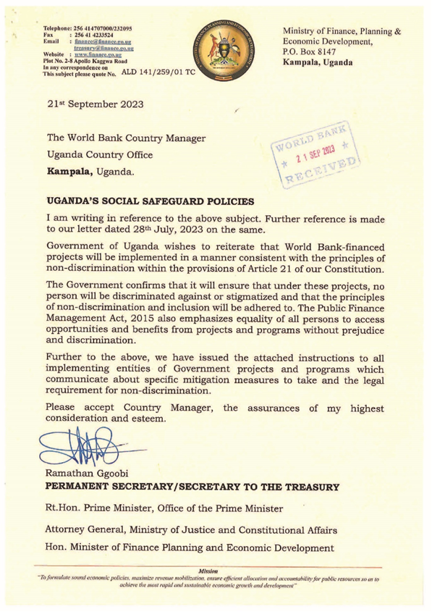



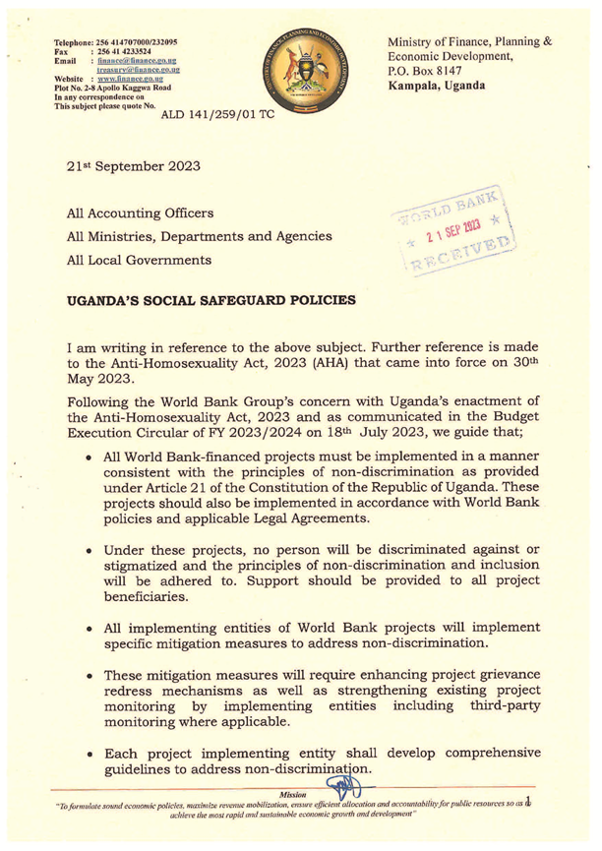

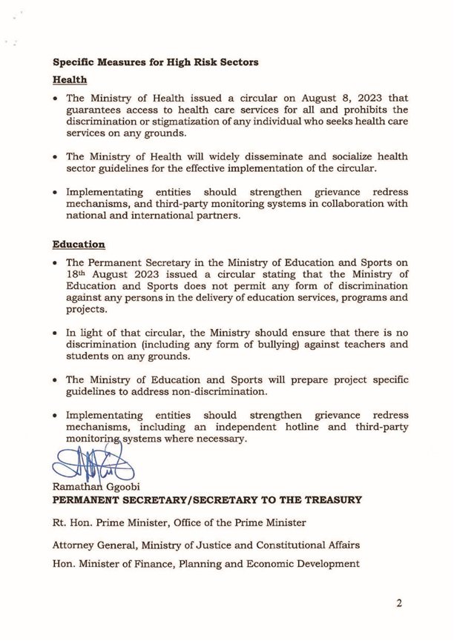

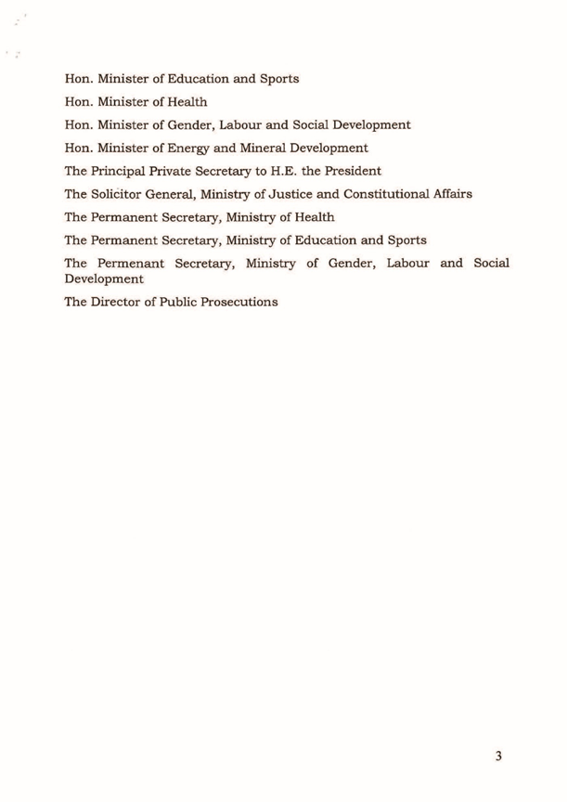

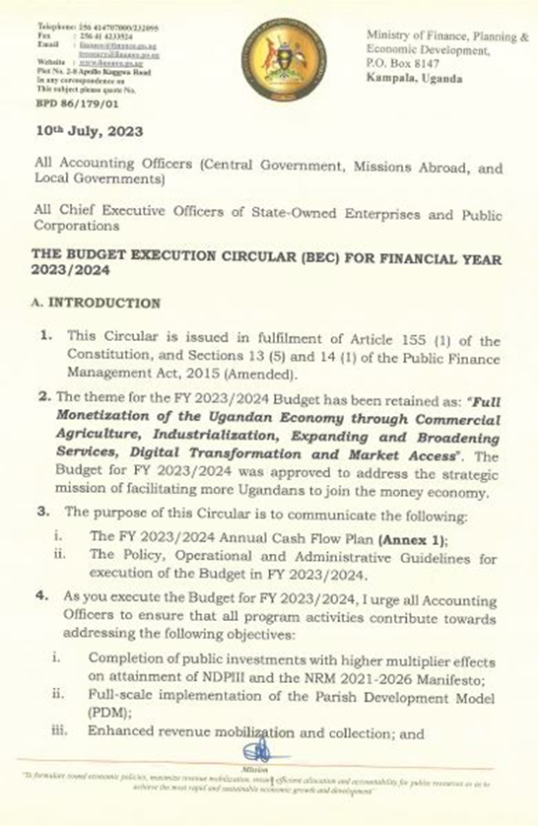

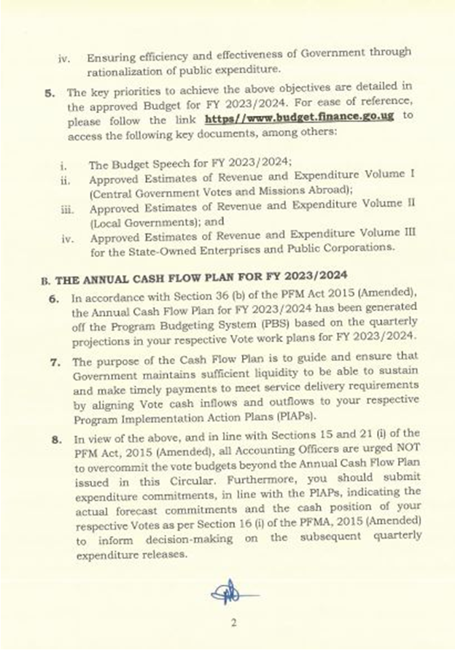

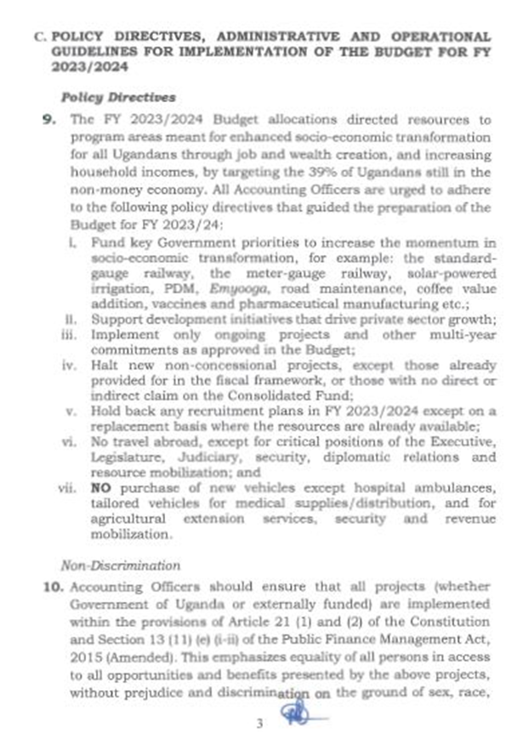



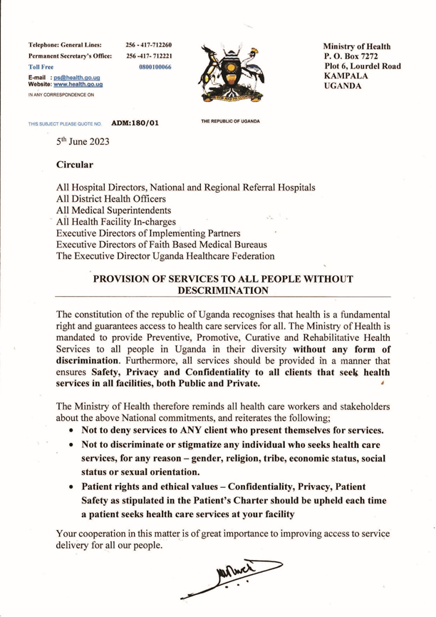

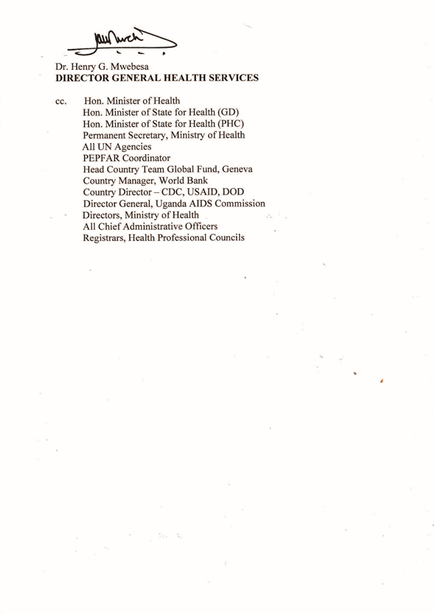

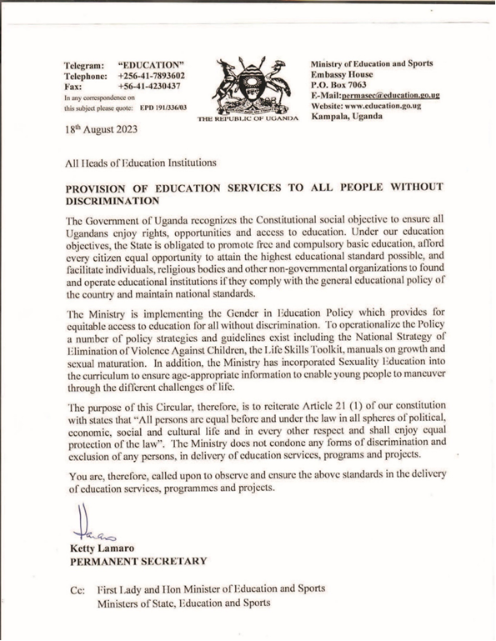

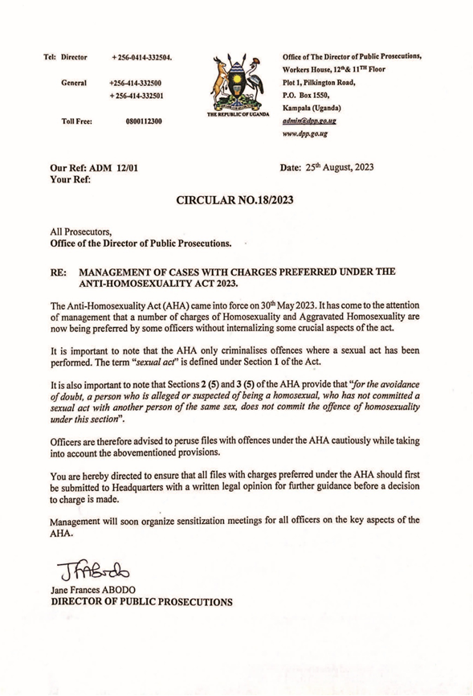

## Annex 4: Enhanced Implementation Support and Monitoring on Non-Discrimination

The World Bank and IFC have hired an international and credible entity (firm, agency) with a strong knowledge of the Ugandan context and a track record of enhanced third-party implementation support and performance monitoring to undertake the tasks described in this section for all projects presently being implemented in the Uganda portfolio. The entity is expected to work with NGO/CSOs and country-based development partners.

The Enhanced Implementation Support and Monitoring (EISM) will primarily focus on supporting project teams to implement mitigation measures to address grievances and concerns from beneficiaries, communities, and workers relating to discrimination from project benefits.

The objectives of the Enhanced Implementation Support and Monitoring include:

* Assisting project teams to enhance existing project-level grievance mechanisms and develop and operate an independent mechanism that would identify, manage, and monitor cases of discrimination.
* Assisting the WB in strengthening the capacity of PIU/PCUs, workers, and contractors, subcontractors, and service providers.
* Ensuring contracts, codes of conduct, hiring procedures, whistle-blower protection protocols, and other measures, as needed, are in place to allow remediation of cases of discrimination.
* Develop a strong data management system and process that secures personal data and information in a manner that is safe, ethical, and confidential.
* Where cases of discrimination are reported through the above mechanism, the EISM will report the grievances to the Bank, propose appropriate remediation, and follow up on agreed actions to resolve the cases.
* Support the WB/IFC to monitor the efficacy of the agreed measures to mitigate the impacts on WB/IFC financed operations.

Table 11 illustrates the enhanced implementation support and monitoring steps. Figure 8 contains the Enhanced Implementation Support and Monitoring process. Figure 9 contains Complaint Management for vulnerable or marginalized individuals or groups.

1. **SCOPE OF WORK AND ACTIVITIES**

To provide enhanced implementation and monitoring support to the World Bank/IFC operations in Uganda the EISM will:

1.1 Establish an effective and confidential mechanism to receive, manage, refer, and monitor grievances related to discrimination across the WB/IFC portfolio.

**To do so the EISM will:**

* **Enhance existing project-level grievance redress mechanisms** to safely, ethically, and coincidentally receive cases related to discrimination on World Bank/IFC financed operations and refer them to an appropriate grievance handling mechanism.
* **Design and operate a mechanism for receiving grievances** related to discrimination on WB/IFC financed operations (including from project level grievance mechanisms noted above).
* **Establish a hotline or an alternative complaint mechanism**, for individuals to lodge complaints of discrimination on WB/IFC financed projects or voice their concerns without fear of reprisal. The EISM is an alternative to lodging complaints through a GOU-led project-level GRMs

**NOTE**: The EISM firm has established a nationwide GRM hotline – 0800 333125, designed specifically to receive grievances or concerns from vulnerable or marginalised individuals or groups that may be discriminated against or excluded from benefiting from all World Bank and IFC financed projects. The hotline is hosted and operated by a local NGO. IFPA-CD will also benefit from the same hotline.

|  |  |  |  |  |
| --- | --- | --- | --- | --- |
| Table 12: Enhanced Implementation Support and Monitoring Steps | | | | |
| Act as a key first step in the referral process from project-level GRMs | | | Designed specifically to handle complaints restricted to WB/IFC projects | |
| Step 1 |  | Receives and document complaints of discrimination in accessing WB/IFC projects’ | |  |
| benefits, services, and opportunities. | |
| Step 2 | Develops specific security protocols to ensure that communications are safe, ethical, and confidential. | | | |
| Step 3 | Establishes a data management system on an international server guaranteed by the provider as safe and secure encryption and privacy. | | | |
| Step 4 | Implements a data privacy and protection policy to include confidentiality clauses to be signed by all personnel entrusted with managing referrals or referral-related information. | | | |
| Step 5 | Handles complaints in a confidential, anonymous, and non-judgmental manner which is sensitive to local context and in local languages. | | | |
| Step 6 | Provides detailed monthly reports of complaints received to the WB/IFC | | | |
| Step 7 | Provides ad hoc incident reports of all allegations to WB/IFC within 48 hours of receipt. | | | |
| Step 8 | Reports grievances to the WB/IFC, proposes appropriate remediation, and follows up on agreed actions to resolve the case. | | | |
| Step 9 | Maps available services for vulnerable or marginalized individuals or groups including counselling, legal services, protection, and other services. | | | |
| Step 10 | Refers individuals to the appropriate local services or organizations as needed. | | | |
| Step 11 | Regularly evaluates the effectiveness of mitigation measures to determine whether and how well the mitigation measures are functioning. | | | |
| Step 12 | Recommends and supports the implementation of adjustments to mitigation measures based on regular evaluations and their impact. | | | |
|  |  |  |  |  |

**1.2 Outreach and sensitization to project beneficiaries and communities involved with the World Bank/IFC Bank/IFC Portfolios**.

Activities related to Outreach and sensitization to project beneficiaries and communities include:

* Assist the WB/IFC to prepare and implement a plan to disseminate information about the support provided by the entity including support to existent GRMs.
* Prepare community/beneficiary information materials on their rights within the Constitution of Uganda and World Bank/IFC policies informed by various official circulars issued by the GOU on non-discrimination and World Bank/IFC policies.
* Develop and implement a methodology to conduct periodic outreach to beneficiaries/communities to hold consultations on non-discrimination to identify issues and risks in a safe, ethical, and confidential manner.

**1.3 Capacity strengthening and technical support**

Activities related to capacity strengthening and technical support include:

* **Support to the WB/IFC on training of** government staff and private sector consultants/clients, workers, and contractors on non-discrimination by developing training materials, identifying venues, providing trainers, etc.
* **Support to the WB/IFC** with training project level GRMs on non-discrimination in World Bank and IFC financed Projects by developing training materials, identifying venues, providing trainers, etc.
* **Preparing training modules** for call center operators, data management personnel, and community outreach personnel on appropriate handling of sensitive information.
* **Providing technical support** to the GOU for the development of Guidelines on Non-discrimination of Workers.

**1.4 Monitoring and Evaluation**

Activities related to monitoring and evaluation include:

* **Developing a system to regularly monitor WB/IFC projects for** 1) implementation of agreed GOU actions to mitigate the risk of discrimination on WB/ IFC projects, 2) incidents of discrimination on World WB/IFC financed projects.
* **Regularly evaluating the effectiveness of mitigation measures** to determine whether and how well the mitigation measures are functioning to improve WB/IFC awareness of incidents of discrimination on WB/IFC financed operations.
* **Recommending and supporting the implementation of adjustments to mitigation measures** based on regular evaluations and their impact.

1. **SCOPE OF WORK AND ACTIVITIES**

The GOU and its PIUs remain responsible for the implementation of all project activities including supporting the WB/IFC to ensure the agreed measures on non-discrimination in the portfolio are implemented fully, ethically, safely, and to an appropriate standard of quality; and to support the WB/IFC to enhance our awareness of cases of discrimination across the WB/IFC portfolio.

The GOU will facilitate the work of the Entity and collaborate as needed on all activities requiring their direct involvement, such as outreach and sensitization activities, capacity strengthening and technical support as well as the monitoring and evaluation of mitigation measures. The GOU will also ensure that the work under the EISM can be undertaken safely in accordance with existing circulars and their dissemination.

**Figure 9: Description of Enhanced Implementation Support and Monitoring (EISM) Process**

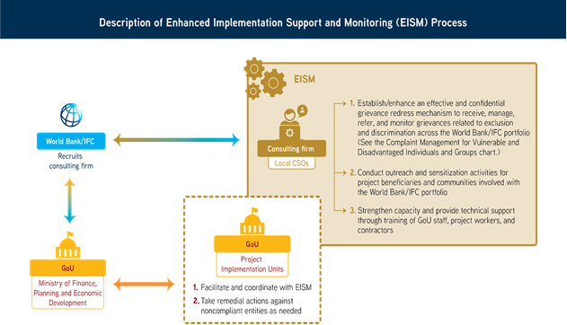

**Figure 10: Complaint Management for Vulnerable or Disadvantaged Individuals or Groups**

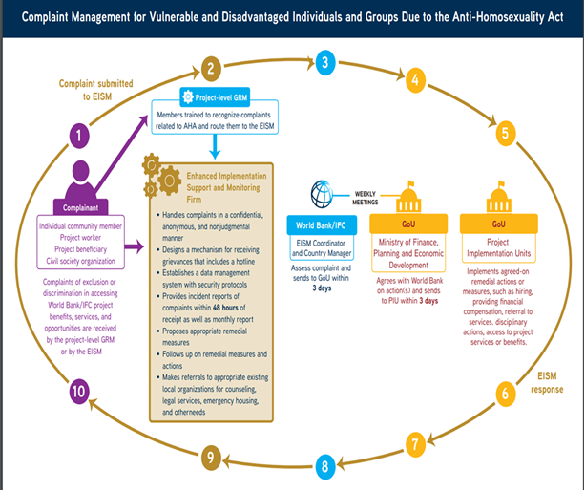

## ANNEX 5: Guidelines For Implementing Mitigation Measures to Address Exclusion and Discrimination -Related Risk

In July 2024, the Environmental and Social documentation and its annexes including ESMF, VLD guideline, SEPs, POMS etc. for all ongoing projects in the Ugandan portfolio were updated to include specific measures to mitigate the risk of discrimination against or exclusion of any affected individuals and groups in providing or receiving benefits in World Bank-financed projects and programs in Uganda. The ESMF and SEP for IFPA_CD includes such mitigation measures in various sections as appropriate.

The measures involve ensuring access to a project-level Grievance Redress Mechanism (GRM), establishing a dedicated hotline for receiving exclusion and discrimination-related complaints, requiring contract clauses and codes of conduct on non-discrimination, and training project workers and contractors and community outreach activities on Inclusion and Non-discrimination (IND).

Through a competitive process, the World Bank and International Finance Corporation (IFC) have contracted an international firm SREO Consulting Ltd. (SREO) to support the implementation of the mitigation measures. SREO will partner with local Civil Society Organizations (CSOs) and/or individuals with expertise and experience in inclusion and non-discrimination in Uganda.

The World Bank will support the Ugandan government in the rollout of the mitigation measures through Enhanced Implementation Support and Monitoring (EISM), targeting PIU/PCUs including various stakeholders such as contractors, subcontractors, frontline service providers, and local stakeholders, as required and set out in the environmental and social documentation.

This annex presents guidelines on how to implement the mitigation measures, including main steps and the roles and responsibilities of task teams, the Ugandan government, PIUs/PISTs, the World Bank, CSOs, SREO, and other stakeholders.

**Steps for Implementing Mitigation Measures**

Depending on the status of a particular project, the following steps may or may not be followed sequentially. One or more of the steps might not be relevant to a project, or it might be possible to accomplish two or more steps at the same time.

SREO and the relevant World Bank task team leader, social development specialist, and PIU/PIST should discuss and agree on the relevance and sequence of steps prior to their implementation.

**1. Assess the Status of the Project**

The approach, type, and level of effort will vary depending on a project’s implementation status:

* **Ongoing projects.** Ongoing projects require retrofitting to include mitigation measures. Such projects should be considered high priority for monitoring because of the existing risk of discrimination.
* **Early-stage projects.** Projects at an early stage of implementation require retrofitting to include mitigation measures, but the need for monitoring is not as urgent as for ongoing projects. The priority level for early-stage projects will depend on the status of activities on the ground and whether or not a PIU and service providers are in place.
* **Closing and closed projects.** Projects that have closed since June 2023 or that will be closing in the next six months require a due diligence review to assess if there are any outstanding complaints or issues related to the discrimination of vulnerable or marginalized individuals or groups and if any remedial measures are needed.

The results of the due diligence should be incorporated into the standard environmental and social closure review unless it has been completed already. No further action is needed.

* **Pipeline projects.** A project that has not yet begun implementation provides the opportunity to integrate exclusion and discrimination related risk mitigation measures and monitoring into its design.

IFPA-CD as a pipeline project has presented such an opportunity to integrate these mitigation measures and monitoring into its design.

**2. Enhance Existing Project-Level Grievance Redress Mechanisms and Establish a Hotline**

SREO will distribute a questionnaire to World Bank and PIU/PIST social development specialists to assess existing project-level GRMs. Based on a review of responses, it will recommend actions that the PIU/PIST or service providers can take to improve the GRMs.

With the support of SREO, the PIU/PIST and the social development specialist will revise the project GRMs to include effective, safe, ethical, and confidential referral pathways, ensuring that individuals or groups feel secure reporting incidents and that grievances are addressed quickly, efficiently, and appropriately.

SREO will provide training to GRM staff so they can recognize social exclusion and discrimination-related complaints and route them to the EISM. The enhanced process will enable the PIU/PIST to identify complaints of exclusion or discrimination sent to the GRM and forward them to SREO within 48 hours of receipt.

**Hotline on Discrimination and Exclusion**

SREO has designed and operates a hotline (0800 333125) as an alternative way to receive complaints about the exclusion or discrimination of vulnerable or marginalized individuals or groups related to accessing benefits, services, or opportunities in World Bank/IFC operations. The design of the hotline will allow it to:

* Receive complaints in a confidential, anonymous, and nonjudgmental manner that is sensitive to local context and available in local languages.
* Compile detailed monthly reports of complaints.
* Advise complainants on remedial actions.
* Map available services for vulnerable or marginalized individuals or groups, including counseling, legal services, and protection.
* Refer individuals to appropriate local services or organizations.
* Implement a data privacy and protection policy that includes confidentiality clauses which must be signed by all personnel handling referrals
* Establish a data management system that guarantees safety through secure encryption and privacy protocols.
* Develop specific security protocols to ensure communications are safe, ethical, and confidential.
* Ensure all grievance mechanisms have appropriate whistle-blower protection protocols in place that enable safe reporting.

**World Bank’s Grievance Redress Service.** In addition to the enhanced project-level GRM and the dedicated hotline, the World Bank has developed a specific window under its existing Grievance Redress Service (GRS) to manage complaints related to any World Bank project globally. A protocol has been developed to process all complaints related to exclusion or discrimination in the Uganda portfolio.

**3. Conduct Outreach and Sensitization Activities**

The World Bank team, PIUs/PISTs, and service providers should contact SREO to assist with:

* The preparation and implementation of a plan to disseminate information about existing GRMs and the dedicated hotline.
* The development and implementation of outreach activities on non-discrimination delivered to beneficiaries and communities in a safe, ethical, and confidential manner.

**4. Strengthen Capacity and Deliver Technical Support**

The World Bank team, PIUs/PISTs, and service providers should contact SREO to assist with:

* Training workers, contractors, and project-level GRM staff on non-discrimination and inclusion, including developing training materials, identifying venues, and hiring trainers.
* Delivering any other needed technical support related to the implementation of the mitigation measures.

SREO will prepare training modules for call center operators, data management personnel, and community outreach personnel on the appropriate handling of sensitive information given the exclusion and discrimination context.

**5. Conduct Monitoring and Evaluation**

Task team leaders, social development specialists, PIUs/PISTs, and service providers should contact SREO to:

* Support the monthly and quarterly monitoring and evaluation of the implementation of agreed measures and actions to mitigate the risk of exclusion and discrimination and to reduce incidents of due to the same.
* Provide comments on regular evaluations of the effectiveness of mitigation measures.
* Offer feedback on recommendations and support the implementation of adjustments to mitigation measures based on their effectiveness.

**6. Take Remedial Action**

When a discrimination or exclusion complaint is reported to the dedicated hotline, the following process should be followed:

* SREO will report the grievance to the World Bank, propose appropriate remedial actions, and follow up on agreed actions to resolve the case.
* The World Bank’s EISM coordinator and country manager will assess the complaint and then forward it to the Ministry of Finance, Planning and Economic Development. If the Ministry does not object to the World Bank’s recommendations, they will be forwarded to the PIU/PIST.
* The PIU/PIST is responsible for implementing the agreed measures, which might include training and retraining, hiring, offering financial compensation, providing service referrals, taking disciplinary actions, and providing access to project services and benefits.

**Roles and responsibilities for the Implementation of Mitigation Measures**

The different steps presented are guidance on the how to do and the sequencing for the implementation of the mitigation measures bearing in mind that the sequencing can vary from one project to another, and activities done in parallel in some instances. Each Step identifies the roles and responsibilities of the GOU, PIU/PIST, WBG, CSOs and SREO. The roles and responsibilities are summarized in this section in the box below.

This section also provides more specific information on roles and responsibilities to implement the mitigation measures of the EISM firm RSEO and the PIUs/PIST. The mitigations measures identified in the Projects’ environment and social instruments will be implemented by the GOU through the PIU/PIST with the support of the EISM firm RSEO hired by the World Bank with NGO/CSOs and country-based development partners in implementing these mitigation measures. SREO’s specific responsibilities include:

* Helping project teams improve existing project-level grievance redress mechanisms, and developing and operating an independent mechanism to identify, manage, and monitor cases of discrimination.
* Developing a robust data management system and process that secures personal data and information safely, ethically, and confidentially.
* Working with the World Bank to strengthen the capacity of PIUs/PISTs, workers, contractors, subcontractors, and service providers.
* Ensuring that contracts, codes of conduct, hiring procedures, whistle-blower protections, and all other needed protocols are in place to remediate cases of discrimination.
* Supporting the World Bank in monitoring the efficacy of the agreed mitigation measures.
* Reporting complaints of discrimination to the World Bank, proposing appropriate remedial actions, and following up on agreed actions to resolve cases.

With the support of SREO, PIUs/PISTs are responsible for implementing mitigation measures as described in the environmental and social instruments, including:

* Developing training, sensitization, information, educational, and communication materials on the principle of non-discrimination of individuals or groups who are vulnerable or marginalized.
* Conducting consultations on non-discrimination with targeted external stakeholders, including NGOs, CSOs, local governments, and other stakeholders, as appropriate.
* Integrating clauses on non-discrimination and codes of conduct on non-discrimination into all project contracts, which must be signed by all contractors, subcontractors, and service provider staff.
* Reviewing all relevant policy and protocol documents, including those for human resources and whistle-blower protections.
* Facilitating the monitoring of all measures to ensure their implementation, that all reported incidents are shared with the World Bank, and that they are addressed promptly.

|  |
| --- |
| **Box 1: Roles and Responsibilities for the Implementation of Mitigation Measures**  ***Government of Uganda***   * Facilitating the implementation of mitigation measures under the leadership of the Ministry of Finance, Planning and Economic Development and through PIUs. * Following up on reported cases of discrimination in coordination with the World Bank EISM coordinator and country manager. * Achieving agreement with the World Bank on remedial actions and forwarding recommendations to PIUs.   ***Project Implementation Units/Project Implementation Support Teams***   * Reviewing and enhancing project-level GRMs. * Ensuring the implementation of mitigation measures. * Facilitating capacity strengthening and community outreach efforts. * Implementing agreed-on remedial actions and measures.   ***World Bank (task team leaders, social development specialists, and the EISM Coordinator)***   * Supporting capacity strengthening and training sessions. * Facilitating communication between SREO and the Ugandan government, SREO and task team leaders, and SREO and PIUs/PISTs. * Overseeing the remediation of reported cases, makes recommendations, and follows up to ensure their resolution.   ***Civil Society Organizations***   * Hired by the EISM firm (SREO) to coordinate the monitoring of activities in Uganda. * Participate in capacity-building and outreach activities to disseminate information about the hotline and the GRS to relevant populations. * Receive and manage referrals for issues outside the EISM’s scope.   ***SREO Consulting, Ltd.***   * Establishes a dedicated hotline and assists PIUs/PISTs in improving existing GRMs. * Conducts outreach and sensitization activities. * Provides capacity-strengthening and technical support to PIUs/PISTs. * Monitors and evaluates discrimination complaints. |

**Annex 4: IFPA-CD UPDATED GRM SYESTEM**

The toll-free lines have been established for both UWA (0800100960 and WhatsApp number 0740560236) and NFA (0800264036 and WhatsApp number 0707608920) and are functional. MWE toll-free (800203655) line to receive project related grievances on activities in the refugee hosting areas and it will also be the second level for grievance escalation from both UWA and NFA.

Each implementing institution (MWE, UWA & NFA) shall always have in place two officers responsible for receiving calls from the provided project numbers, recording all received grievances in the complaint’s logbook, channelling grievances received to responsible officers and following up to ensure that it is resolved and then closed off.

The responsible officer is the social safeguards focal person for the project at UWA and NFA. The project Social Risk Management Specialist is responsible for resolution of grievances at MWE and overall project grievances and ensuring its well documented, followed up on, resolved and closed off. A complaint is only closed off once the complainant confirms satisfaction with the resolution process and outcome provided and if despite solutions and feedback provided and all possible options explored and still unresolved then complaint may take this case to the next level for resolution.

A centralized email for reporting of grievances and any project related issues is open and managed by MWE [ifpacd@mwe.go.ug](mailto:ifpacd@mwe.go.ug) where project beneficiaries and all other stakeholders’ grievances can be sent.

Suggestion boxes will be placed in project community areas where project activities are ongoing closer to communities likely to be affected to create multiple uptake channels for grievances. Each protected area will nominate an officer in charge of collecting grievances from the suggestion boxes working with the Local Council 1 chairperson who is responsible for suggestion boxes in their area of operation.

Develop and print IEC material with key information about the project and most importantly, the toll-free numbers, emails, WhatsApp numbers and other available channels for grievance reporting. In addition to the English version the IEC material shall be translated into relevant local languages in the project area and displayed in the respected locations.

**NFA AND UWA GRIEVANCE REPORTING IEC WITH TOLL FREE LINES**

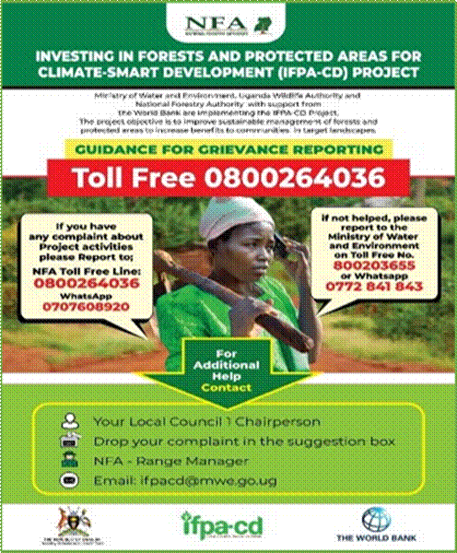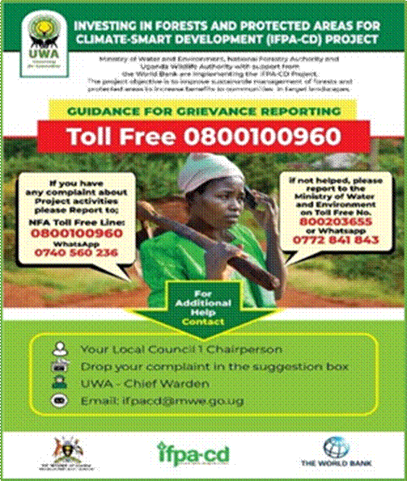

**FLOW CHART FOR GRIEVANCE REPORTING TOLL FREE LINE**

When a call is received from the toll free numbers(call centre), the call Center personnel records the grievance in the log book and immediately refers it to the social Safeguards Officer for the agency (UWA & NFA) for an immediate follow up and resolution and if it needs the field office involvement, it is then forwarded to the field office (Chief Warden – UWA & Range Manager - NFA). This should all be done within one day of receiving the grievance. A follow up is made by the field officer to the field and feedback provided to the complainant within two working days of receiving the grievance. Once the complaint is resolved the case is closed. And if not resolved the complaint is escalated to the next level in this case MWE. If not resolved by MWE, the complainant can use other mechanism which involves Court or report to WB GRS.

**NFA AND UWA TOLL FREE LINE RESPONSE FLOW CHART**

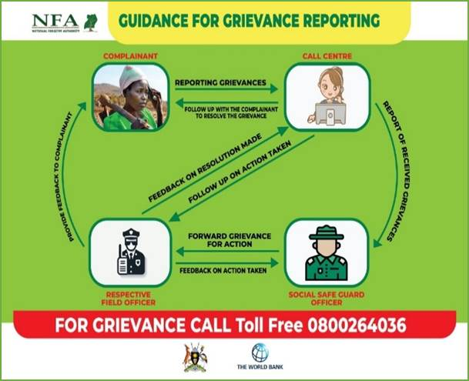 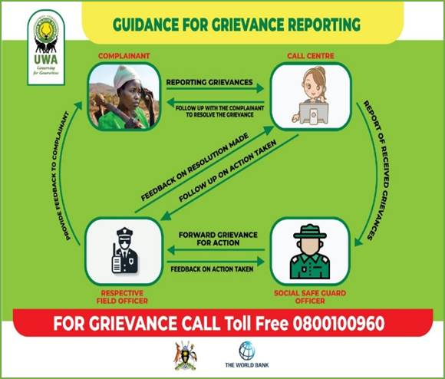

**FRRM IN REFUGEE SETTLEMENT**

The IFPA-CD project through MWE will work together with UNHCR and use its inter-agency common service plat form for Feedback, Referral and Resolution Mechanism (FRRM) to receive complaints and feedback related to the project. Any issues received through its call centre will be forwarded to the Project Social Risk Management Specialist who will register the grievance or feedback in a logbook, follow up on it and ensure it’s resolved while keeping the aggrieved person informed and periodically as agreed updating the FRRM system with the status of the grievance received until closure. A detailed technical working mechanism will be agreed upon with UNHCR prior to operationalisation of this.

1. World Bank (2016). *Country Partnership Framework for the Republic of Uganda for the Period FY16-2, extended.* 
2. https://www.earthranger.com/.
3. A total of 3 meetings with the Batwa were organized in the Southern Sector of Bwindi alone.
4. A total of 3 meetings were organized in the Southern Sector of Bwindi alone.